1. I find 3 configurations in chapter 4 of programming guide, what configuration I need to set or I need to set all configurations in my system?

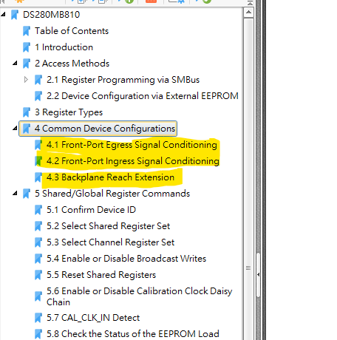

2. Check the application configuration sequence, I saw the step8 ~step9 is focus on channel register 0x3 to set EQ BST[2:1] and BW, but it divides into 3 times to write the same register 0x3.

Regarding to section 4.2 setup, the 1st time write 0x2 to register 0x3, and 3rd time write the 0xc0 to register 0x3, the 1st time setting value will be over writing by the 3rd times and cause to the incorrect setting?

Can we write 0xc2 by once command to replace the setting value of step8~step9?

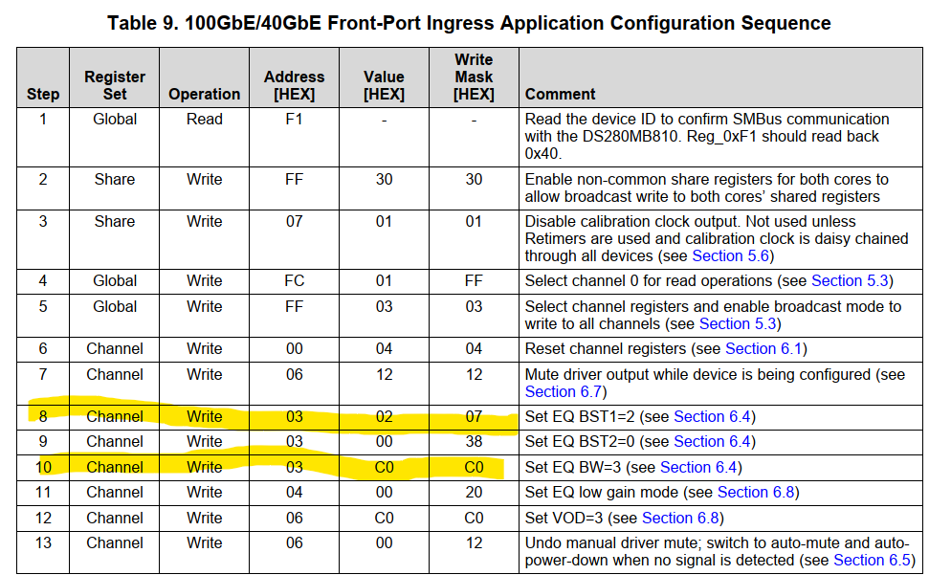

3. Would you please help to provide the extra DS280MB810 setting process for our application since we have two DS280MB810s, not only the descriptions of programming guide?

4. The programming guide mentions the Egress configuration, the step1 to read register 0xf1 to get 0x42 as table 8, but I check the Ingress configuration process, the register 0xf1 should read back 0x40 as Table 9 showing, it seems not meet the 0xfc define as Table 5 showing.

Would you please help to check the correct value of 0xf1 while do the Ingress configuration process? Or I miss understanding something?

