Hi Team

We have use TI DS90UB914Q and DS90UB913Q.

The source picture

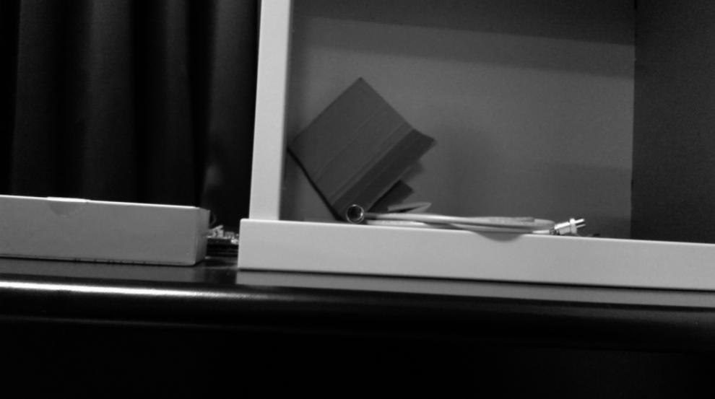

Transmission signal from DS90UB914Q and DS90UB913Q and get picture

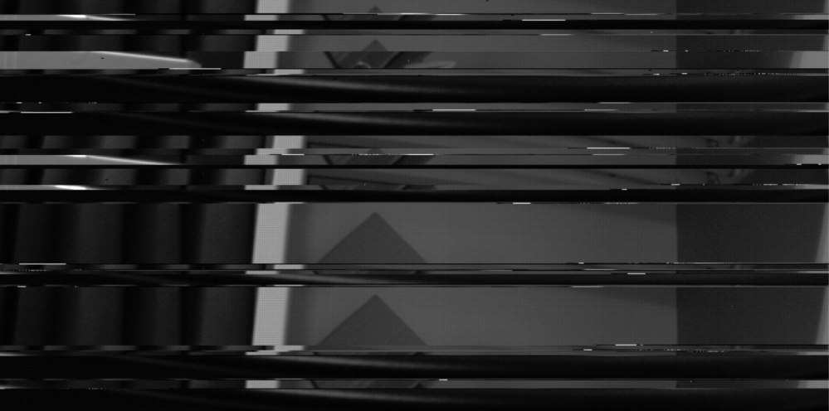

The sch as below

 

Did we need any SW setting for this device?

