Hi Team,

I have few questions about DS90UB935-Q1:

Can I work with DS90UB935-Q1 & DS90UB954-Q1?

In below snippet from TI's website I marked the "problematic" specifications.

Can I work with pixel rate of 25M in DS90UB935-Q1/953-Q1? I asked because the min is 37.5M.

I need pixel clock of 12.5MHz-25MHz and want to use RAW14 data (grayscale), hence require one color component with 14 bits.

I don't clearly see these limitations in the datasheet but want to confirm.

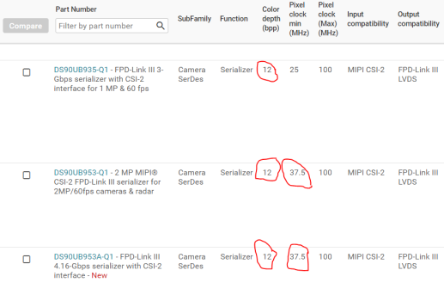

In DS90UB953 EV-Kit there is a place for daughter card to deliver CS2 (see picture below).

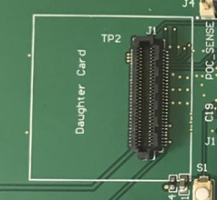

I can't find any information regarding this card. Can you advise if TI or 3rd party have matching board?

Same for DS90UB954 EV-Kit, I have J24 connector (CSI Output). Again, Can you advise if TI or 3rd party have matching board?

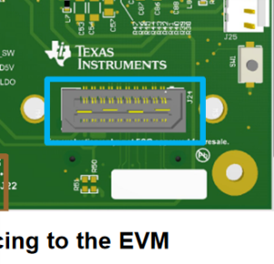

Thanks,

Shlomi