DS90UB953 Eye Diagram Test Standard Confirmation
1、Circuit block diagram：
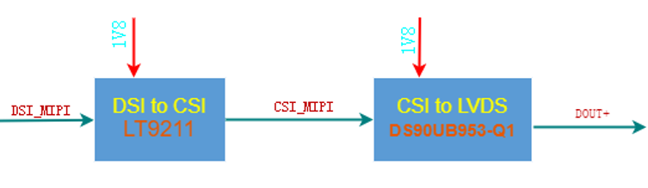

2、Eye pattern：
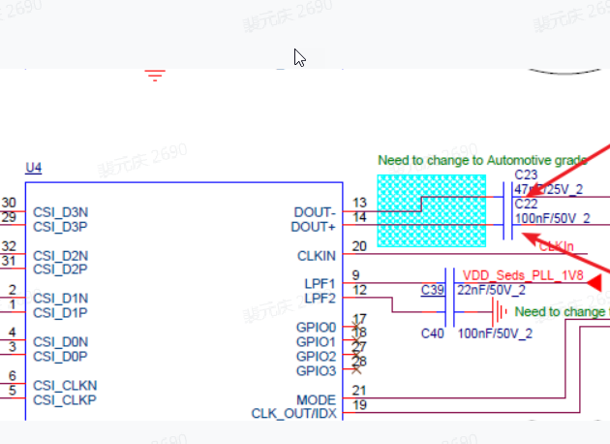
The video signal is output through DSI-MIPI, and the eye diagram signal measured at the output of DS90UB953 is shown in the figure below.
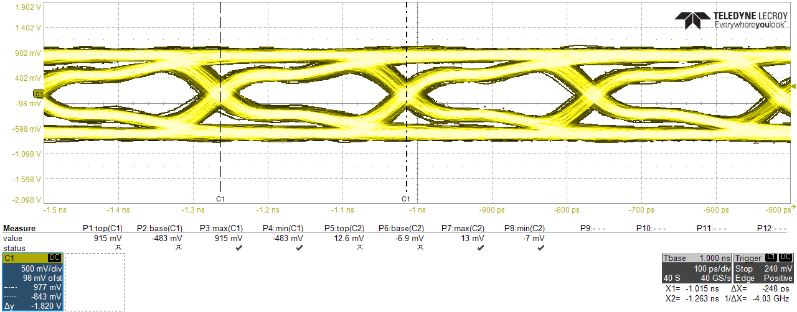

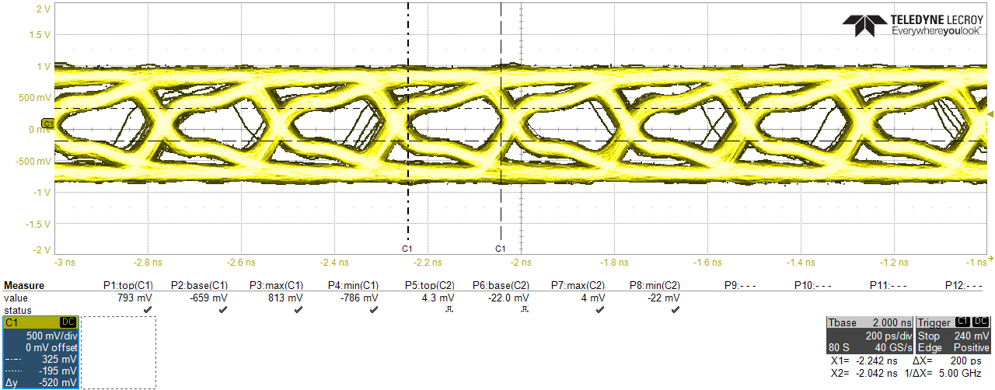

3、Questions：
Regarding the evaluation criteria of the signal quality output by the DS90UB953, can you help check if eye we tested was ok or not，Could you provide eye pattern criteria of DS90UB953 since I can’t find in DS90UB953 datahseet?

