DS90UB954 lock pin noise interference

DS90UB953 PoC circuit

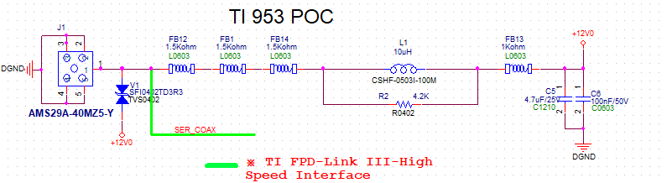

DS90UB954 PoC circuit

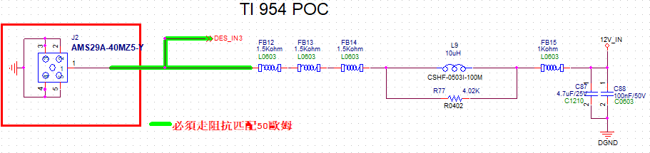

4-ch LED driver circuit

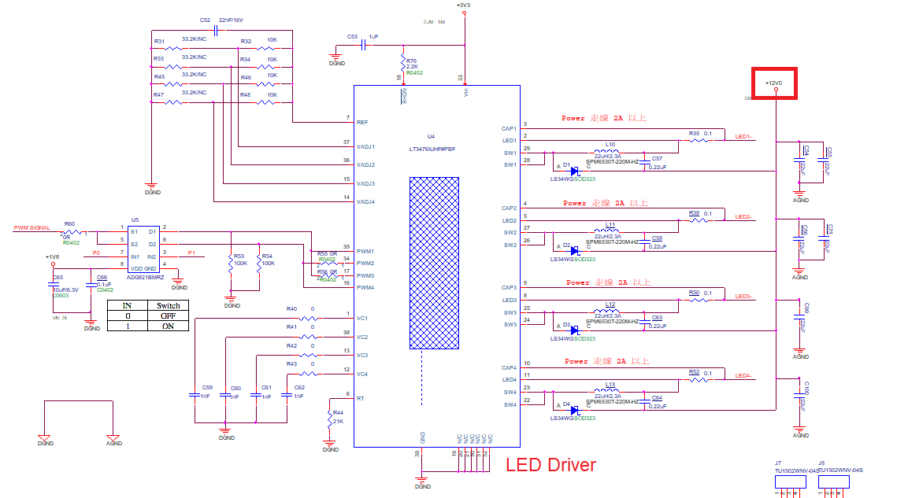

when the LEDs turn-off, measured the DS90UB954 Lock pin with no noise interference.

when the LEDs turn-on, measured the DS90UB954 Lock pin with 50Hz noise interference.

when LEDs turn on, the DS90UB953 clkout pin has measured the same noise interference.