i.MX6D MIPI-CSI2 interface fail to lock DS90UR910 deserializer

Table of Contents
1. Overview 3
1.1 Board Setup 3
2. Issue observed 3
2.1. Issue 3
3. Debug status 3
3.1. Power measurement on DS90UR910 3
3.2. Configuration of DS90UR910 3
3.3. Status pins of DS90UR910 4
3.4. Nitrogen6x Video Input Source 4
4. Result 4
4.1. Status of DS90UR910 4
4.2. Status of MIPI-CSI2 DPHY (i.MX6D) 5
5. Community Help 5

Overview
SanSan board with i.MX6D is not able to receive video input signals via MIPI-CSI2 from DS90UR910.

Board Setup
There are mainly three board:
- Video input source (YAMAHA YGV642)
  - This board will feed 800x480, 60 fps RGB24 video input
- Serializer (DS90UR905) board provided by Sansan
- Sansan Board contains
  - DS90UR910-Q1 10 to 75 MHz 24-bit Color FPD-Link II to CSI-2 Converter

- Video input source is connected with Serializer(DS90UR905) board.
- Serializer(DS90UR905) board is connected with Sansan board (contains DS90UR910-Q1 10 to 75 MHz 24-bit Color FPD-Link II to CSI-2 Converter).

Issue observed

Issue

- The serializer (DS90URE905 chip) board is receiving input signals (RGB24) and giving output signals on its output DOUT+/- pins.
- Though DS90UR910 on SanSan board receiving input signals on RIN+/- pins, it is not giving output on CLK+/- and DATA1-2+/- pins.

- On SanSan board, from i.MX6D side, MIPI-CSI2 DPHY is not able to receive and lock CLOCK with DS90UR910.

- On SanSan board, from DS90UR910 side, DS90UR910 is not providing output on CLK+/- and DATA1+/-, DATA2+/-.

Debug status

Power measurement on DS90UR910
We have measured power on following power pins of DS90UR910 and power is 1.77V on each pin.
- VDDL
- VDDP
- VDDA
- VDDIO
- VDDCSI

Configuration of DS90UR910
- Controlling of EQ and CONFIG strapped control inputs pins according to Table 1. DS90UR910-Q1 Configuration Modes (pg-14) and Table 2. Receiver Equalization Configuration(pg-15)
  - We are overriding EQ and CONFIG strapped control inputs of DS90UR910 with register settings.
  - We are setting “USEREG” field of Register CONFIG1 (0x01) to value ‘1’.
- MODE field of Register CONFIG1(0x01) set to “00”
  - We have also tried with setting this value to “01”
- Receive equalization control: EQ field of Register EQ Control (0x03).
  - Currently set value is “Approximately 3 dB”
  - Though, we have tried all possible 8 combinations.

Status pins of DS90UR910
- LOCK pin status output
  - Status: Always remains LOW
- PASS pin normal mode status output pin
  - Status: Always remains LOW

Nitrogen6x Video Input Source
  - We have replaced SanSan’s Video Input source board.
  - Instead, we used Boundary Device Nitrogen6x board as Video input source to feed 800x480 video RGB24 to Serializer (DS90UR905) board.

Result

Status of DS90UR910
- Sometimes, we seeing pulse signal on the LOCK pin of the DS90UR910 chip
- Below image shows LOCK signal observed on the pin 24 of DS90UR910 (sometimes)

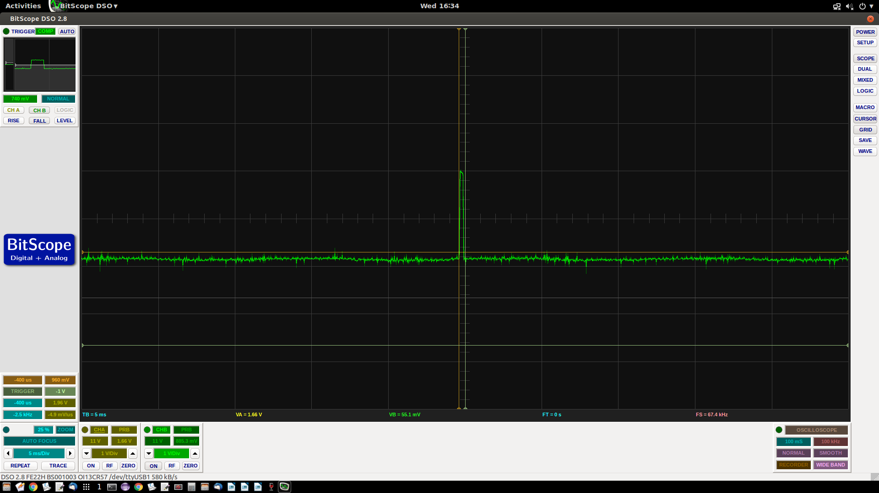

- The PASS pin remains always LOW.
- No signals are observed on the CLK+/-, DATA0+/- and DATA1+/- output pins.

- The significance of these pins is as follows: Pin Functions (continued) (pg-4)

Pin | Pin  no. | Sign-al type | Description | Our observation
LOCK | 24 | Outp-ut | LVCMOS, LOCK status output;  LOCK = 1, PLL acquired lock to the reference clock input; DPHY outputs are active  LOCK = 0, PLL is unlocked | Sometimes pulse signals seen but most of the time remains LOW.
PASS | 25 | Outp-ut | LVCMOS, normal mode status output pin (BISTEN = 0);  PASS = 1: No fault detected on input display timing,  PASS = 0: Indicates an error condition or corruption in display timing. Fault condition occurs if:  1) DE length value mismatch measured once in succession,  2) VSync length value mismatch measured twice in succession,  BIST mode status output pin (BISTEN = 1);  PASS = 1: No error detected,  PASS = 0: Error detected. | The PASS line remains low  (i.e PASS = 0)

Status of MIPI-CSI2 DPHY (i.MX6D)

- The MIPI interface is not able to acquire a lock on the sensor clock and the MIPI-DPHY Status register (0x021DC014) always shows a value=0x200.

Community Help
- We have raised following question on TI community:
  - https://e2e.ti.com/support/interface/high_speed_interface/f/138/t/663610.

