In both of the reference designs below, TI, is connecting the Positive Line-side signals (TD+ and RD+) to the dotted side of the transformer in the J0011 connector (Pin 1 and Pin 3)

In the PHY’s ds, TI shows the Positive Line-side signals connecting to the NON-dotted sides of the transformer:

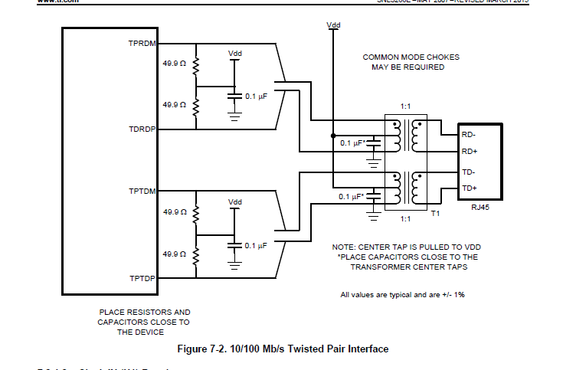

From the DP83848 AspenPHY MAU (ENDURO) Reference design:

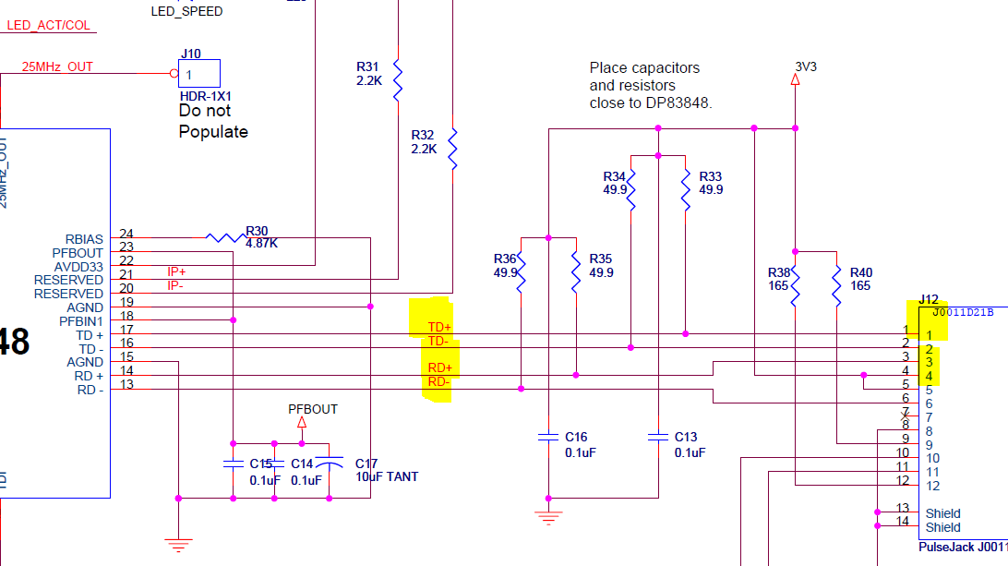

From DP83848J/K PHYTER Mini LS MAU Demo:

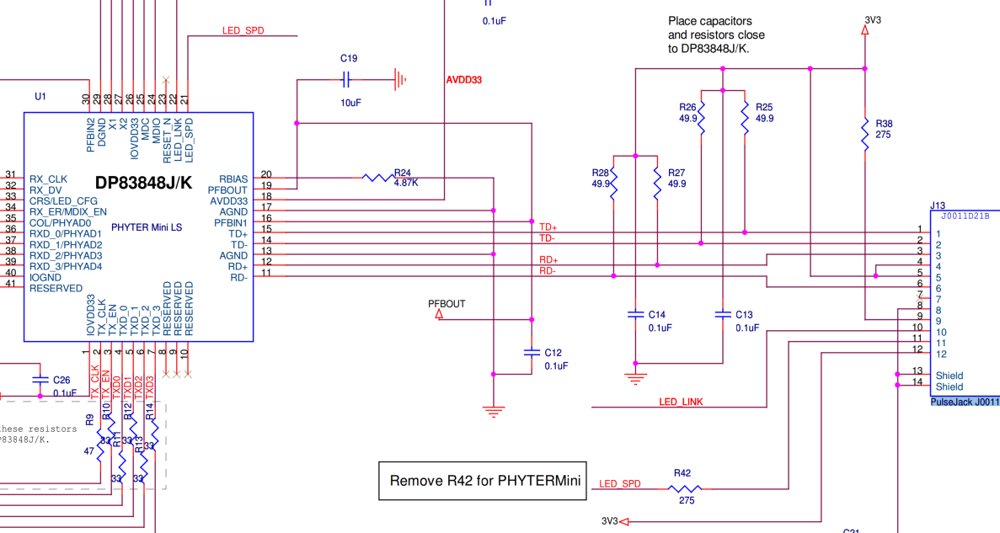

The Pulse Jack wiring diagram for the above two references:

