Hello,

**Question1:**

We choosed DP83620 to work with M287(Freescale A9). Use Tektronix Oscilloscope 5104B for Duty cycle Distortion test, and it failed; But it has no problem when we use DP83848K in another electrical network.

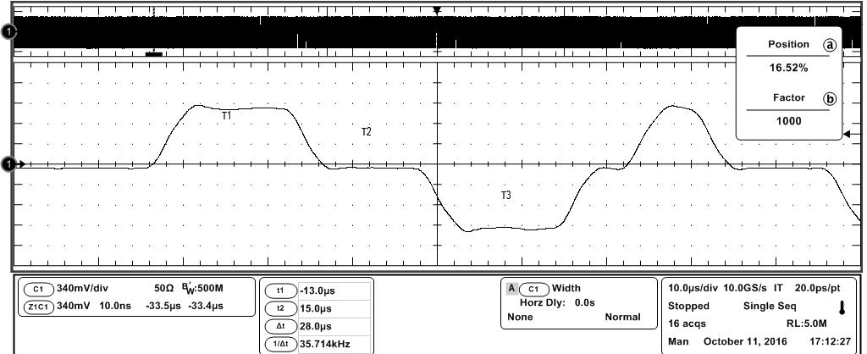

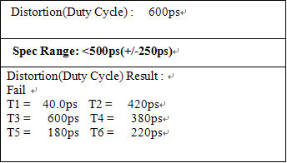

The schematic/PCB and test report as follow:

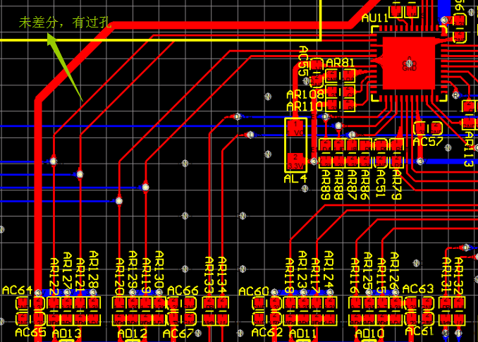

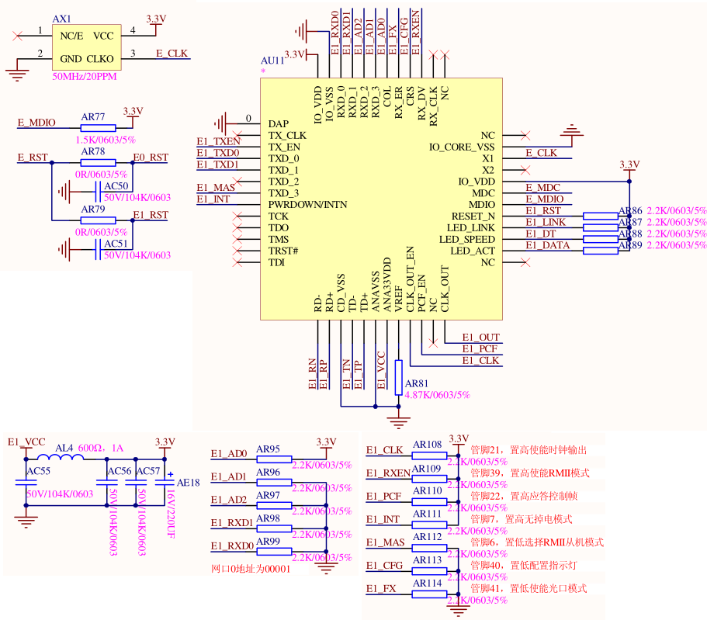

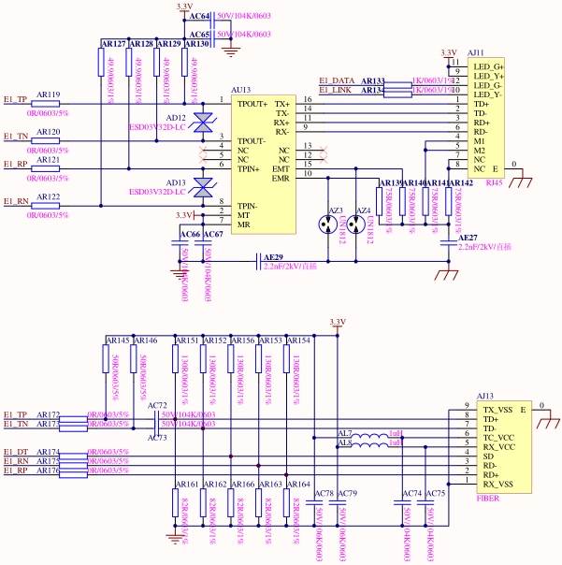

Can you help to analyze what is the cause of the failure?

1. Layout?(The length of differential pairs, Long Routing,etc)
2. Schematic?

**Question 2:**

As Datasheet and EVM, We found DP83620 could use oΩ resistance to switch the output TX+/- and RX+/- to copper or fiber. show as below:

But TI employee had told me that, any branch off and via hole is prohibitive.

