Board-1
- After power up of the PCBA
- Green LED is steady (LNK2/ACT2_N) but no blink in Orange LED ( ACT2)

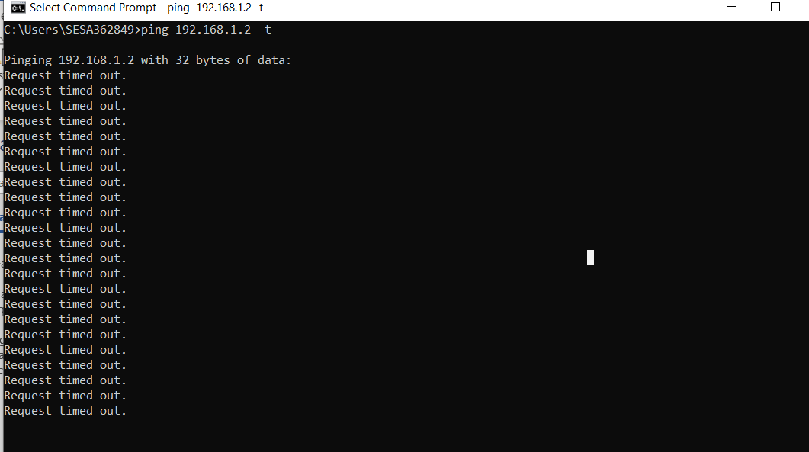
Below is the waveform related to Power,Reset and MDC/MDIO
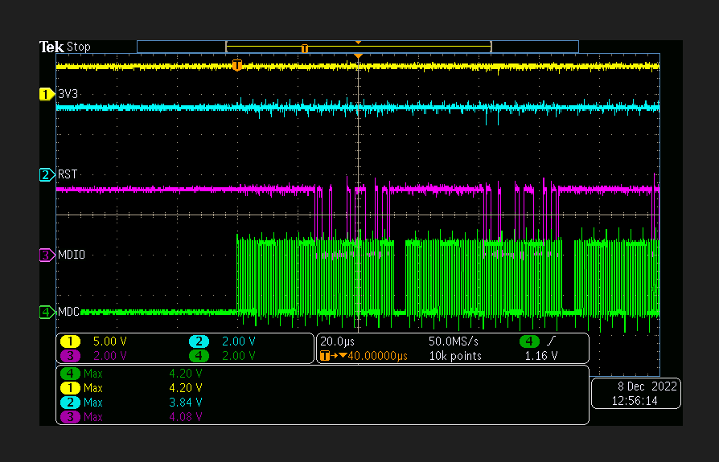
- Later pinging by doing power recycle
- Orange LED in Ethernet port blinking and Green LED is steady