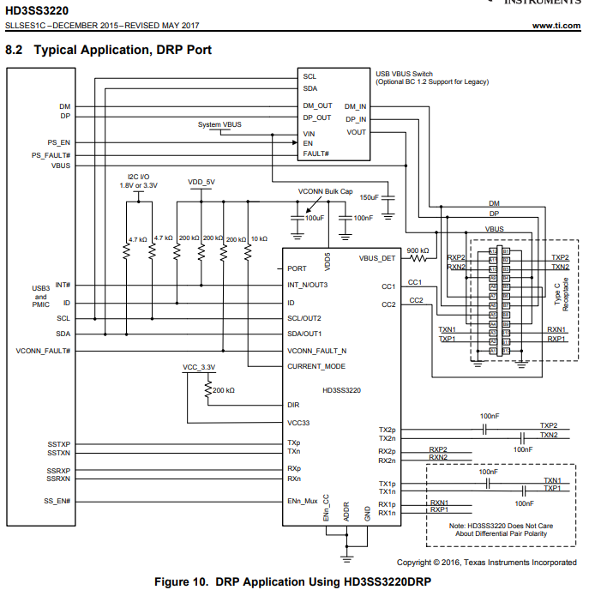

Is it acceptable to remove the capacitors of (A) and (B) then is it ok to place the capacitor to (C) position instead?

(B)

(C)

(A)