Texas Instruments

HPA636 Test Procedure

Rev. B

1.0 GENERAL

1.1 PURPOSE

This document provides detailed test instructions for HPA636. HPA636 allows evaluation of the TPS2051CDBV, TPS2065CDBV, and TPS2530DBV USB power switches.

1.2 SCOPE

This document covers complete instructions for testing the HPA636. Upon completion of this procedure, all units will be categorized as either conforming or non-conforming material and handled accordingly.

1.3 REFERENCE DOCUMENTATION

1.3.1 HPA636_SCH.PDF
1.3.2 HPA636_PCB.PDF

1.4 MATERIALS

1.4.1 Test Log: Not required

1.5 DEFINITIONS

N/A

2.0 SAFETY

2.1 EYE PROTECTION
Safety Glasses are to be worn while performing all testing on the HPA636.

2.2 GENERAL RISKS
This test must be performed by qualified personnel trained in electronics theory and understand the risks and hazards of the assembly to be tested.

2.3 ELECTROSTATIC DISCHARGE
ESD precautions must be followed while handling electronic assemblies while performing this test.

2.4 THERMAL/SHOCK HAZARDS
Precautions should be observed to avoid touching areas of the assembly that may get hot or present a shock hazard during testing.

3.0 QUALITY

3.1 DATA PRESERVATION
Not required

3.2 DATA ACCESS
Not required

4.0 APPAREL

4.1 ELECTROSTATIC SMOCK
4.2 ELECTROSTATIC GLOVES OR FINGER COTS
4.3 SAFETY GLASSES
4.4 GROUND ESD WRIST STRAP SHOULD NOT BE WORN BY THE OPERATOR DURING THIS TEST TO REDUCE THE CHANCES OF HIGH VOLTAGE SHOCK TO THE OPERATOR. WHEN THE CIRCUIT IS NOT POWERED, STANDARD ESD HANDLING PRACTICES SHOULD BE FOLLOWED.

5.0 EQUIPMENT

5.1 TEST FIXTURES

5.2 POWER SUPPLIES
One current-limited power supply capable of supplying 5V @ 5A.

5.3 METERS
One digital volt meter

5.4 OSCILLOSCOPE
A Lecroy 424 oscilloscope or equivalent, one DC voltage probe, and a DC current probe.

5.5 LOADS
One decade box (or equivalent resistor load), capable of providing resistance between 0 and 30 ohms, at 5 amps.

5.6 ADDITIONAL EQUIPMENT
NA

- EQUIPMENT SETUP

    - Set the power-supply output V_{IN} to zero Volts.
    - Ensure that a shunt is installed on the DUT (HPA636) in position J3. Refer to Table 1 for DUT enable/disable settings.

Table 1. DUT J3 Operation.

DUT Assembly # | DUT EVM Orderable # | DUT J3 Operation
HPA636-001 | TPS2051CDBVEVM-636 | Remove shunt to enable, install to disable
HPA636-002 | TPS2065CDBVEVM-636 | Remove shunt to enable, install to disable
HPA636-003 | TPS2530EVM-636 | Remove shunt to enable, install to disable
HPA636-004 | TPS2531EVM-636 | Remove shunt to enable, install to disable

    - Turn on the power supply (V_{IN}) and set the output voltage to 5-V ± 0.1V and the output current-limit to 5-A ± 0.1A. Turn off the power supply.
    - Hook up the HPA636 assembly as shown in Figure 1.

Figure 1. Test equipment setup.

    - Set the oscilloscope timebase to 5ms/div and channel 1 sensitivity to 2V/div. Set the channel 4 (or channel 2 if used) sensitivity to 1A/div. Set the oscilloscope trigger level to 2V, polarity to positive and source to channel 1.

- PROCEDURE

    - Turn on the power supply. Set the load to 21 +/- 2 ohms by setting the tens dial to 2 and the ones dial to one. Enable the DUT using the shunt for J3 and verify that the meter voltage is 5.0 +/- 0.25V. Disable the DUT using the shunt for J3.

NOTE: For the next steps, the DUT will be momentarily enabled into a one ohm load causing the over current protection circuit to trigger the oscilloscope. Enable the DUT for no longer than three seconds to prevent damage to the DUT. Ensure that the scope is properly set up so the waveform can be captured in a timely manner.

    - Set the load to 1 +/- 0.25 ohms by setting the tens dial to 0 and the ones dial to one. Momentarily (less than 3 seconds) enable the DUT with the shunt on J3 to obtain a waveform similar to Figure 2 or Figure 3 (the duty cycle and frequency is not important). Disable the DUT using the shunt on J3 when the waveform is obtained. Verify that the peak-peak current as shown in Figure 2 or Figure 3 is according to Table 2.

NOTE: Depending on the DUT type, the waveform may resemble Figure 2 or Figure 3 The key measurement is the peak to peak current level and not the time characteristics.

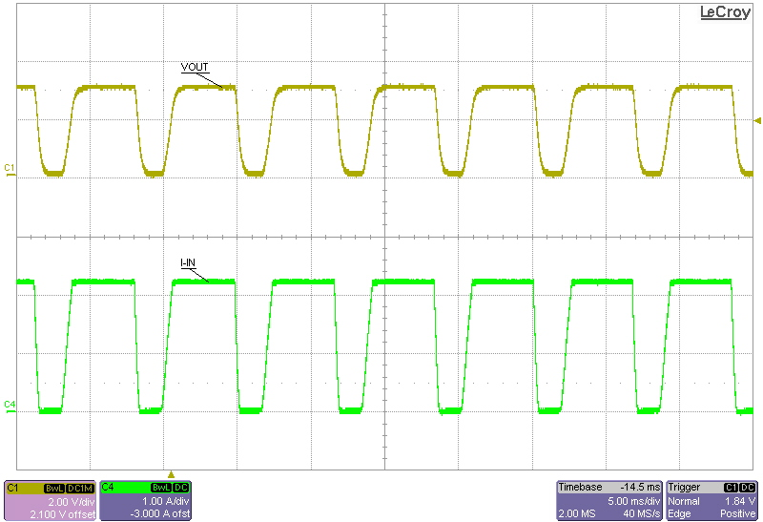

Figure 2. HPA636 Current Waveform (slow enable/disable)

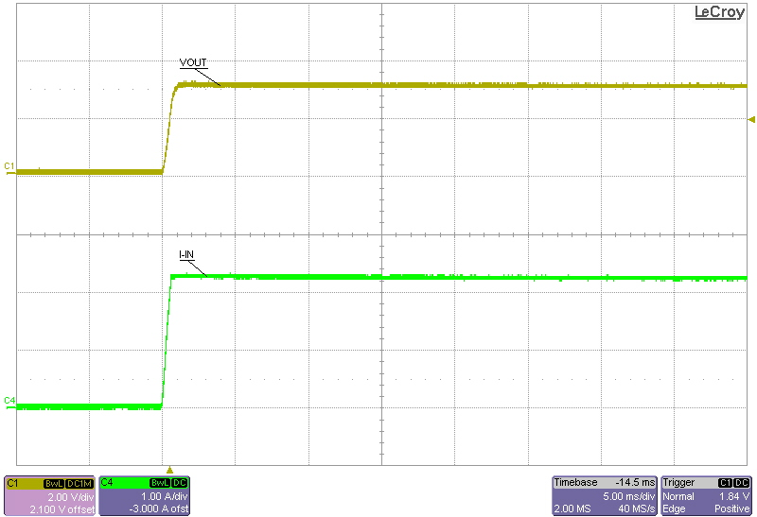

Figure 3. HPA636 Current Waveform (fast enable/disable)

Table 2. DUT Current limit requirements.

DUT Assembly # | Peak-peak current limit
HPA636-001 | 0.85 +/- 0.20A
HPA636-002 | 1.55 +/- 0.25A
HPA636-003 | 1.00 +/- 0.20A
HPA636-004 | 0.38 +/- 0.15A

    - Set the input power supply to zero volts and disconnect all equipment from the DUT. Ensure that a shunt is installed at J3.

MATERIAL DISPOSITION & TRANSFER

8.1 CONFORMING MATERIAL

Units that have passed this test procedure shall be packaged into anti-static ESD approved bags, labeled with two labels according to the table below, and shipped per the P.O.

Label 1  Assembly Number+Dash Number if Applicable | Label 2  Device Number
HPA636-001 | TPS2051CDBV
HPA636-002 | TPS2065CDBV
HPA636-003 | TPS2530DBV
HPA636-004 | TPS2531DBV

8.2 NON-CONFORMING MATERIAL

If yield loss is 2% or less, scrap non-conforming units and adjust P.O. to reflect total amount shipped. Contact the EVM coordinator for assistance if yield loss exceeds 2%.

