Hi Team

I have two question for TUSB6250

1 : I have this file “TUSB6250_Firmware Programmer Users Guide”



**Could you provide this tool ? [ I have v00.00.02.00.562AD403.Default.hex ]**

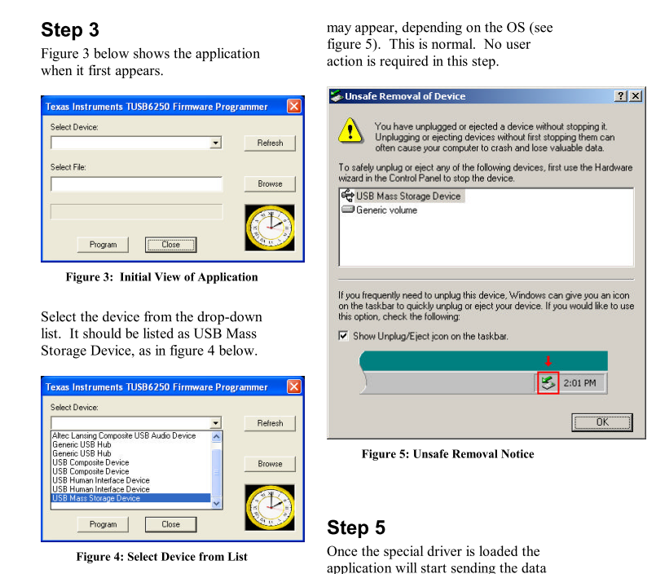

2: I have check TI TUSB6250 Bootcode Application Note

Web : <http://www.ti.com/lit/an/slla126/slla126.pdf>

Page 38 – 45 have 3 sample code

The files are 3 sample code.

  

I have use TI Header.exe to transform for CFG to BIN file. We want use TUSB6250 EEPROM Burner for programmer EERPOM.

BTW , I have some issue for those.

Commend : ex : header.exe 6250a.cfg 6250a.bin –v But have some Error

For 6250A.CFG

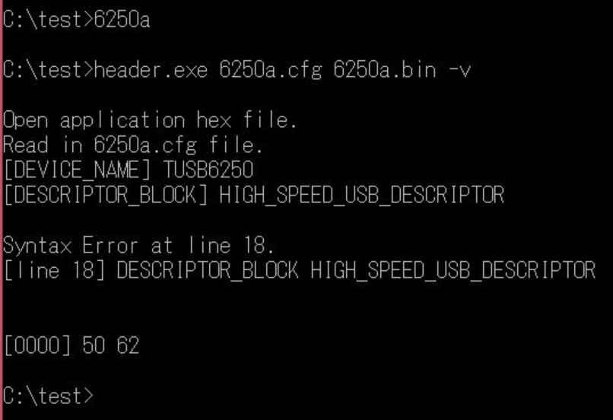

For 6250b

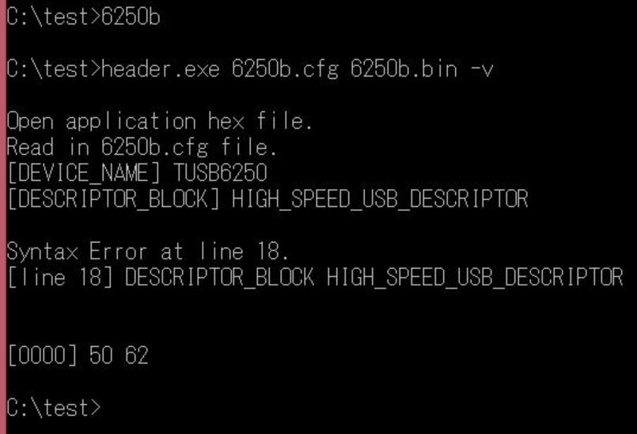

For 6250C

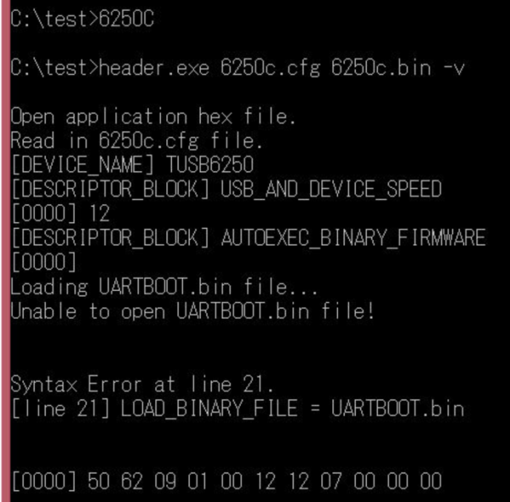

**Could you provide correct CFG file for USB Mass Storage Device application ?**