In our module, the limitation of DDI0 channel is we didn’t connect DDC_CLK/DATA to ROW connector (DDI0_DDCDATA is no pinout). We just have DDI0_AUXP/N to Row connector. Customer wants use DDI0 channel to light HDMI device.

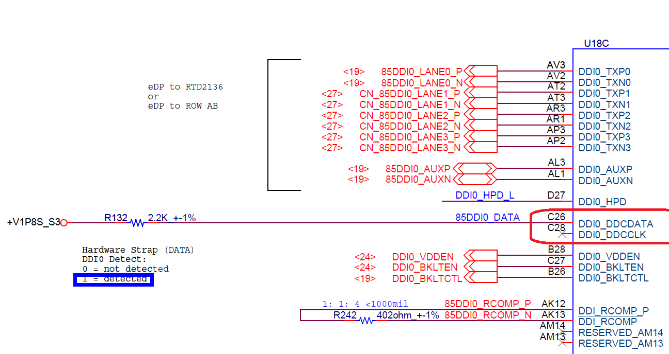

In some reasons and limitation, we only can use DDI1 channel to do some experiments with DP159EVM.

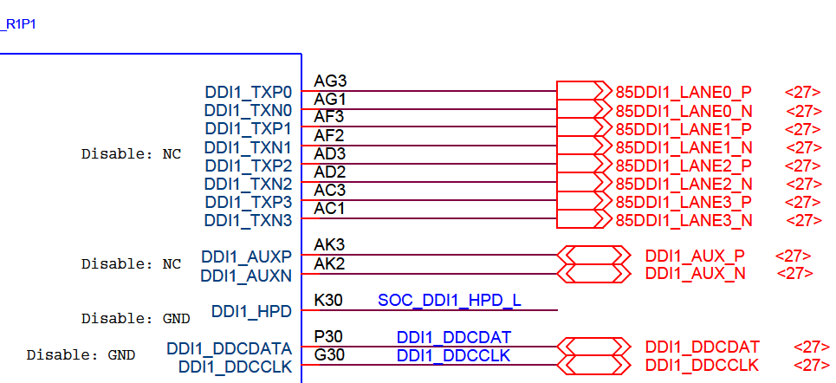

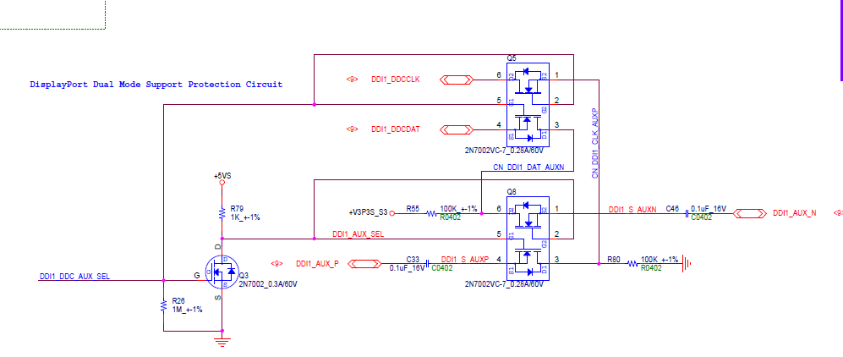

Experiment1:

Using DDI1 channel and plug in DP159EVM by default setting.

=> **It can be screen output. I think it keep DDC_CLK/DATA path, it can be screen output.**

In DP159EVM schematics, DP connector Pin13 is PH to 3.3V, it causes the DDI1_DDC_AUX_SEL to high and CN_DDI1_CLK_AUXP/N change to DDI1_DDCCLK/DATA.

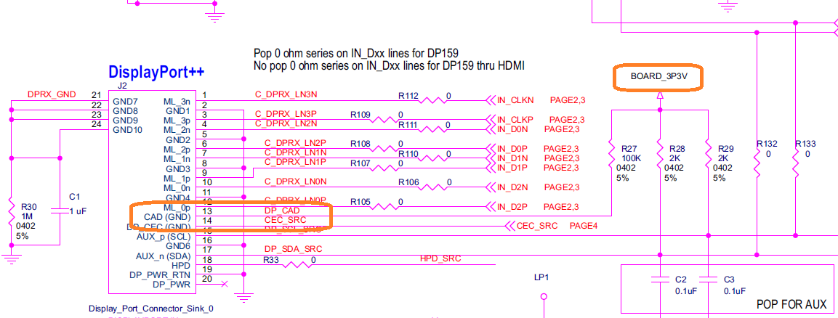

Experiment2:

In the real case, you can see upon figure (DDI0 group), DDI0 channel just keep AUX channel signal, no DDC pin output.

In some reason and limitation, I only can use DDI1 channel to do some experiments. I remove Q5/Q8 and short DDI1_S_AUXP/N with CN_DDI1_CLK_AUXP/N. In order to mapping DDI0 group situation.

=>But it can't output screen.

Also I need your confirmation. The C2/C3 don't reserve in DP159EVM board. The AUX signal is cut off in DP159EVM board.

We need the right configuration in DP159EVM board.

