How to flash the blank SPI flash(MX25V8035FZUI) for new board ? We are not able to flash it using TPS6598x Utilities GUI tool & App customization tool. This is now totally stopping our testing. Please help in sharing the detailed procedure to flash a blank SPI flash device.

Sorry for the delay in this critical step.

Note: *You will need the app config tool to do this because this will allow you to modify the template and save it.*

Are you getting an error when you try to flash? Are you manually loading the low region to prevent errors (step 1a in *shared procedure*)? The General settings tab screenshot can be seen below.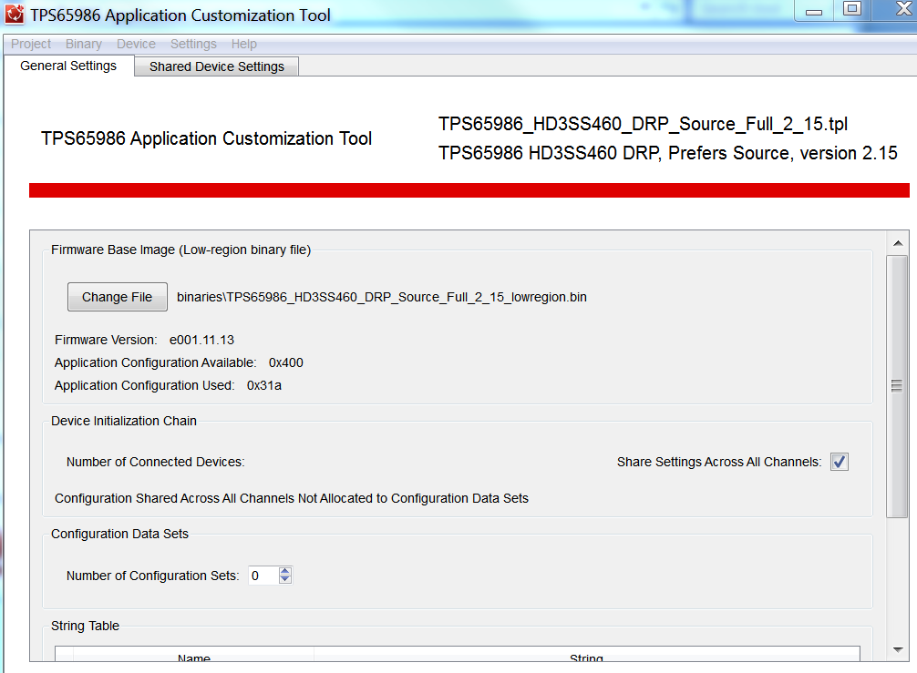

<http://www.ti.com/lit/ug/slvuar8a/slvuar8a.pdf>

Section 2 in the PDF above highlights how to do this.

2. We tried flashing through other evaluation boards also using CCS software. Here flashing is successful but board it not booting (tried connecting same flash to [TPS65986](http://www.ti.com/product/TPS65986) evm also but not working). While flashing the recovery binary, I have given 0x2000 location as offset and it didn't work. Do I need to change the offset or do i need to flash any boot loader/code on 0x0000 location also ?

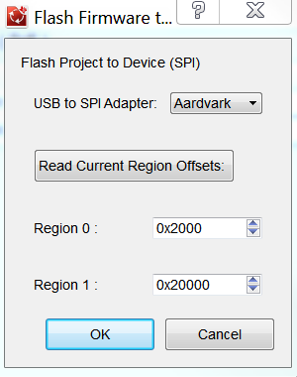

0x2000 offset should not need to be changed. When you hit ‘Read Current Region Offsets’ does is pass or fail?

3. Can we flash the blank SPI device using I2C interface of [TPS65986](http://www.ti.com/product/TPS65986) device ?

If you want to flash using the I2C lines you can use the host interface GUI (which I couldn’t find a test procedure) or you can use the Ardvark and flash the binary that way.

Note: MX25V8035FZUI interface is SPI