Pull up STRAP5 (pin 22), STRAP7 (pin 13) and STRAP8 (pin 14) of 83826 chip to make the chip enter RMII mode。
- Check that the X1 50M clock is normal
- Test RST N pin 32 level, 3.3V normal
- The register values read are as follows

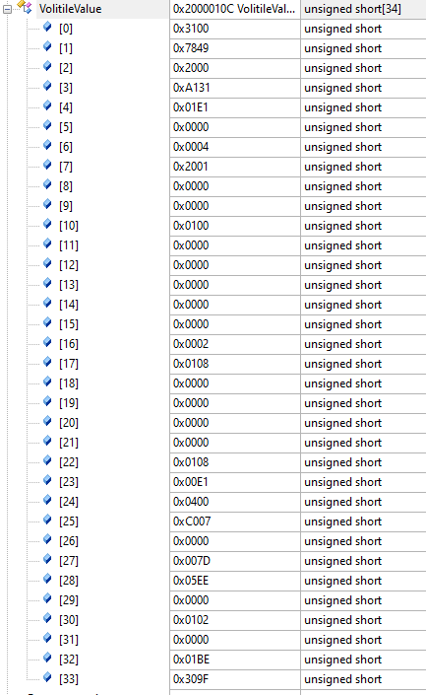
Note: 0-31 is the value of register 0-0x1F, 32 is the value of 0x467, and 33 is the value of 0x468

- Reverse loopback test:
Connect pins 4,5 and 6,7 of 83826 through the transformer, write register 0x16 to 0x0010, read the value of register 0x16 as 0x0110, Then the packet is sent out through mac, and the picture waveform is as follows：
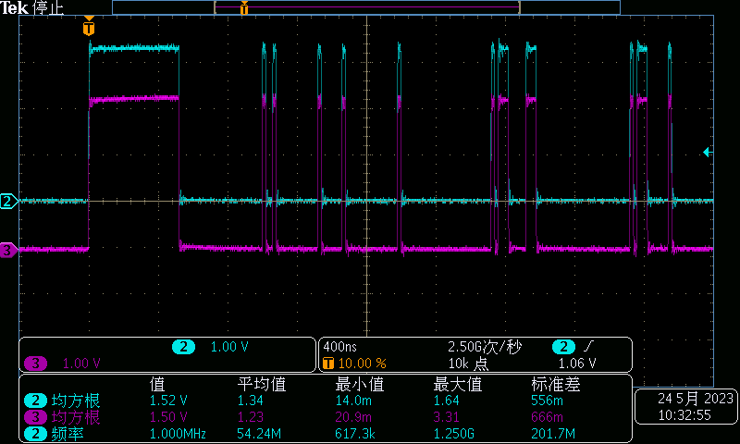
Measurement received, no data, no waveform, loop failure.
- Simulated loopback test：Write register 0x16 of 83826 to 0x0008, read register 0x16 as 0x0108, and then send the packet through the MCU mac，The picture waveform is as follows:
Measurement received, no data, no waveform, loop failure.
- Send and receive data packets via BIST：
Write 0x16 to 0x5000, pin 4, pin 5 and pin 6, pin 7 of 83826 are connected through the transformer back, wait for 1s to read the value of 0x17, is 0x0061, the 11th digit is 0, not passed.

