

M1D navigation product 360 reversing image
Analysis of white noise problems on the interface

【Problem description】
Information 1: On December 7, 2022, the M1D navigation product produced by our company had a white noise fault in the 360 reversing image interface (see Figure 1 and Video 1), 380 units were put into production, and 39 production lines were detected The table is defective, and the failure rate is about 10%. The fault only appears in the reversing 360 interface, and the navigation, radio, Bluetooth and other interfaces of the machine are normal.
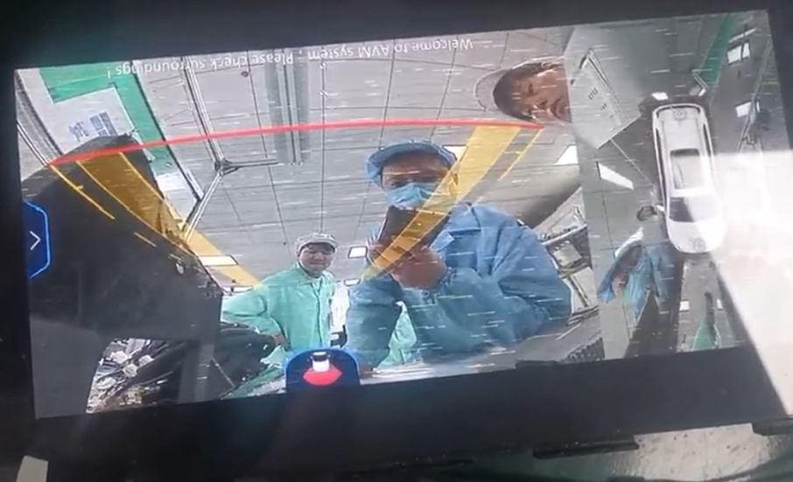
Figure 1
Information 2: Other models using the same platform and solution, such as T1E and T19FLMY, also have different proportions of this fault
Information 3: Through the P2P substitution method, find the fault and follow the chip
Information 4: The severity of different faulty machines is different, some are more serious, some are mild

Information five: In the troubleshooting found that the bad machine and the temperature is related, the bad machine in the reversing interface, aimed at the 947 chip injection liquid nitrogen local rapid cooling, the fault becomes serious, with hot air aimed at the 947 chip to heat up, the fault immediately becomes better, until the fault disappears.
Information 6: Align the 947 chip to heat up and cool, test the waveform of the CLK clock signal under the reversing interface, and find no distortion or amplitude change in the waveform.
Information 7: The fault disappears after the temperature rises, switch to the multimedia interface, spray liquid nitrogen to the 947 to cool down, and then switch back to the reversing interface, the screen does not appear white noise fault, no matter how to cool down, the fault will not be repeated (only under the reversing interface the fault is related to temperature).
Information 8: Display resolution: 1920X720 60P; 360 box output: 1920X720 30P

【Circuit explanation】
Overall product architecture: The whole system is divided into three parts
The following is the box process of the local video display model processing
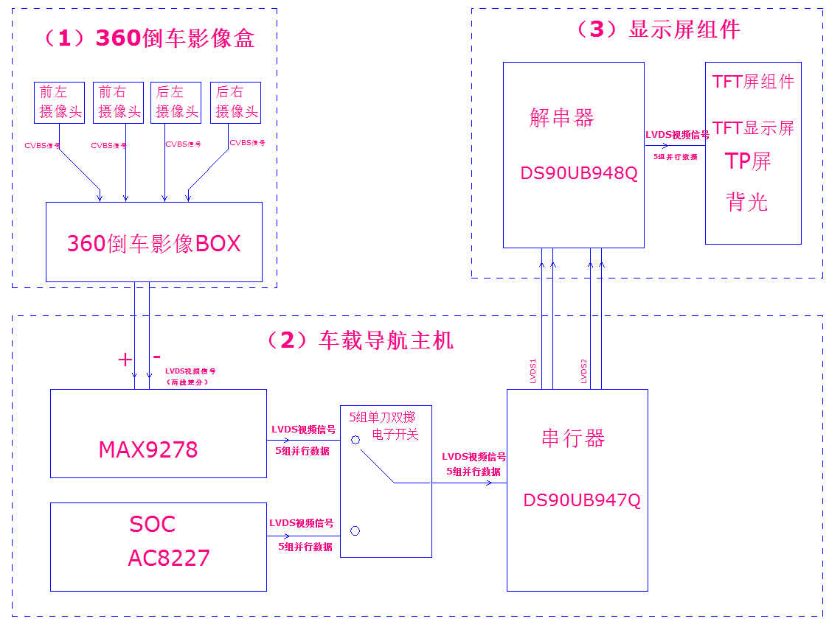

(1) 360 reversing image box: the CVBS video signal of the four-way camera is synthesized into a 360 panoramic surround view image, and the two-line differential LVDS standard is output to the car navigation system through the coaxial line. The actual photo is shown in the figure below
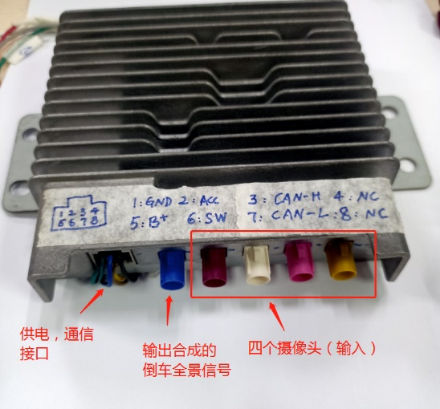
Figure 2: 360 reversing image box
(2) Car navigation system: receives LVDS panoramic video signal from 360 reversing image box, and converts the 2-wire differential LVDS signal into LVDS parallel format [5 groups differential] video signal through the MAX9278 chip. The parallel standard video signal from the SOC is switched by 5 sets of single-pole, single-throw electronic switches: the video source from the SOC is switched on the navigation interface, and the 360 surround view video signal is switched in the reverse state. The actual photo is shown in the figure below
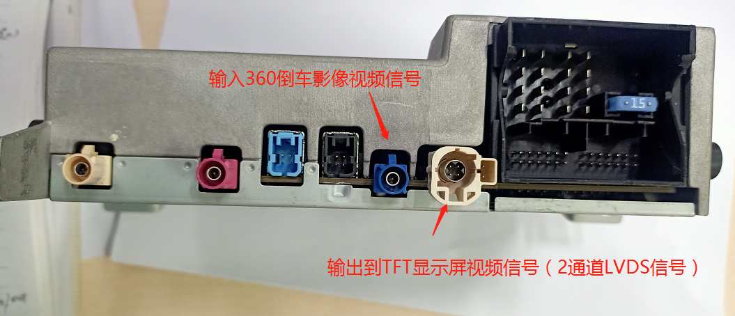
Figure 3: Car navigation system
The video signal is sent to the display through two sets of LVDS differential channels (LVDS1, LVDS2).

(3) Display component: The deserializer [DS90UB948Q chip] in the display assembly converts the serial LVDS data into parallel LVDS data and sends it to the TFT screen for display. The actual photo is shown in the figure below
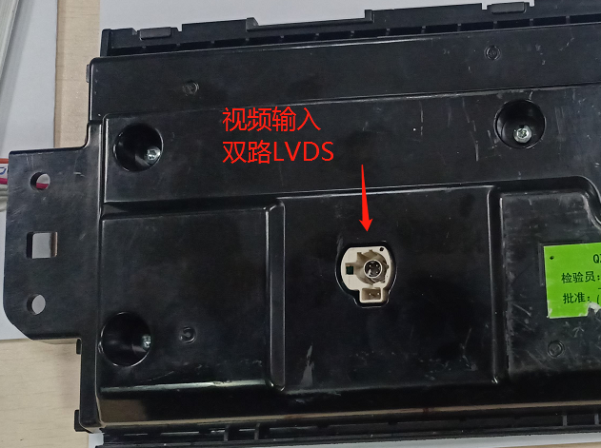
Figure 4: Display assembly
Detailed explanation of the circuits of each part
MAX9278 circuit
(1) The full circuit of the MAX9278 is shown below
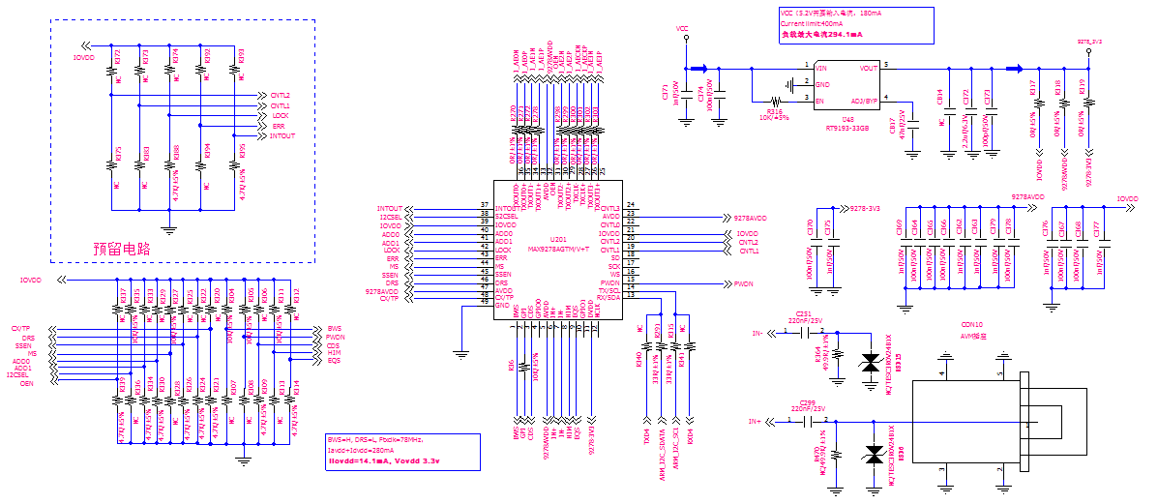

(2) Signal input:
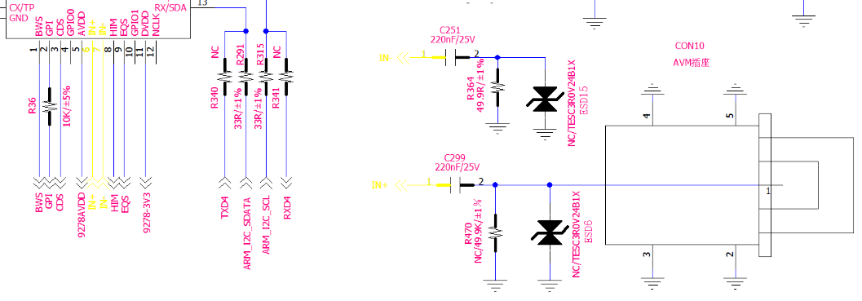
(3) Signal output:

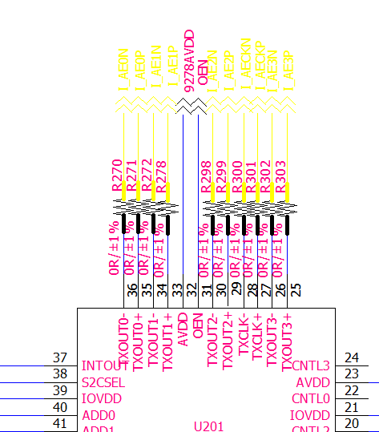
(4) Parameter setting:
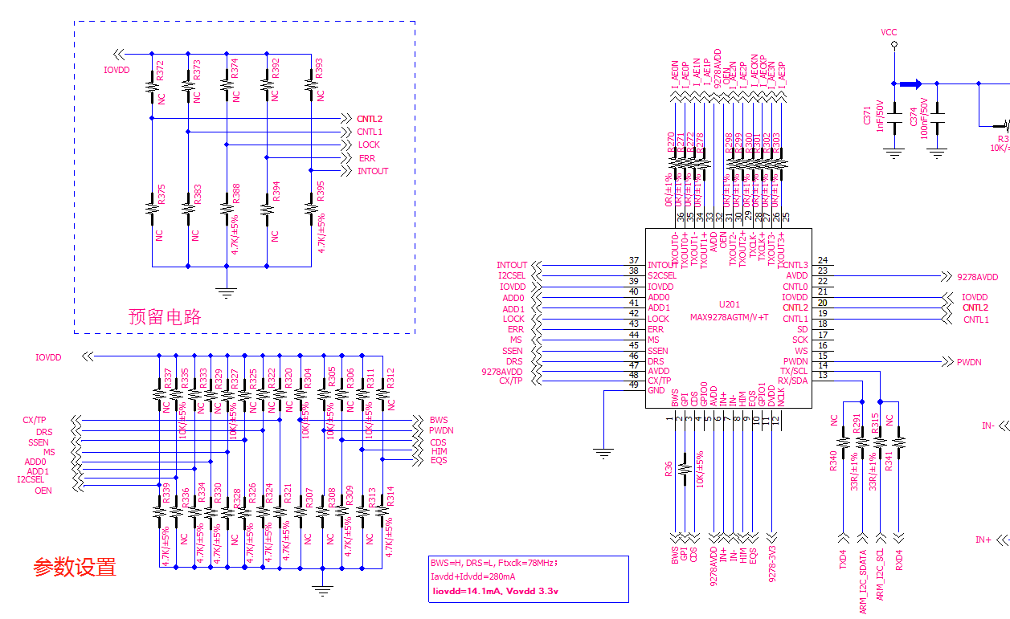

LVDS video signal output for SOC
The LVDS video signal output from the SOC is filtered out by a common-mode inductor, as shown in the figure below
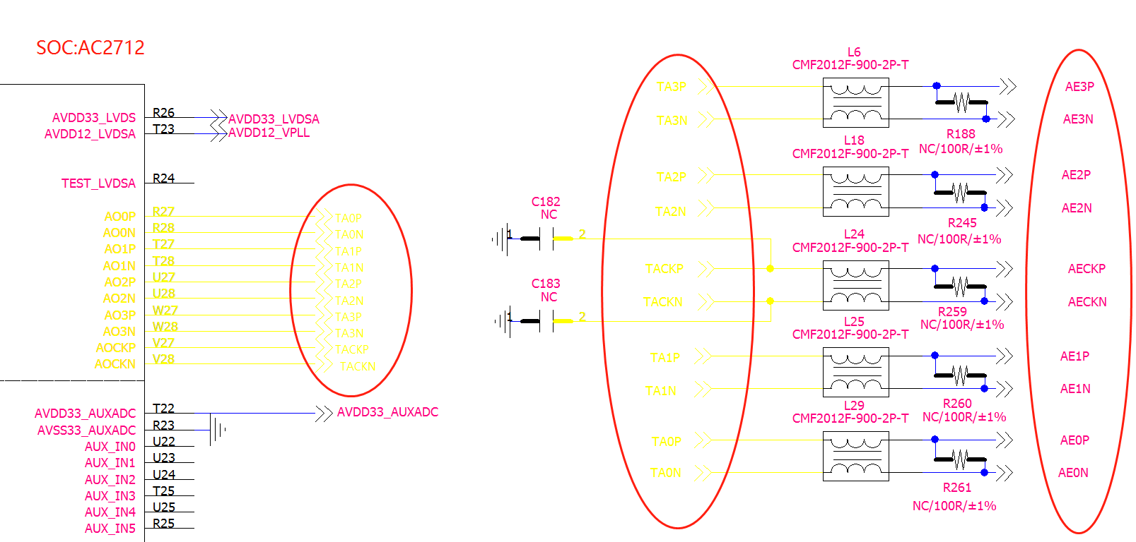

Electronic switching circuits
The function of the electronic open circuit is to switch the video signal, and in the multimedia state, turn on the LVDS signal of the SOC; In the reverse state, turn on the 360 image LVDS signal, the specific circuit is as follows (there are 5 groups of identical switching circuits to control the switching of 5 LVDS signals).

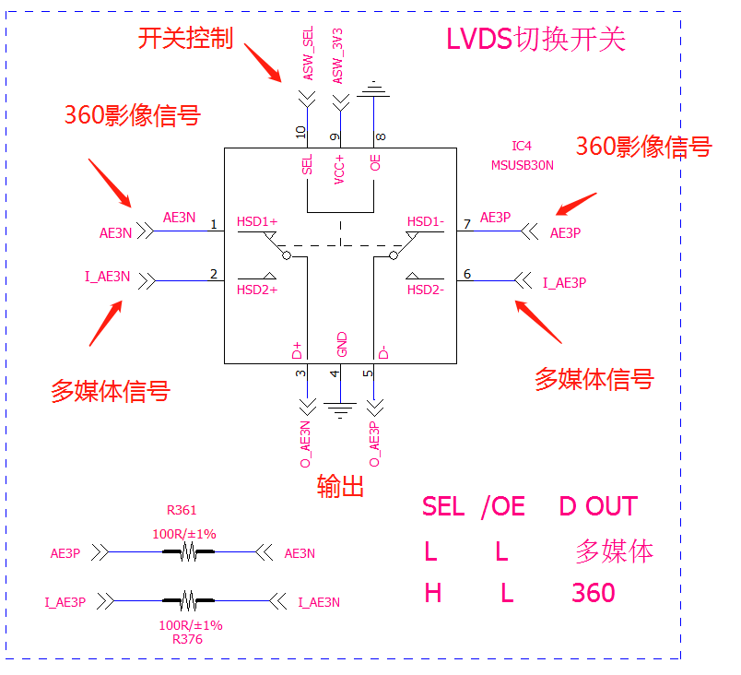
DS90UB947Q circuit
(1) The full picture of DS90UB947Q is as follows
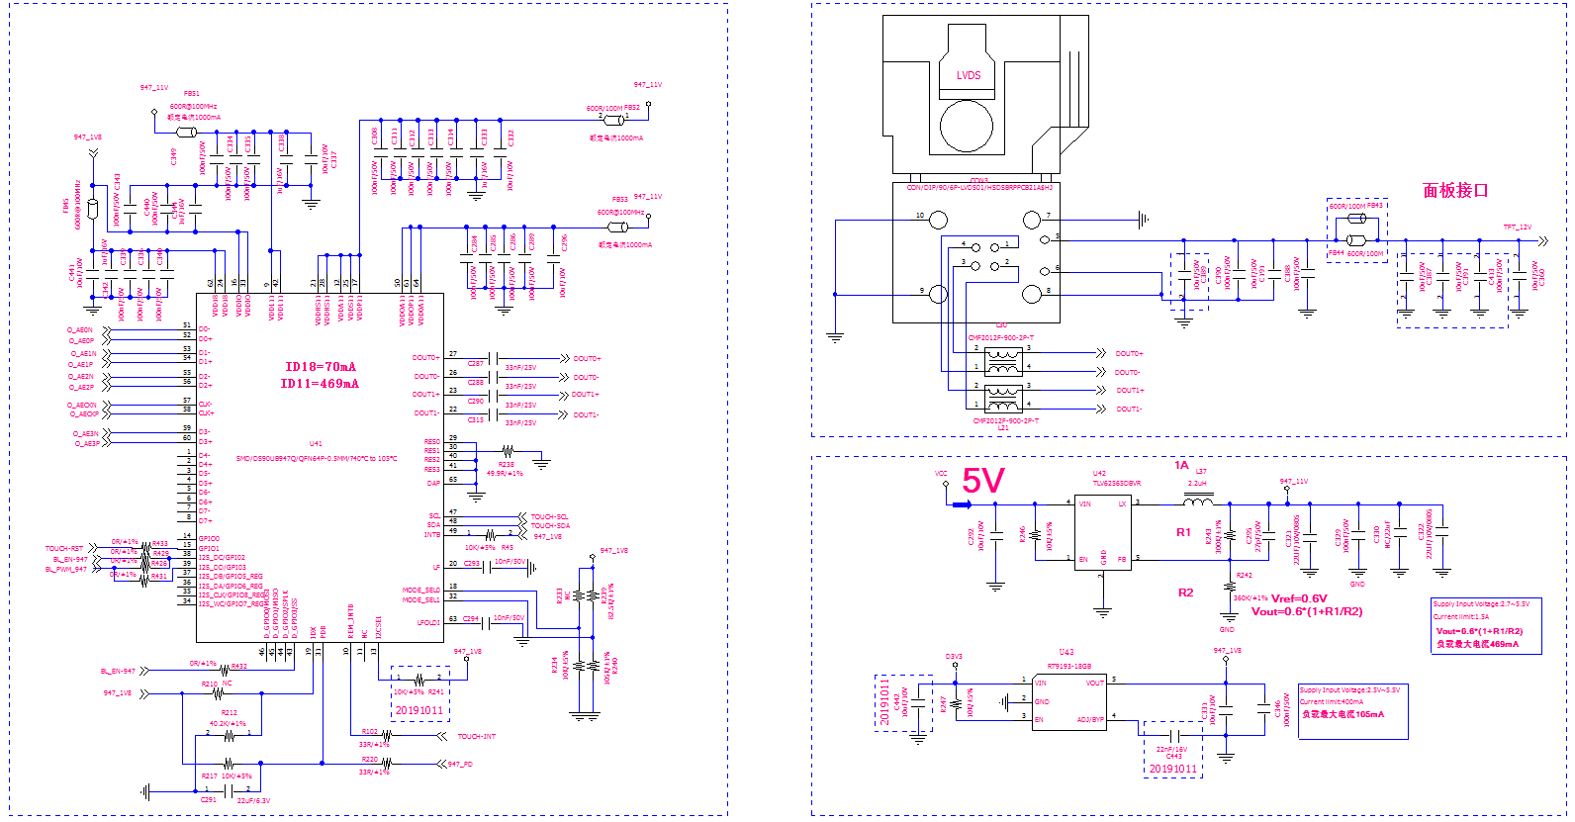

Signal input
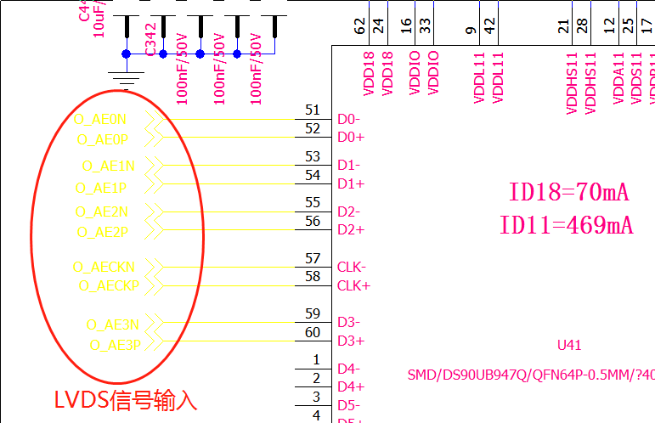

Signal output
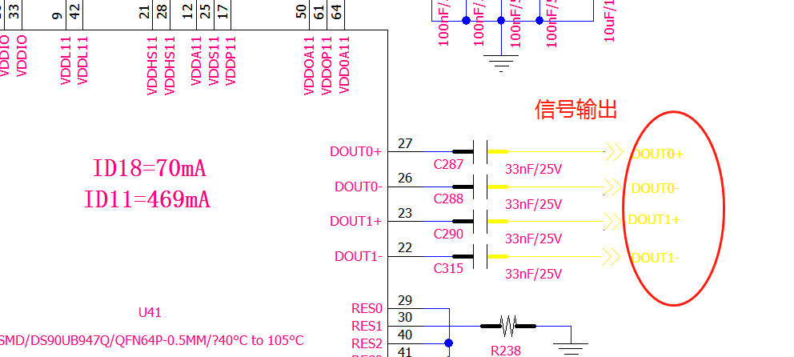
Setup, communication
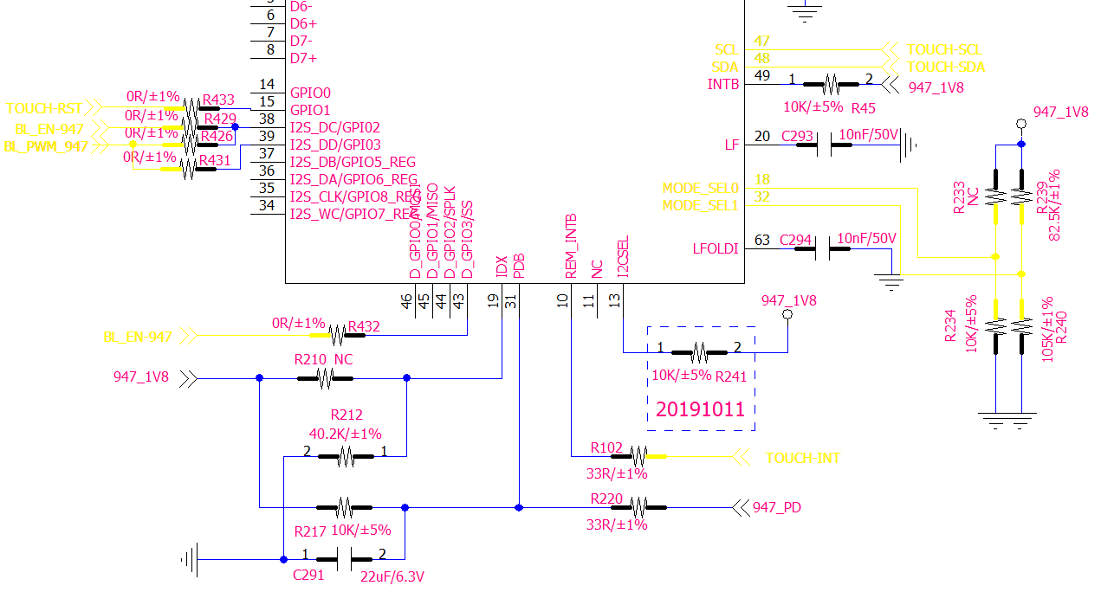
Since the 360 reversing image box and TFT display assembly are provided by customers, the circuit diagram cannot be given here.
【Existing troubleshooting】
Hardware troubleshooting (waveform and voltage test).
NOTE: SINCE THE BANDWIDTH OF THIS OSCILLOSCOPE IS 350MHZ, ONLY THE MEASURED WAVEFORM ≤ 100MHZ CAN ACCURATELY TEST THE WAVEFORM, OTHERWISE THE MEASURED WAVEFORM IS FOR REFERENCE ONLY.
(1) The MAX9278 input and output signal test results are as follows (tested in the 360 state):
The input signal of the MAX9278 is from a 360 camera, and the actual frequency of the signal (since no 360 box output data stream parameters were found, it is assumed here that the clock for the test is 5 4 M) is much larger than the oscilloscope's valid test range. So there is no test input waveform.
The output signal of the MAX9278 is a single 8-bit LVDS format (1 clock differential signal + 4 differential data signals), and since the frequency on the data line is greater than the measurement frequency of the oscilloscope, the following waveform is for reference only
The AC amplitude of the AE0 differential signal waveform is about 384mV_{PP}, and the differential signal waveform image is well symmetrical, and the unfolded details are shown on the right side of the figure below.
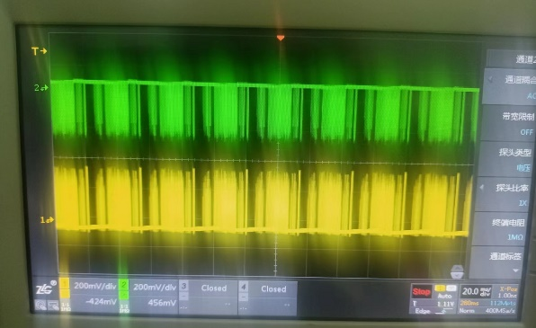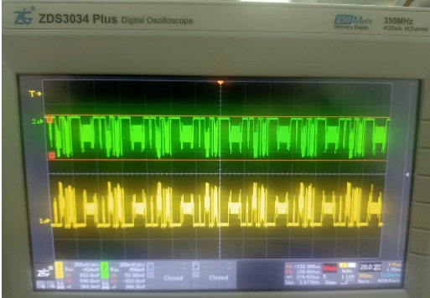
AE0 (35/36 pins of the MAX9278) Waveform unfolded on the left
The AC amplitude of the AE1 differential signal waveform is approximately 360mV_{PP,} and the differential signal waveform image is well symmetrical, as shown in the figure below.
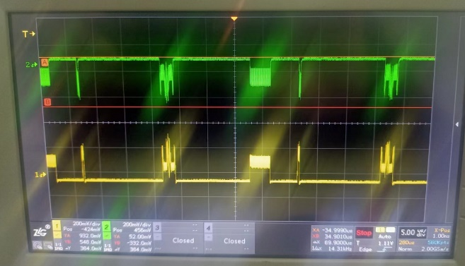
AE1 (MAX9278的34/33脚)
The ac amplitude of the AE2 differential signal waveform is approximately 336mV_{PP}, and the differential signal waveform image is well symmetrical, as shown in the figure below.
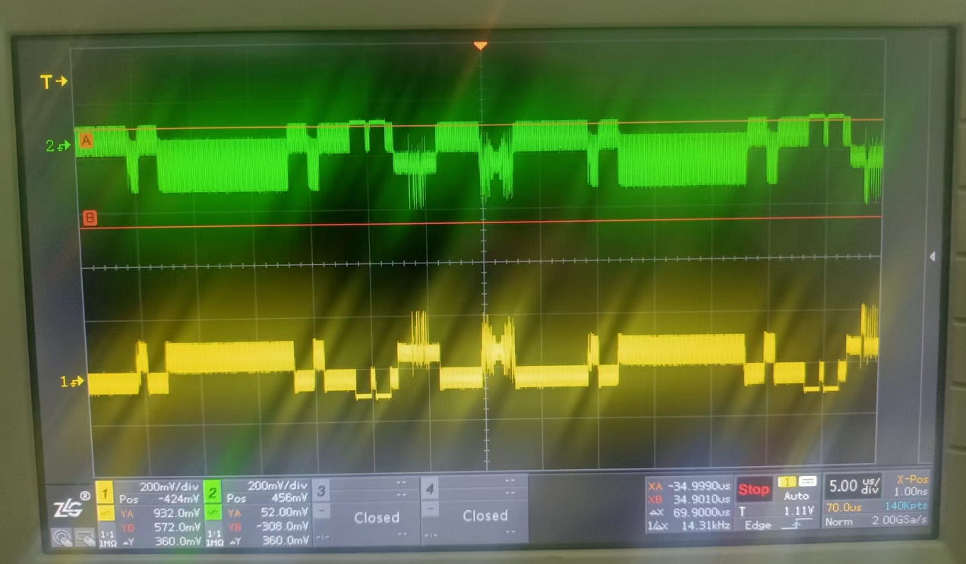
AE2 (MAX9278的29/30脚)
The ac amplitude of the AE 3 differential signal waveform is approximately3 68mV_{PP}, and the differential signal waveform image is well symmetrical, as shown in the figure below.
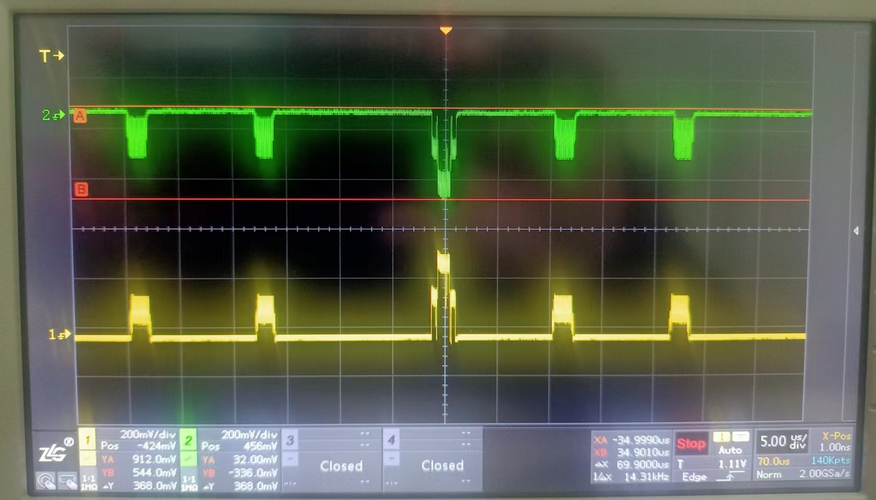
AE3 (MAX9278的25/26脚)

THE AC AMPLITUDE OF THE CLK DIFFERENTIAL SIGNAL WAVEFORM IS APPROXIMATELY 200mV_{PP}/114 mV_{PP} FREQUENCY: 52.25 MHZ (AVERAGE) AS SHOWN IN THE FIGURE BELOW.
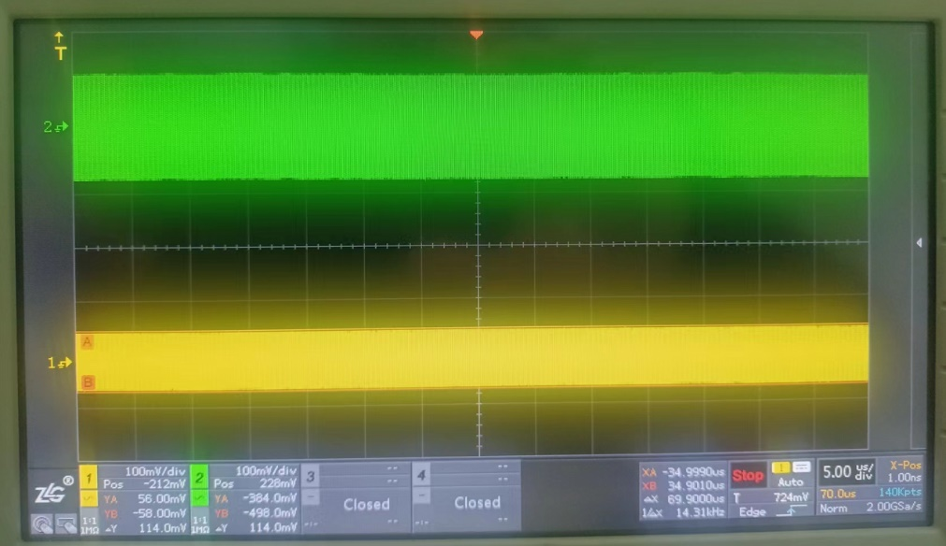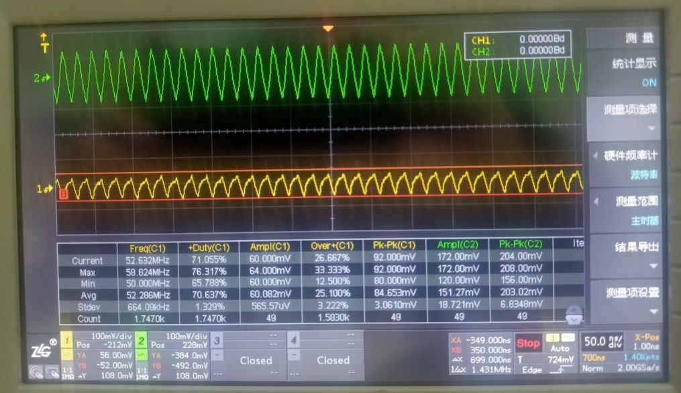
CLK (MAX9278的27/28脚)

(2) The SOC output LVDS signal test is as follows (test in the multimedia interface):
The output signal is a single 8-bit LVDS format (1 set of clock differential signal + 4 groups of differential data signal) Since the frequency on the data line is greater than the measurement frequency of the oscilloscope, the following waveform is for reference only:

The AE0 differential signal waveform has an ac amplitude of approximately 230mV_{PP} with good symmetry, and the unfolded details are shown in the figure below

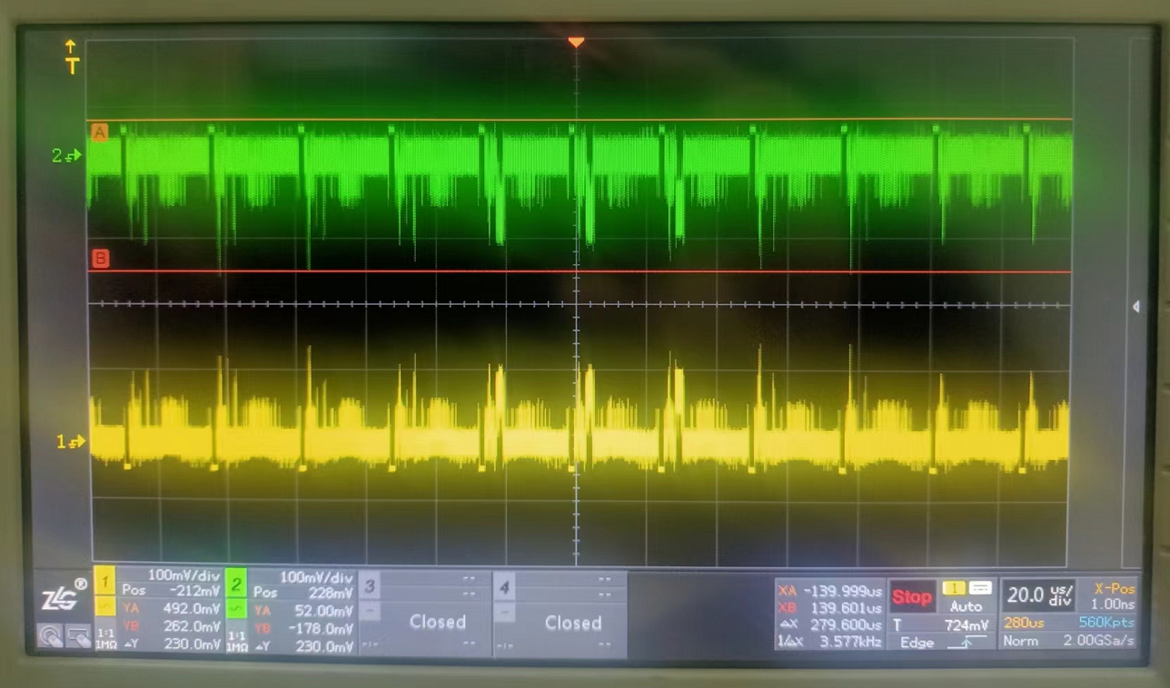
Test both ends of R261
The AE1 differential signal waveform has an ac amplitude of approximately 234mV_{PP} with good symmetry, as shown in the figure below
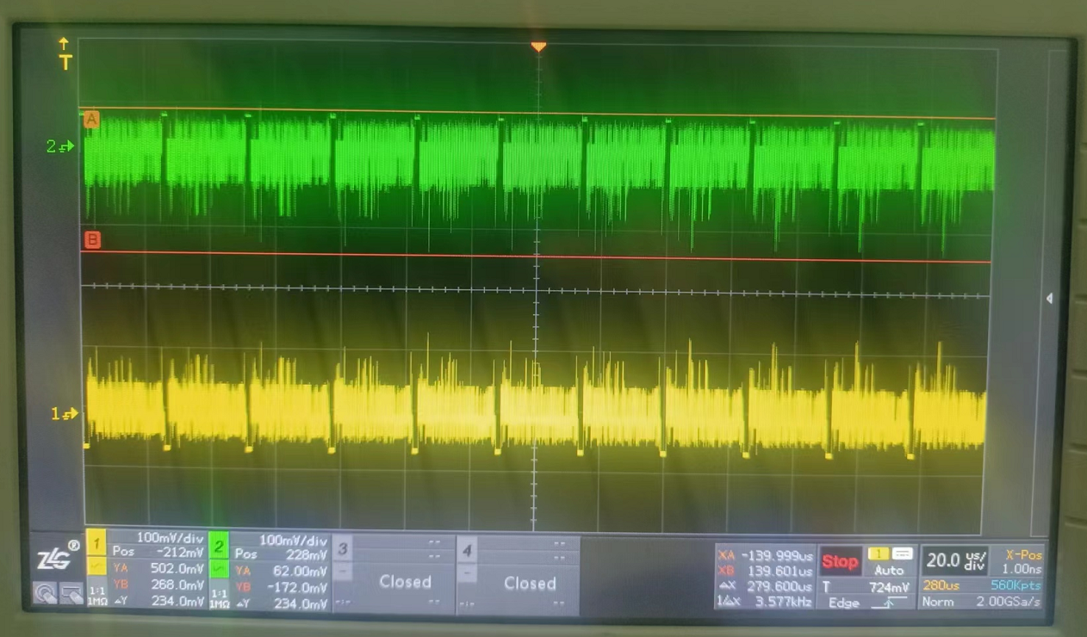
Test both ends of R260
The AE2 differential signal waveform has an ac amplitude of approximately 242mV_{PP} with good symmetry, as shown in the figure below

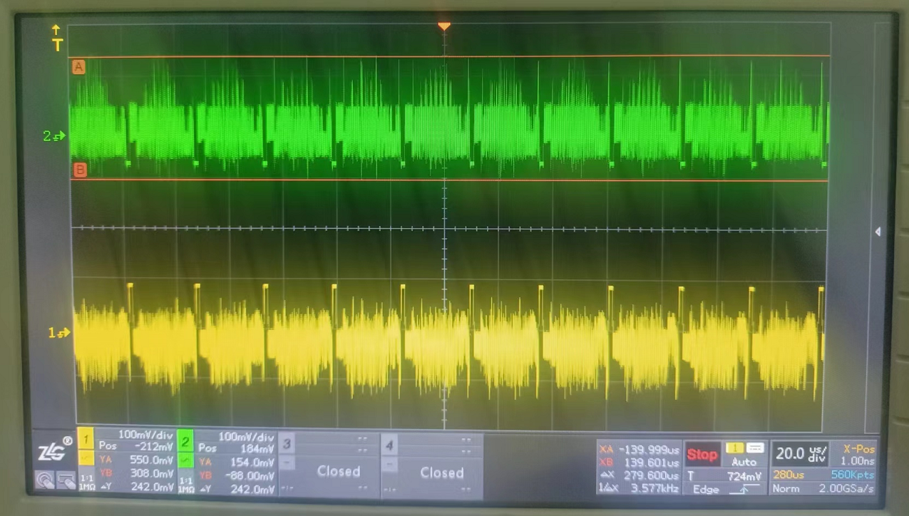
Test both ends of R245
The AE3 differential signal waveform has an ac amplitude of about 308mV_{PP} with good symmetry, and the details of the expansion are shown in the figure below
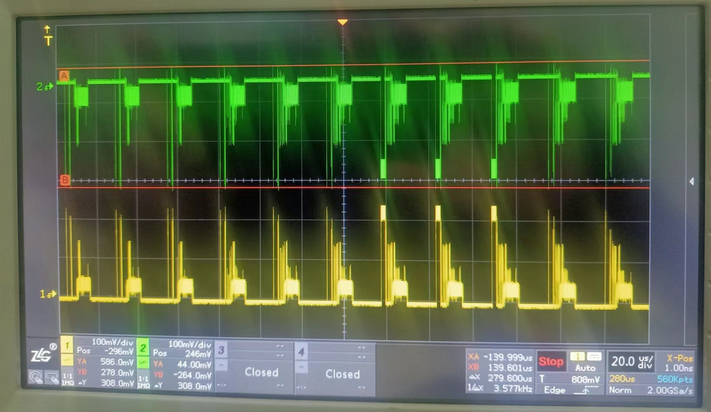
Test both ends of R188
The CLK differential signal waveform has an ac amplitude of approximately 90 mV PP / 76mV_{PP,} a frequency of 80.056 M (average), good symmetry, waveform and unfolding See the figure below for details

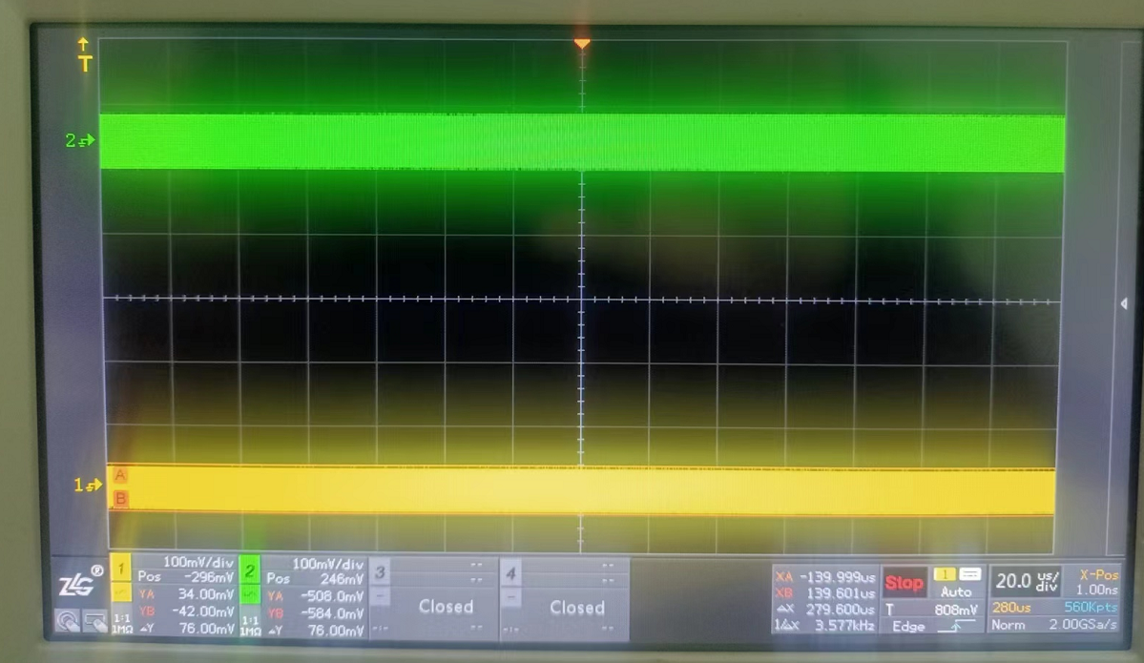
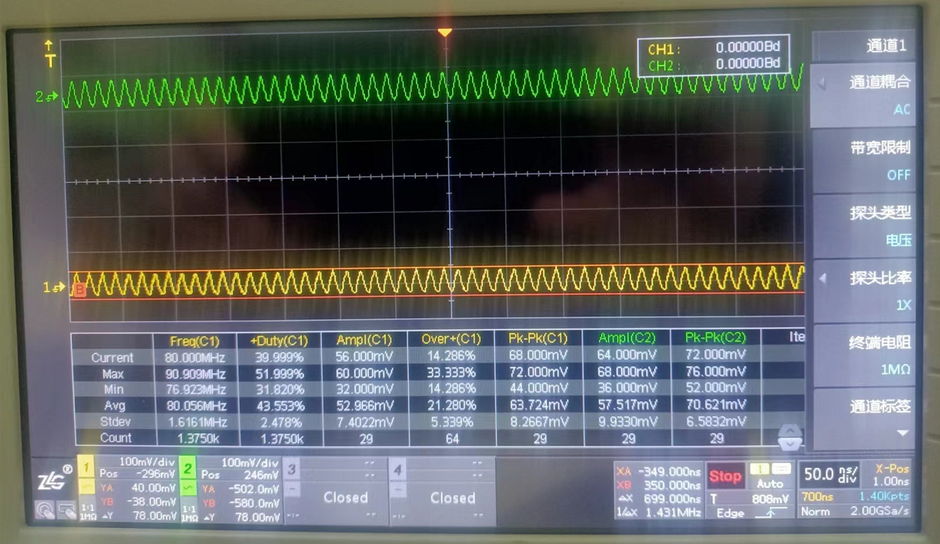
Test both ends of R259

(4) The power supply and ripple test results of each chip are as follows:
a) MAX9289 power supply: The test chip has a voltage of 3.26V on pins 5, 2 pins, 3 pins, andpins 4 7 and a ripple value of 19.4 mV_{PP} Conclusion: Normal
b) 1. of the DS90UB947Q 8V power supply: The voltage value of the test chip pin 16, pin 33, pin 24, and pin 62 is: 1.79V, and the ripple value is 15 mV _{PP} Conclusion: Normal
c) 1. of the DS90UB947Q 1V power supply: test chip 12 pins, 17 pins, 21 pins, 25 pins, 28 pins, 50 pins, 61 pins The voltage values of pins, 64 pins, 9 pins, and 42 pins are: 1.11 V, and the ripple value is 37.2 mV _{PP} Conclusion: Normal

