**Please check the bus voltages at pins 2 and 6, and that the flying capacitors at pins 1/3 and pins 4/5 are being switched. Some solder connection might be broken.**

*Across C1 Capacitor:*  
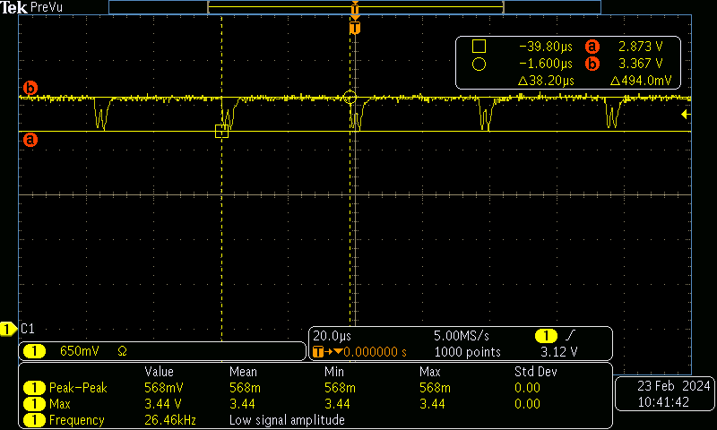

*Across C2 Capacitor:*

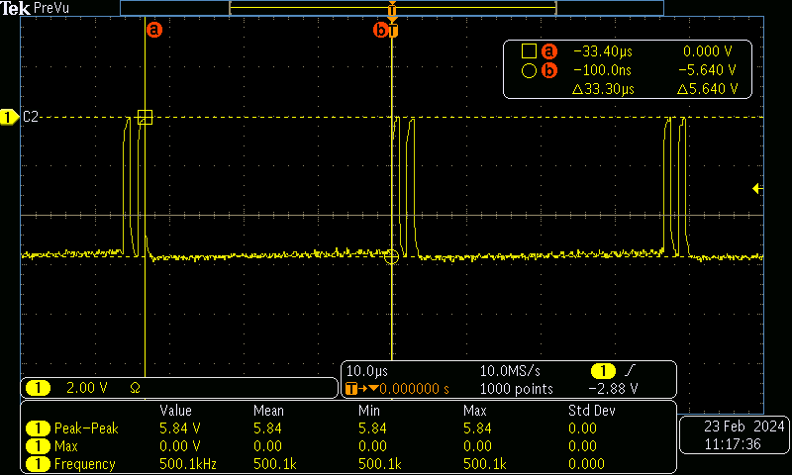

***Captured again suspecting the probe was not making contact across both pins.***

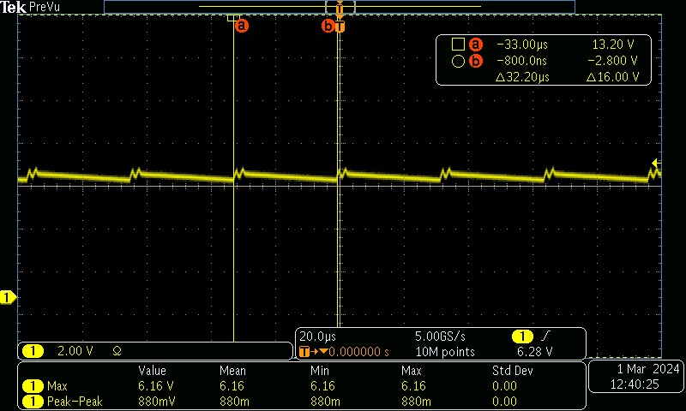

*At VP:*  
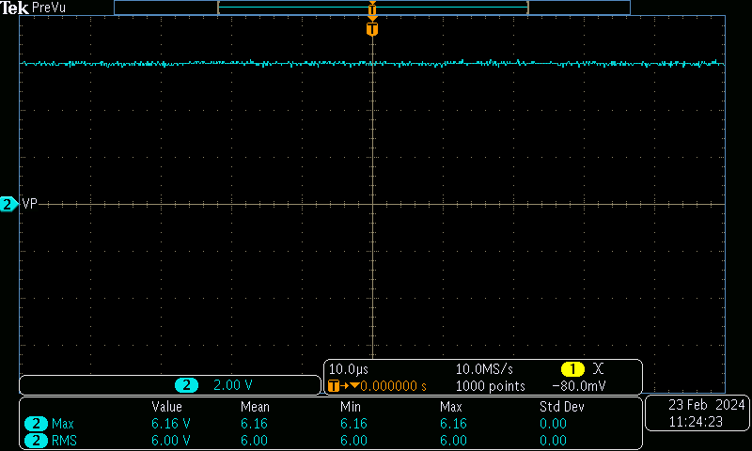

*At VN:*

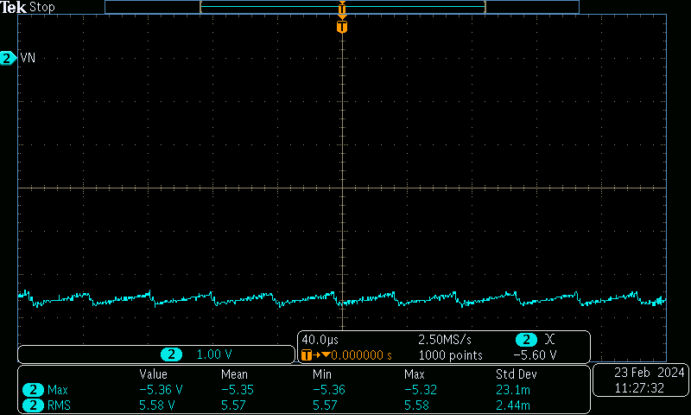

**1. Could you please let me know the part marking on top of the MAX3232E? I want to trace it in our internal system and see if there has been able problems reported in the past + check its legitimacy status (sometimes counterfeit devices can show up and we can look into if the device is valid or not)**

*The top marking of the IC where failures are observed*

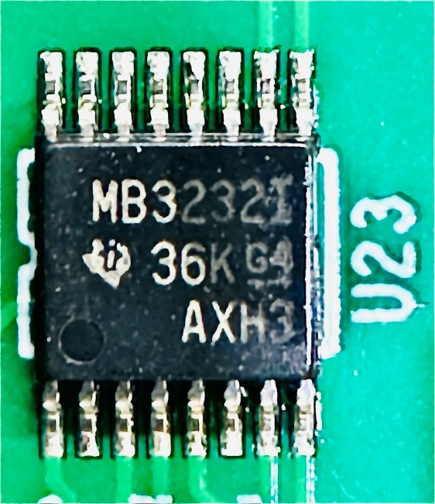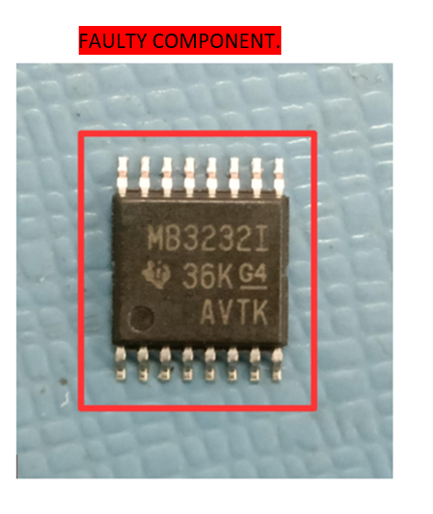

**2. Can you show the output voltage of DOUT2 when you disconnect the RS-232 serial cable - essentially an unloaded driver test**

*This is without the RS-232 serial Cable. Also, I had touched up the IC, C1, and C2 capacitors before capturing this waveform.*

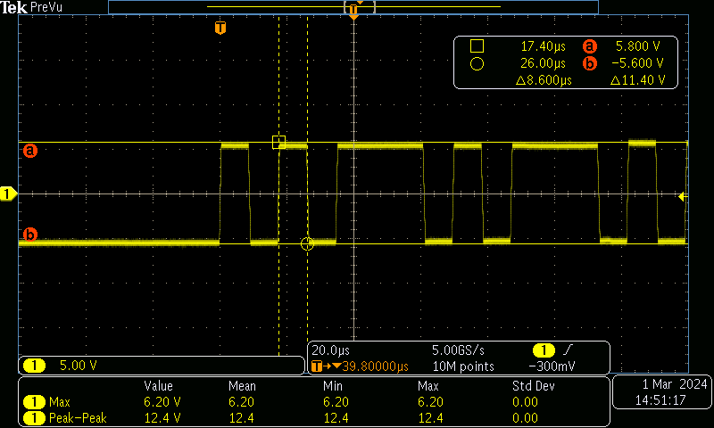

*This is with the RS-232 serial Cable after touch-up.*

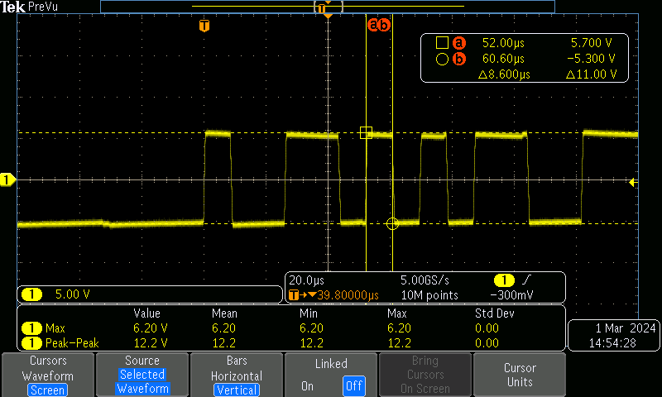

**And just as a question - has any other component (diodes, resistors, etc...) been added to the RS-232 bus besides the cable and transceivers?**

*DIAG_TXD and DIAG_RXD are the UART lines connected to the processor via MAX3232E IC which is connected to an RJ45 connector for serial port access. In the path from MAX3233E to RJ45 connector there is an ESD diode added: NUP2105LT1G from ON semiconductor to protect from any voltage transients.*  
