VBUS voltage on Sandisk drive, able to detect

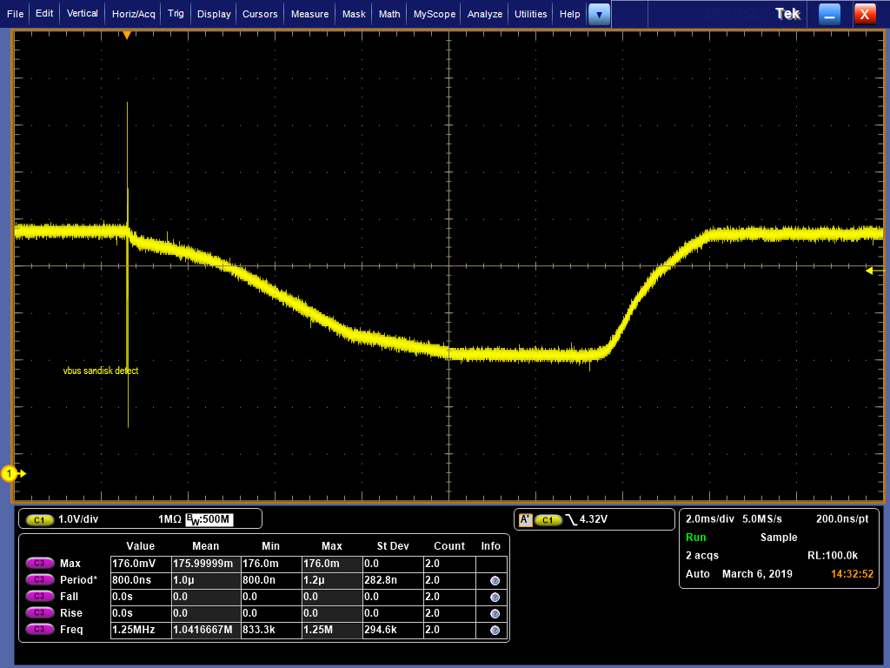

VBUS voltage on Kingston drive, not able to detect

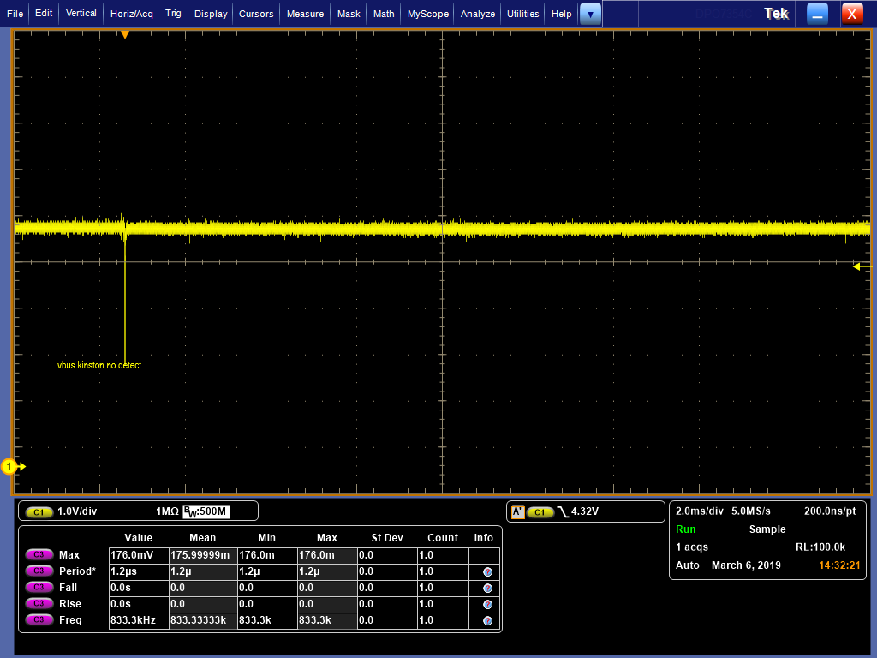

SSTX pair on Sandisk drive, connector side(after AC couple capacitor)

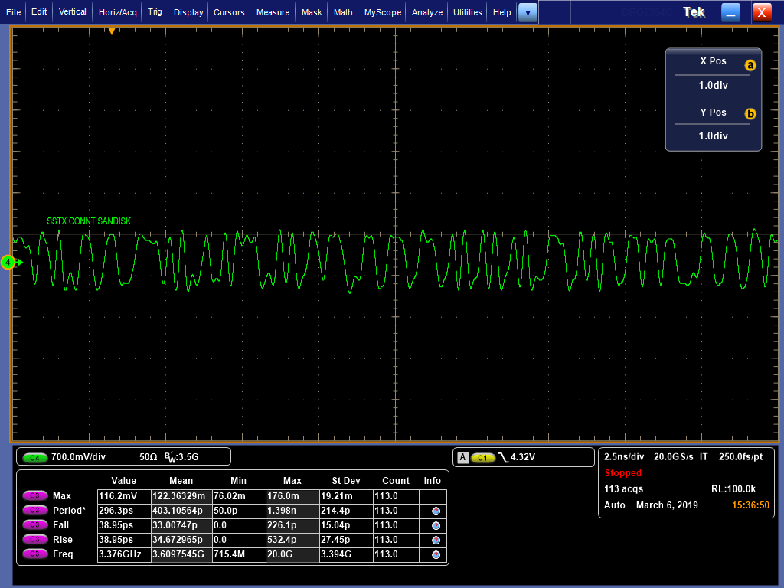

SSRX pair on Sandisk drive, connector side

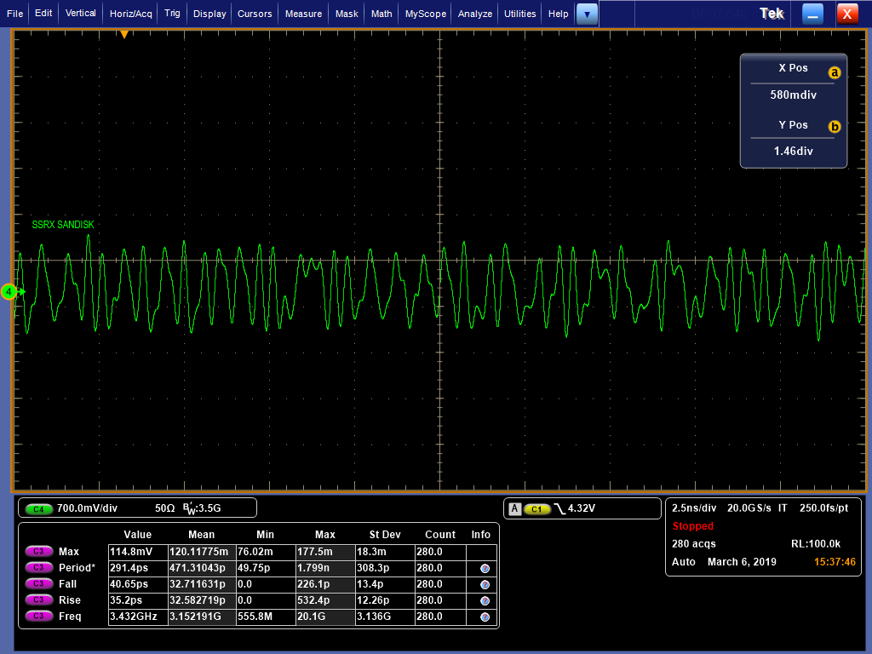

SSRX pair on Kingston drive, connector side

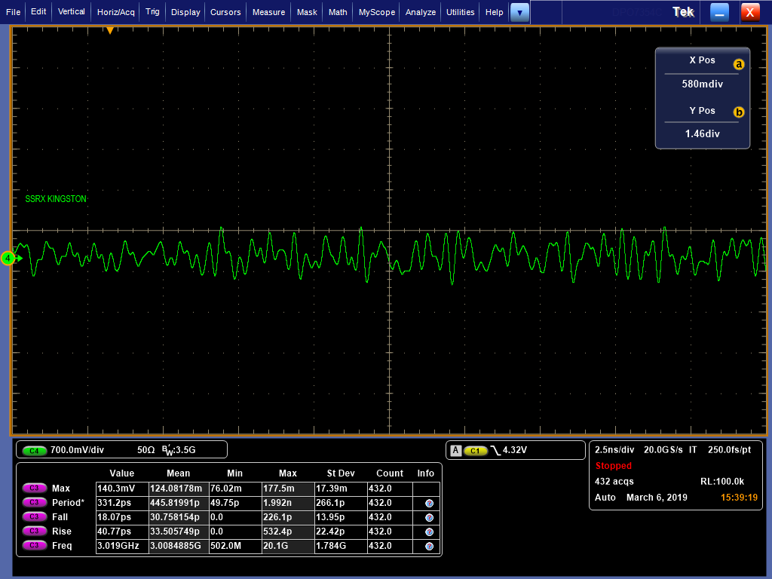

SSTX pair on Kingston drive, connector side(after AC couple capacitor)

