FILENAME : C:\ZEEIDEAS\Idea#3_____Virya_Infotech\USB_2_AUDIO_SUPPLIES\TI_GUI\Flash\USB_Audio_Flash_____v1.bin

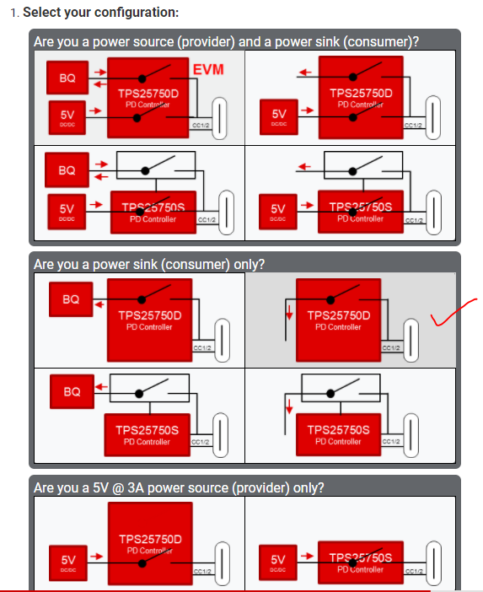

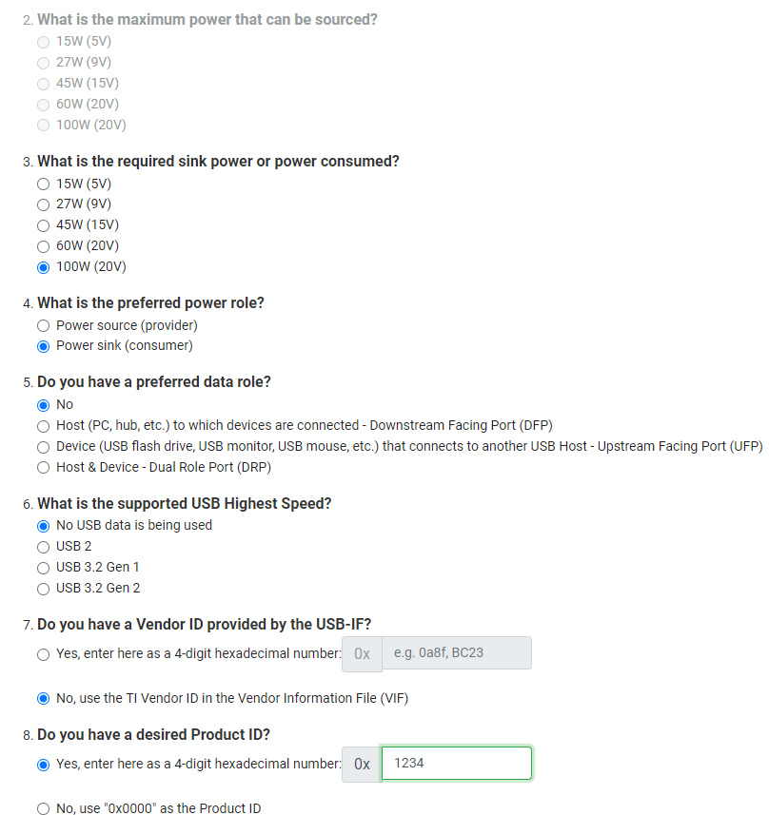

FILENAME : C:\ZEEIDEAS\Idea#3_____Virya_Infotech\USB_2_AUDIO_SUPPLIES\TI_GUI\Flash\USB_Audio_Flash_____v2.bin
