Hi Team,

I am replacing my current N-type connection to a P-type (or maybe an M-type) connection, so that the laser’s body will be the GND (mainly for thermal reasons).

I need an IC driver solution for an M-type connection, or for a P-type connection (and not for the enclosed N-type connection that I am using right now).

I enclosed the current solution schematic I am using a Maxim-IC driver (the connection Laser Diode/Photo Diode is an N-type connection, connected to J2).

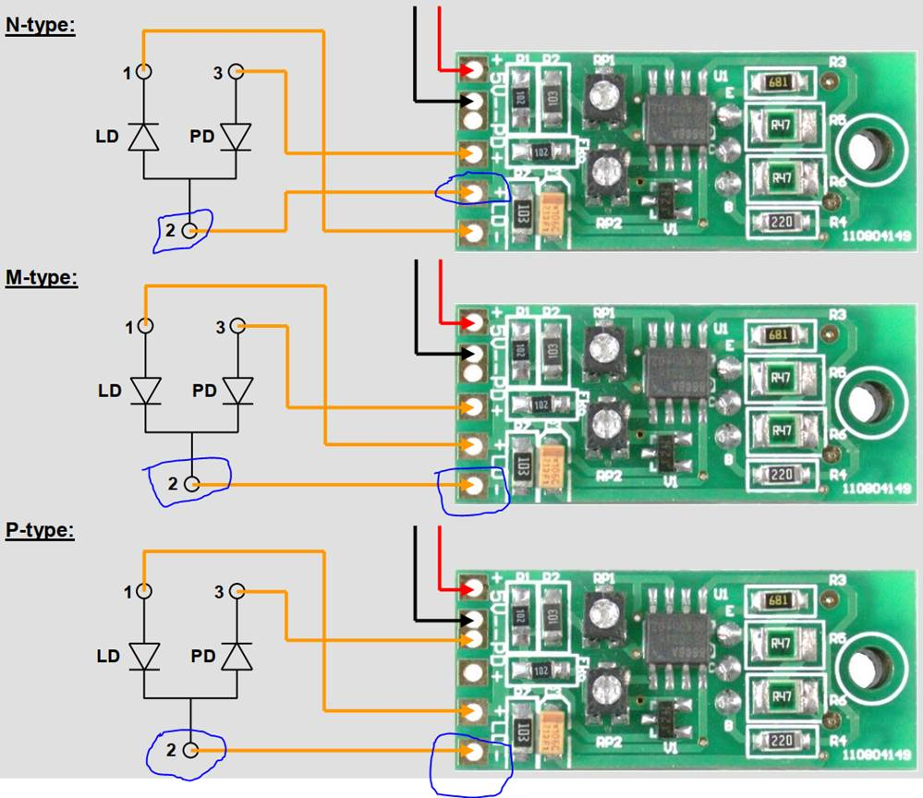

I need a single driver, and I am using a continuous mode (CW) transmission.

Does ONET4211LD/4201LD will fit this requirements?

Please let me know what you think would be the best solution.

Thanks,

Shlomi