Module pack I2C traces. Rev. 3 board. Taken for BAT2 at the connectors. Pull-ups are required or voltage only reaches 2.3 to 2.5 Volts.

1. Clock with no pull-up

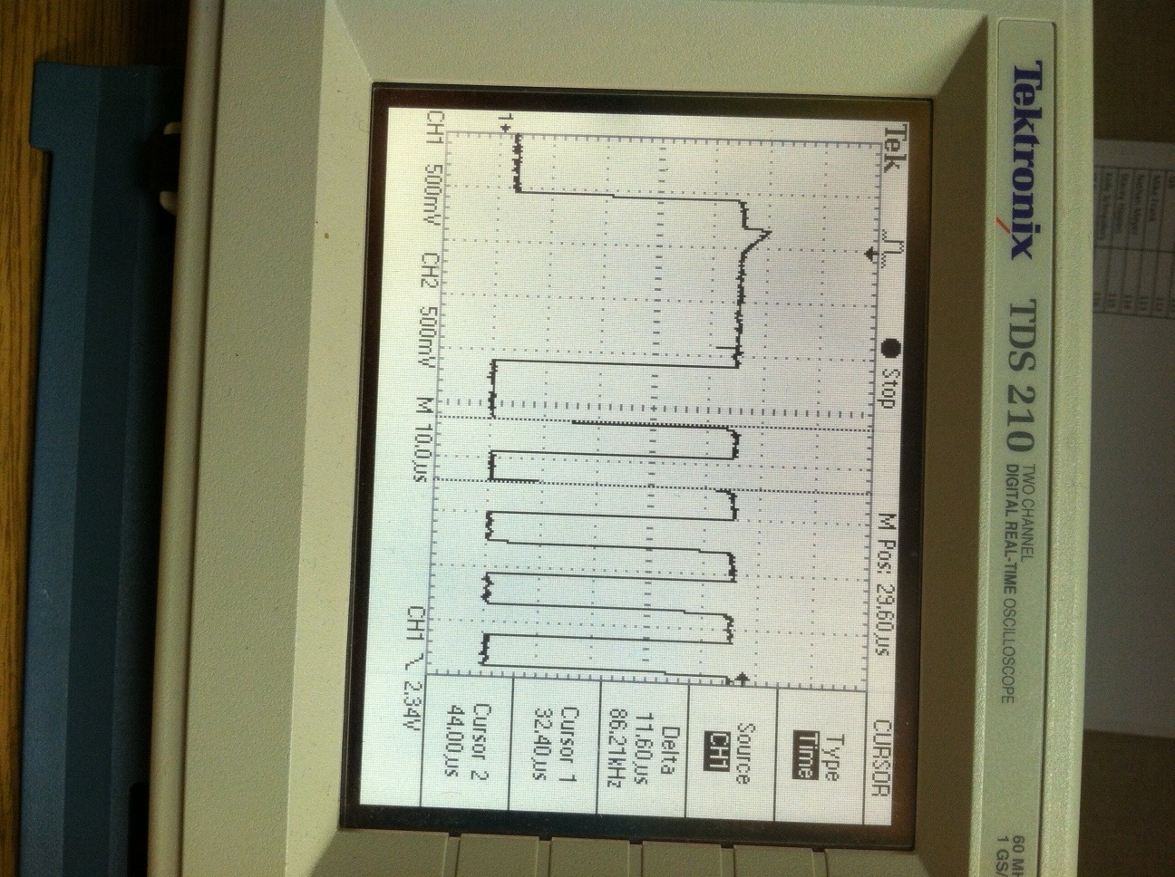

1. Data with no pull-up

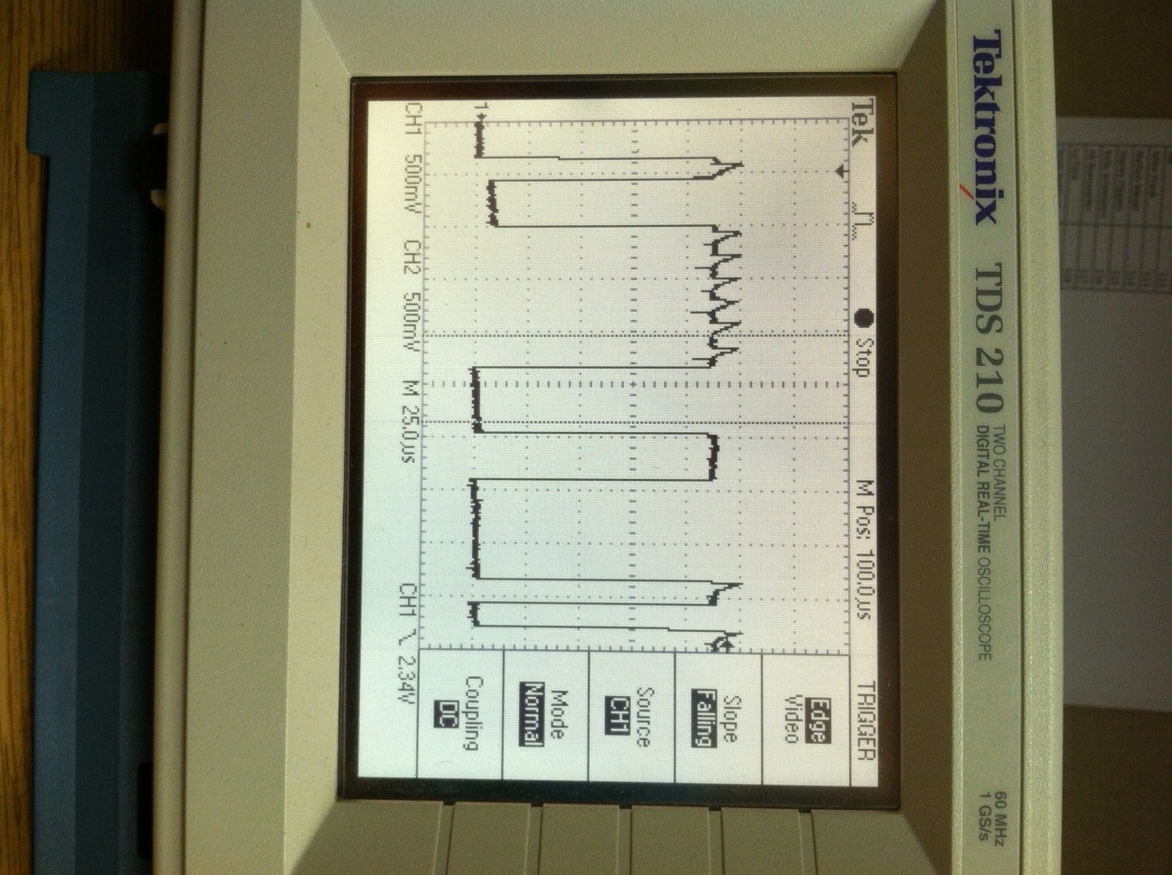

1. Clock with 4.7K pull-up

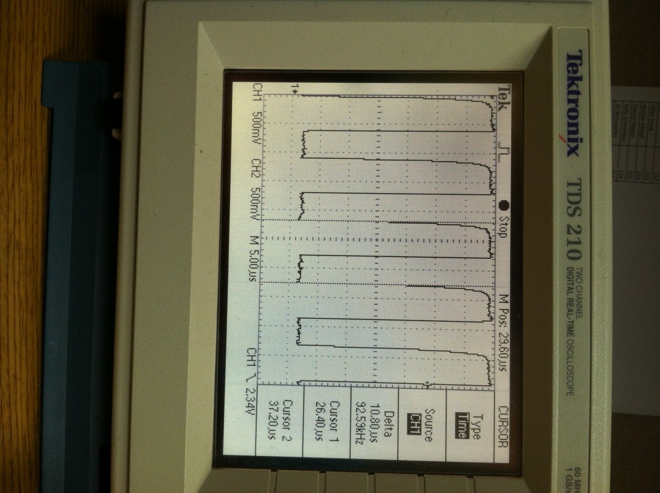

1. Data with pull-up 4.7K

