Hi Bobby,

Can you please approve the below connection between the P82B96TD to UltraScale FPGA using the TCA9803device.

UltraScale LVCMOS18  Input/Output levels are marked in the bottom picture.

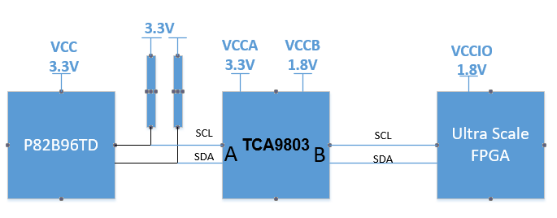

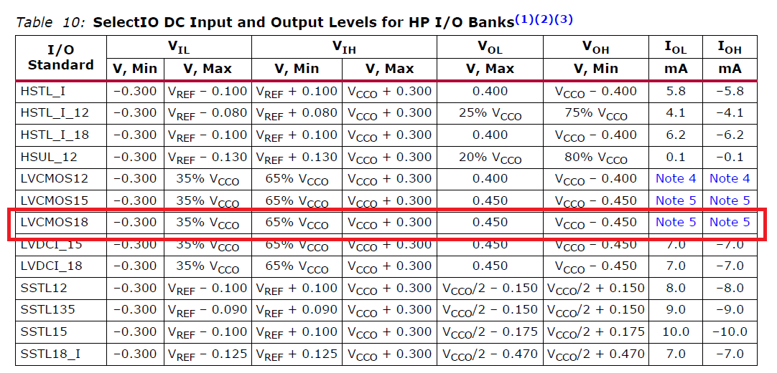

Thanks,

Shlomi