This port is routed via the FPGA’s MII-RGMII converter to the processor.
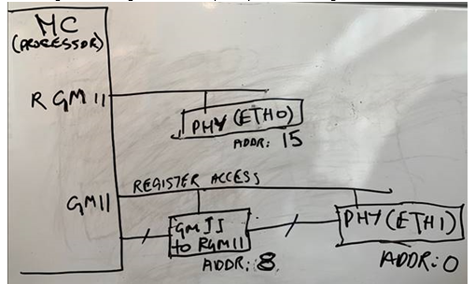
PHY corresponding to ETH0 is directly connected to the RGMII interface on the processor.
PHY corresponding to ETH1 is connected to the GMII interface on the processor via the “GMII to RGMII” core on the FPGA.
