Problem Statement:
After multiple plug-in and plug-out of RJ-45 cable with PoE, PHY (DP83867ISRGZR) goes faulty due to which auto-negotiation is not able to complete successfully and link doesn’t establish.
It is observed that impedance of Differential Transmit and Receive Signal Pins (Pin No. 7 and 8, 10 and 11) of PHY (DP83867ISRGZR) goes low.

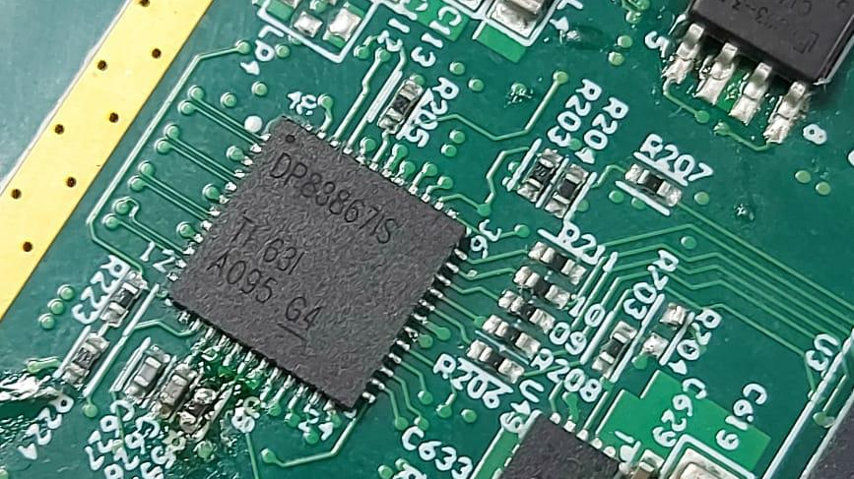
Figure 1 TI PHY (DP83867ISRGZR) Used
Circuit Design Implemented:
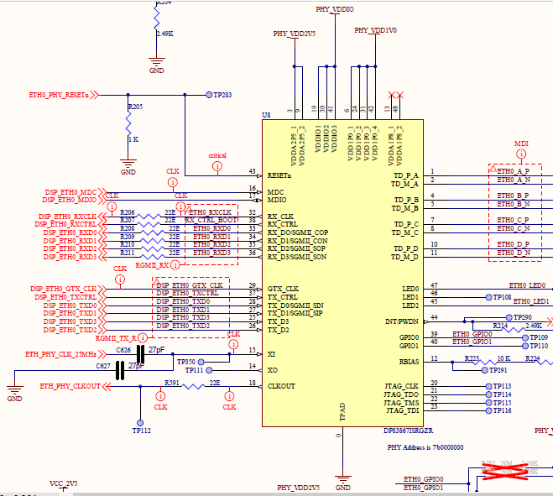
Figure 2 TI PHY (DP83867ISRGZR) IC Design
PHY Bootstrap Settings:
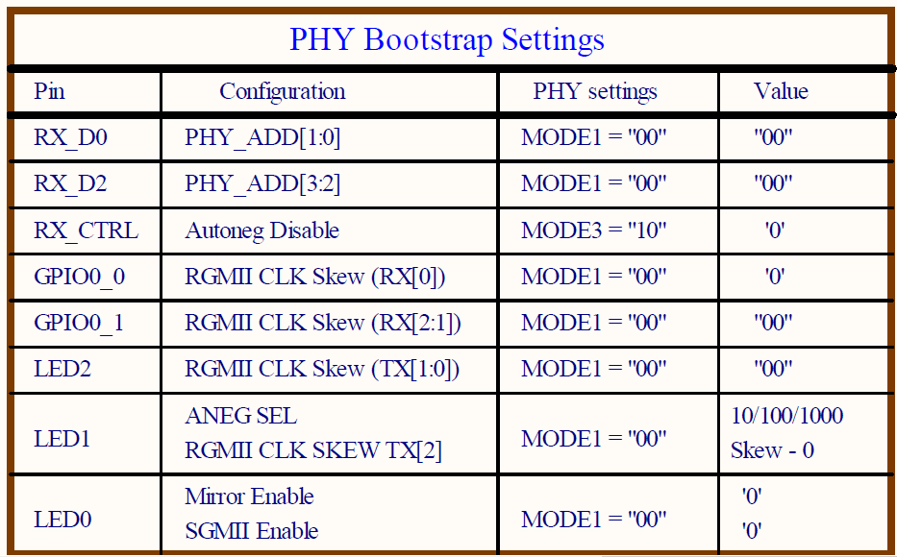

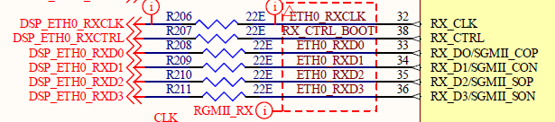
Figure 3 Bootstrap 1,2 and 3 Design
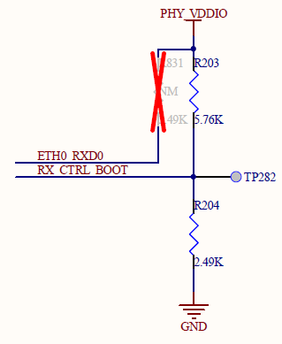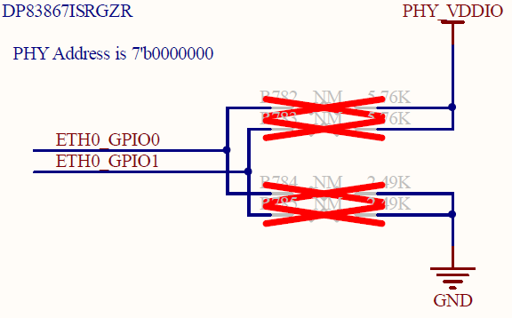
Figure 4 Bootstrap 4 and 5 Design
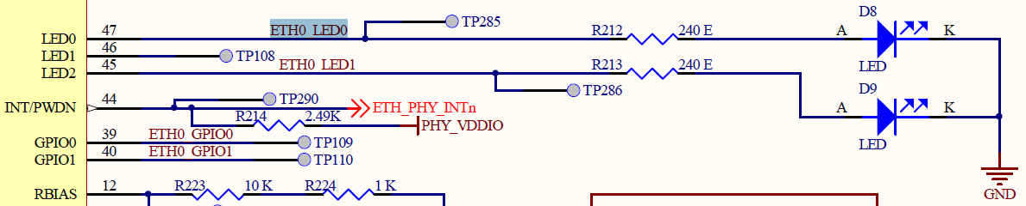
Figure 5 Bootstrap 6,7 and 8 Design

Protection Circuit:
Below is the protection devices detail that we have used in our design:
Table 1 Bootstrap Settings
RefDes | Manufacturer | MPN
D6, D7, D36, D37 | littelfuse | LC03-3.3BTG
U32 | Pulse | HX6098NL
G1-G4 | BOURNS | 2036-09-SM-RPLF
RV1- RV4, RV6, RV7 | littelfuse | TMOV14RP115E
D17-D19, D27-D31 | VISHAY | V12P10-M3/86A

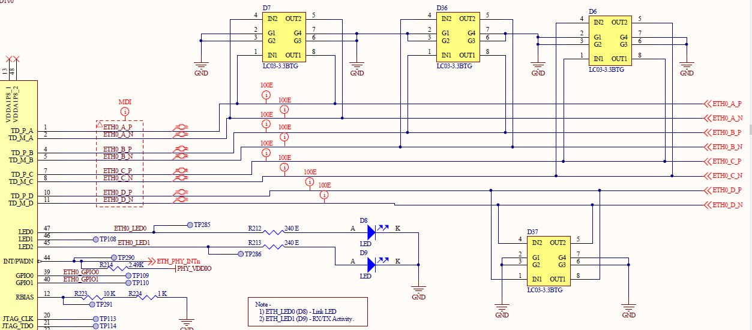
Figure 6 Protection Diodes D6,D7 and D36,D37
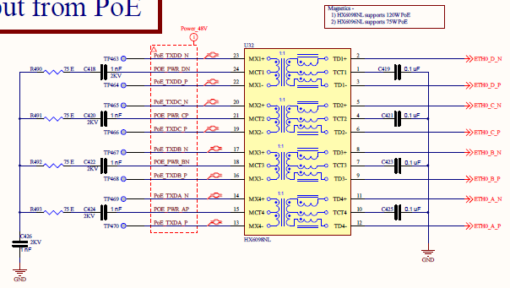
Figure 7 Transformer U32

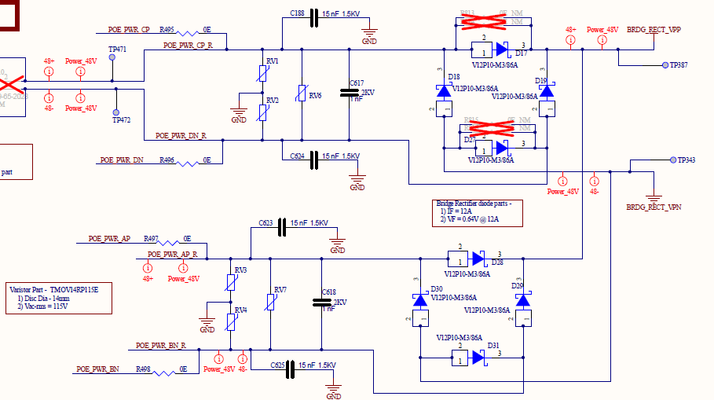
Figure 8 Protection MOVs and Schottky Diodes & Rectifiers

Power (48V) Input Design:

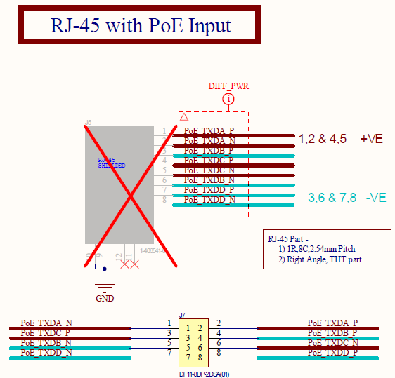
Figure 9 Ethernet Connector
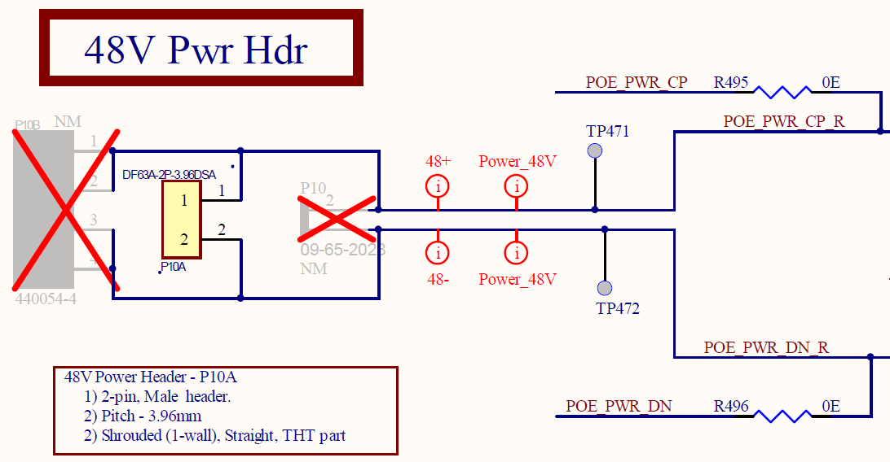
Figure 10 2-pin power connector for dc supply
Problem Description:
In our board we have used TI PHY (DP83867ISRGZR) and other protection circuits to power-up using PoE of 48V through RJ-45 connector as in above images.
It is designed to have an option for power-up using both DC supply and PoE with PHY DP83867ISRGZR as in above images.
When we were using dc supply to power the board and using normal ethernet, the board was working properly with 1Gbps link speed.
After we started powering-up with PoE, observed failures over time.
Detail testing exercise done is as below:
- 48V dc power is given at pair C and pair D using PoE adaptor.
- Initially it was working properly with successful auto-negotiation completion and link establishment.
- When multiple (10 times) plug-in and plug-out of RJ-45 was performed, auto-negotiation has not been able to complete successfully and link didn’t establish.
- Then it is observed that there is variation in impedance (measured w.r.t. GND) at PHY Differential Transmit and Receive Signal Pins (Pin No. 7 and 8, 10 and 11). They are getting low as in below table.
- We have observed this issue on 4-5 chipsets.

Table 2 Impedance Variation on different chipsets
Chip- Sets | PHY Pin | Affect on Impedance (measured w.r.t. GND (TPAD))
1 | Pair C : Pin 7 and 8  Pair D : Pin 10 and 11 | Pair C: 1.6K instead of 2K  Pair D: 500E instead of 2K
2 | Pair C : Pin 7 and 8  Pair D : Pin 10 and 11 | Pair C: 2K  Pair D: 5E instead of 2K
3 | Pair C : Pin 7 and 8  Pair D : Pin 10 and 11 | Pair C: 161E instead of 2K  Pair D: 1.3K instead of 2K
4 | Pair C : Pin 7 and 8  Pair D : Pin 10 and 11 | Pair C: 1.9K instead of 2K  Pair D: 210E instead of 2K

