Hi Team,
I am trying to use the IBIS model of SN65LVDM050-Q1 to simulate and observe the signal quality at the receiver. Here are the details of the circuit and the simulation results captured.
- Circuit designed using hyperlynx linesim. Assigned the IBIS model of SN65LVDM050-Q1 to a differential IO buffer in the linesim and added transmission line (50ohm cable with length of 100 inch) and termination(100ohm) to the circuit.
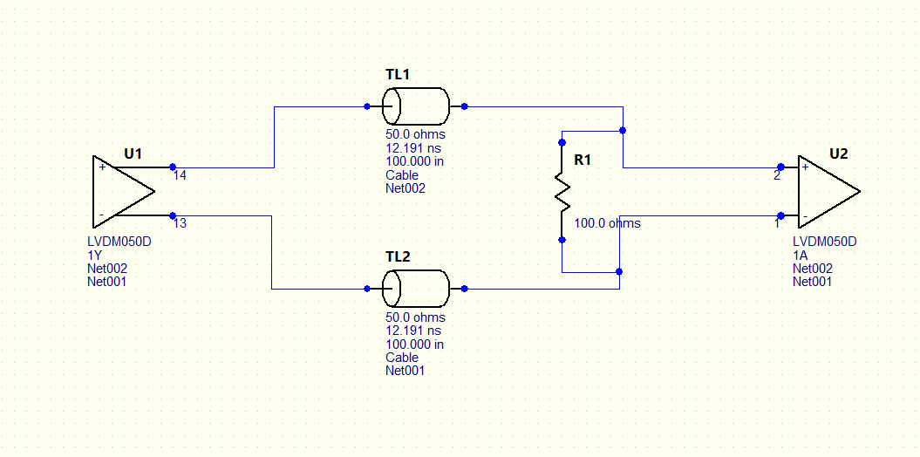
- Simulated the interface simulation and here is the waveform captured. The below image shows the waveform captured at the receiver end (U2) and the next one shows the wave form captured at driver end (U1). Stimulus: 100Mhz signal with 50% duty cycle.
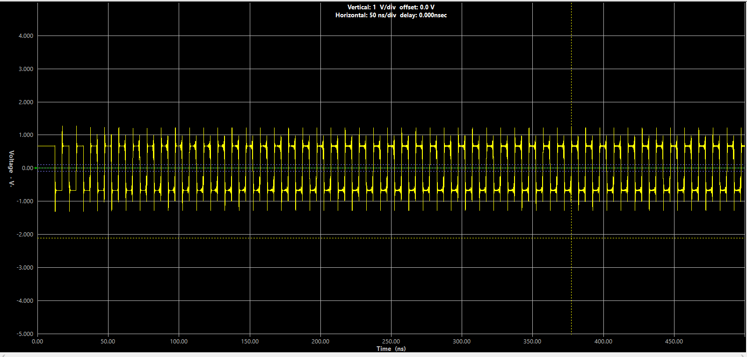
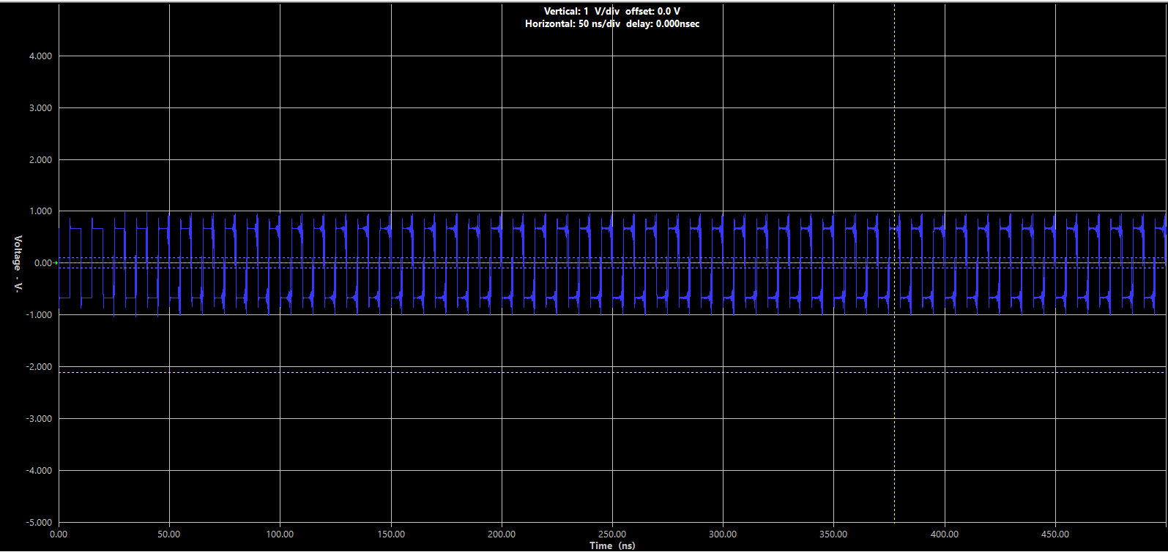
- Here is the eye diagram simulation result. Signalling rate: 0.1Gbps
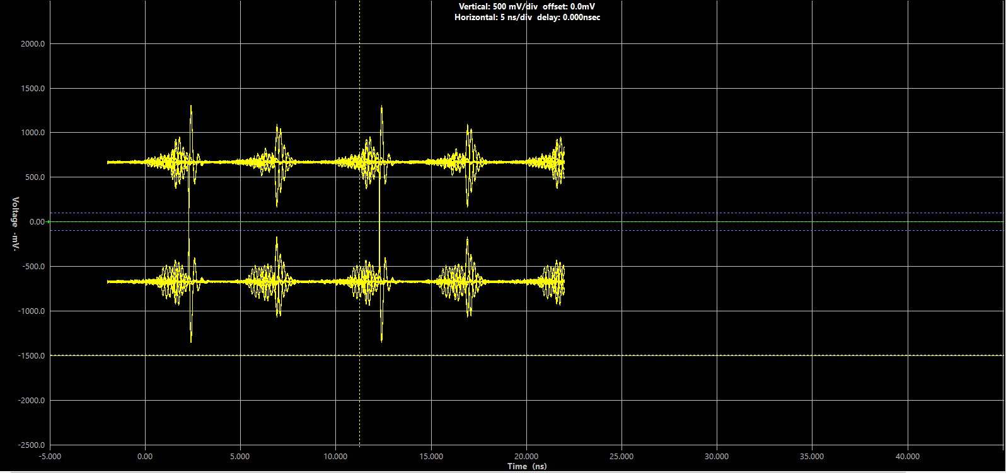
Queries:
- As seen in the waveforms, there is an overshoot and undershoot seen. Also, the eye diagram is distorted. Any modifications are required in the circuit?
- My application uses twisted pair cable (cat5e) for communication between 15 transceivers with last one about 20meter apart (M-LVDS interface). But there is no twisted pair transmission line available in the linesim. I am using a cable as transmission line which has R=135.8, L = 609.53nH and C=243.14pF for 100-inch length. Is there any way I can simulate the transceiver with twisted pair cable parameters?
- I tried the same simulation with SN65MLVD203B Ibis model, but I did not see such overshoot and undershoot even for longer length of cable. Is there any limitations using the SN65LVDM050-Q1 IBIS model.
- Is there an eye mask’s parameters available for the M-LVDS interface? Would be great if you can share if available.

