Hi Ti team,

We have 2 questions need your help.

1. We follow the power on sequence below, but we found the value of 0xE5 is 0x00 on 1 of our devices, and it’s 0x01 on 2 other devices.

Do you have any ideas about how this happened?

Here is the waveform we measured.

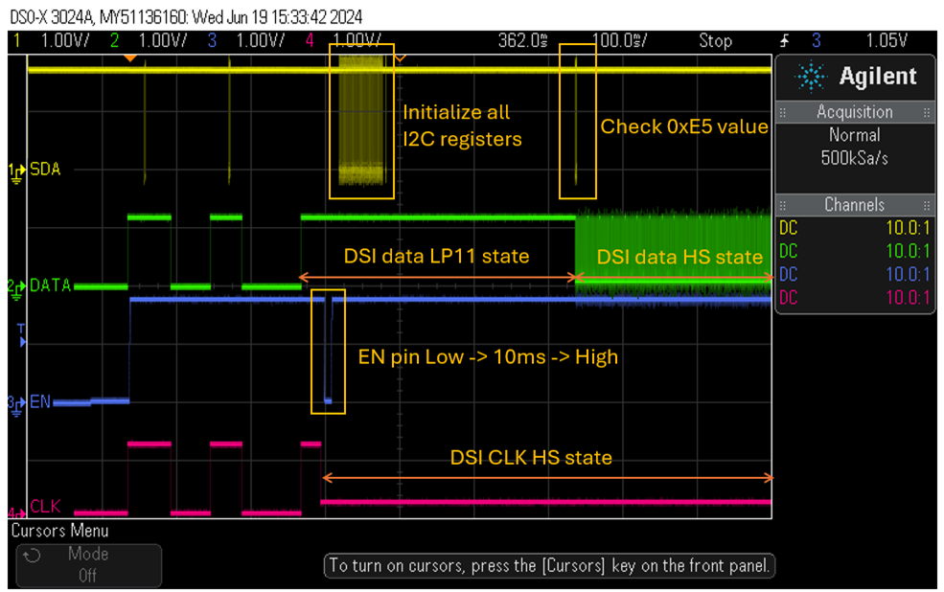

1. If we initialize all CSR registers while booting up (the above power on sequence), do we need to do the same when the device enters suspend/resume?

Or we just need to simply follow the video stop/restart sequence below?

