Questions about dp83td510 conneted to MAC
- I am not sure whether it is the driving problem or the problem of my circuit design, or maybe it is the problem of my manual welding.The syestem cannot establish connection with PC.
- Only the TI official website datasheet information, can you provide MAC+ DP83TD510 connection scheme reference circuit design and drive demo scheme.

My test case:
imx6ull(MAC) + dp83td510 + Router + PC
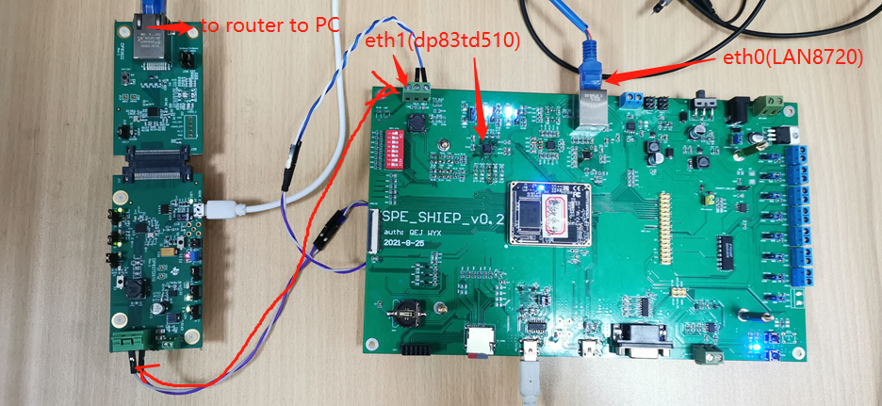

driver：
PHY（dp83td510）+ MAC（imx6ull），RMII is used，PHY should be set as slave mode，50MHz clock signal is given from imx6ull.The dp83td510 driver I used download from ti website, branch is linux5.9 kernal：
https://git.ti.com/git/ti-analog-linux-kernel/dmurphy-analog.git
commitID: 665dda641db7e5c25fe5f7ce24006e4aeb30556e
branch: origin/dp83td510_phy
Then，I got the dirver, and transplant the dp83td510 driver in branch ‘origin/dp83td510_phy’to NXP website linux 5.9 kernel.In device-tree file， I set ti,master-slave-mode = <0>;，and tried DP83TD510_SLAVE_24、DP83TD510_SLAVE_1 two modes，but not works, cannot establish connection with computer。

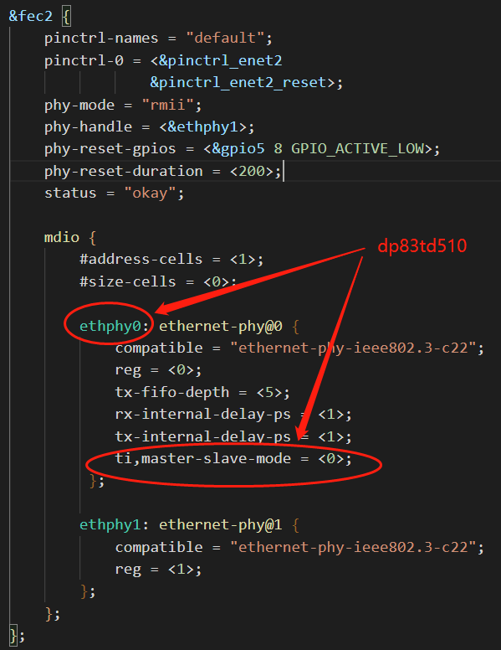
MDIO driver maybe ok, because I can read register normally.

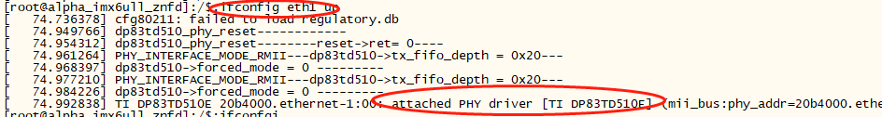
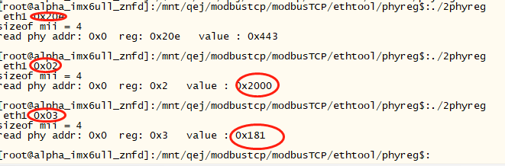
Such as PHY ID read normally.

hardware：
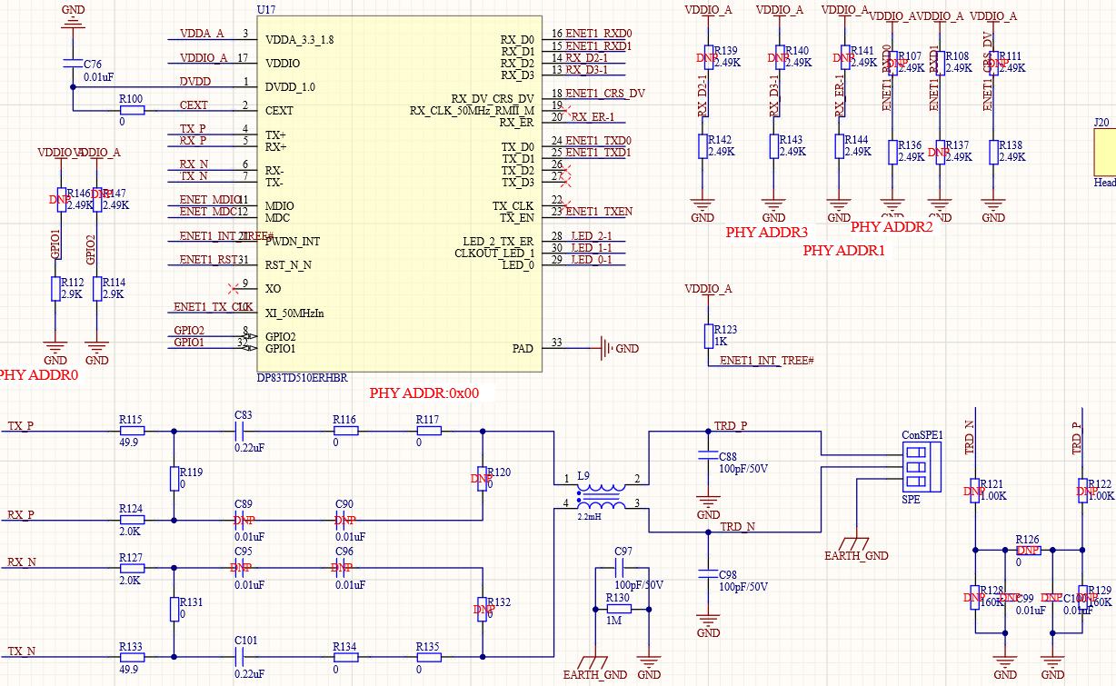
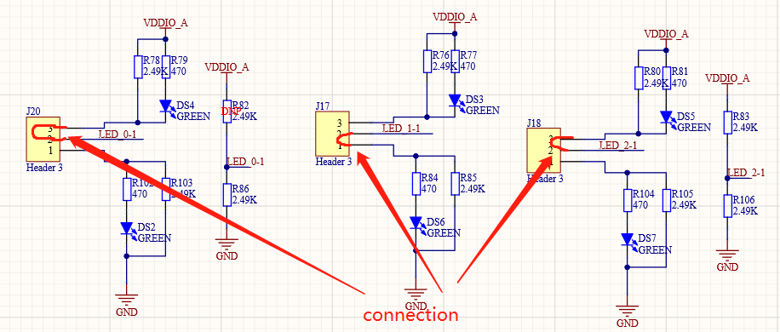
strap9、strap6、strap4、strap1 are all set to 0，that is to say my PHY address is 0， Eth1 in my linux system(my system is double phy, the other one is normal connection).
strap7（J18，pin28）:1
strap3(pin15):1
strap8（J20，pin29）:1
strap2(pin14):0,CRS_DV
strap10(pin8):0
strap5(pin18):0

test：
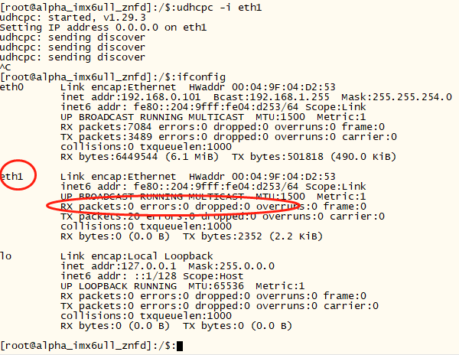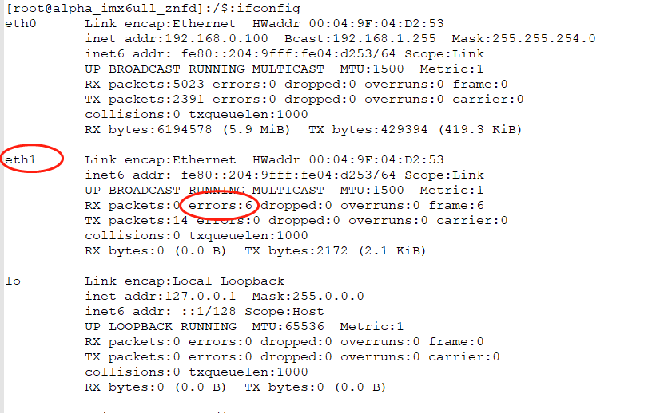
when I execute cmd:‘udhcpc -i eth1’，DS5 always bright，DS4 always flash quickly, seems to try to establish with PC。
case1:dp83td510 driver in kenel4.14 from TI,transplanted to my kernel5.9(NXP)
RX packets:0 errors:6 dropped:0 overruns:0 frame:6
case2：dp83td510 driver in kenel5.9 from TI,transplanted to my kernel5.9(NXP)
RX packets:0 errors:0 dropped:0 overruns:0 frame:0
