We are going to PCB layout as soon as Sep 19, and hope someone skilled with the T.I. TPS65982 can review that section of our schematic.
Our PCB will consume 20 volts @ 3 amps. We have an OEM power supply capable of delivering that. We need the T.I. TPS65982 on our PCB to negotiate power delivery from the power supply.
No data will transfer in either direction, except to negotiate the power. We just want the power as if it were coming in from a barrel connector, except that it must come through a USB PD type C connector.
We started our design with the T.I. TPS65982 EVM as our example, and then whittled away unneeded features; at least I THINK they are unneeded!
Questions:
- The figure below from the TPS65982 EVM manual shows an Aardvark programmer connector. Would it be OK to connect an external 5V supply to VBUS, and rely on an un-programmed TPS65982 deliver LDO_3V3 to the Flash? The programmer shown in the EVM supplies 5V. Can we just connect this to VBUS?
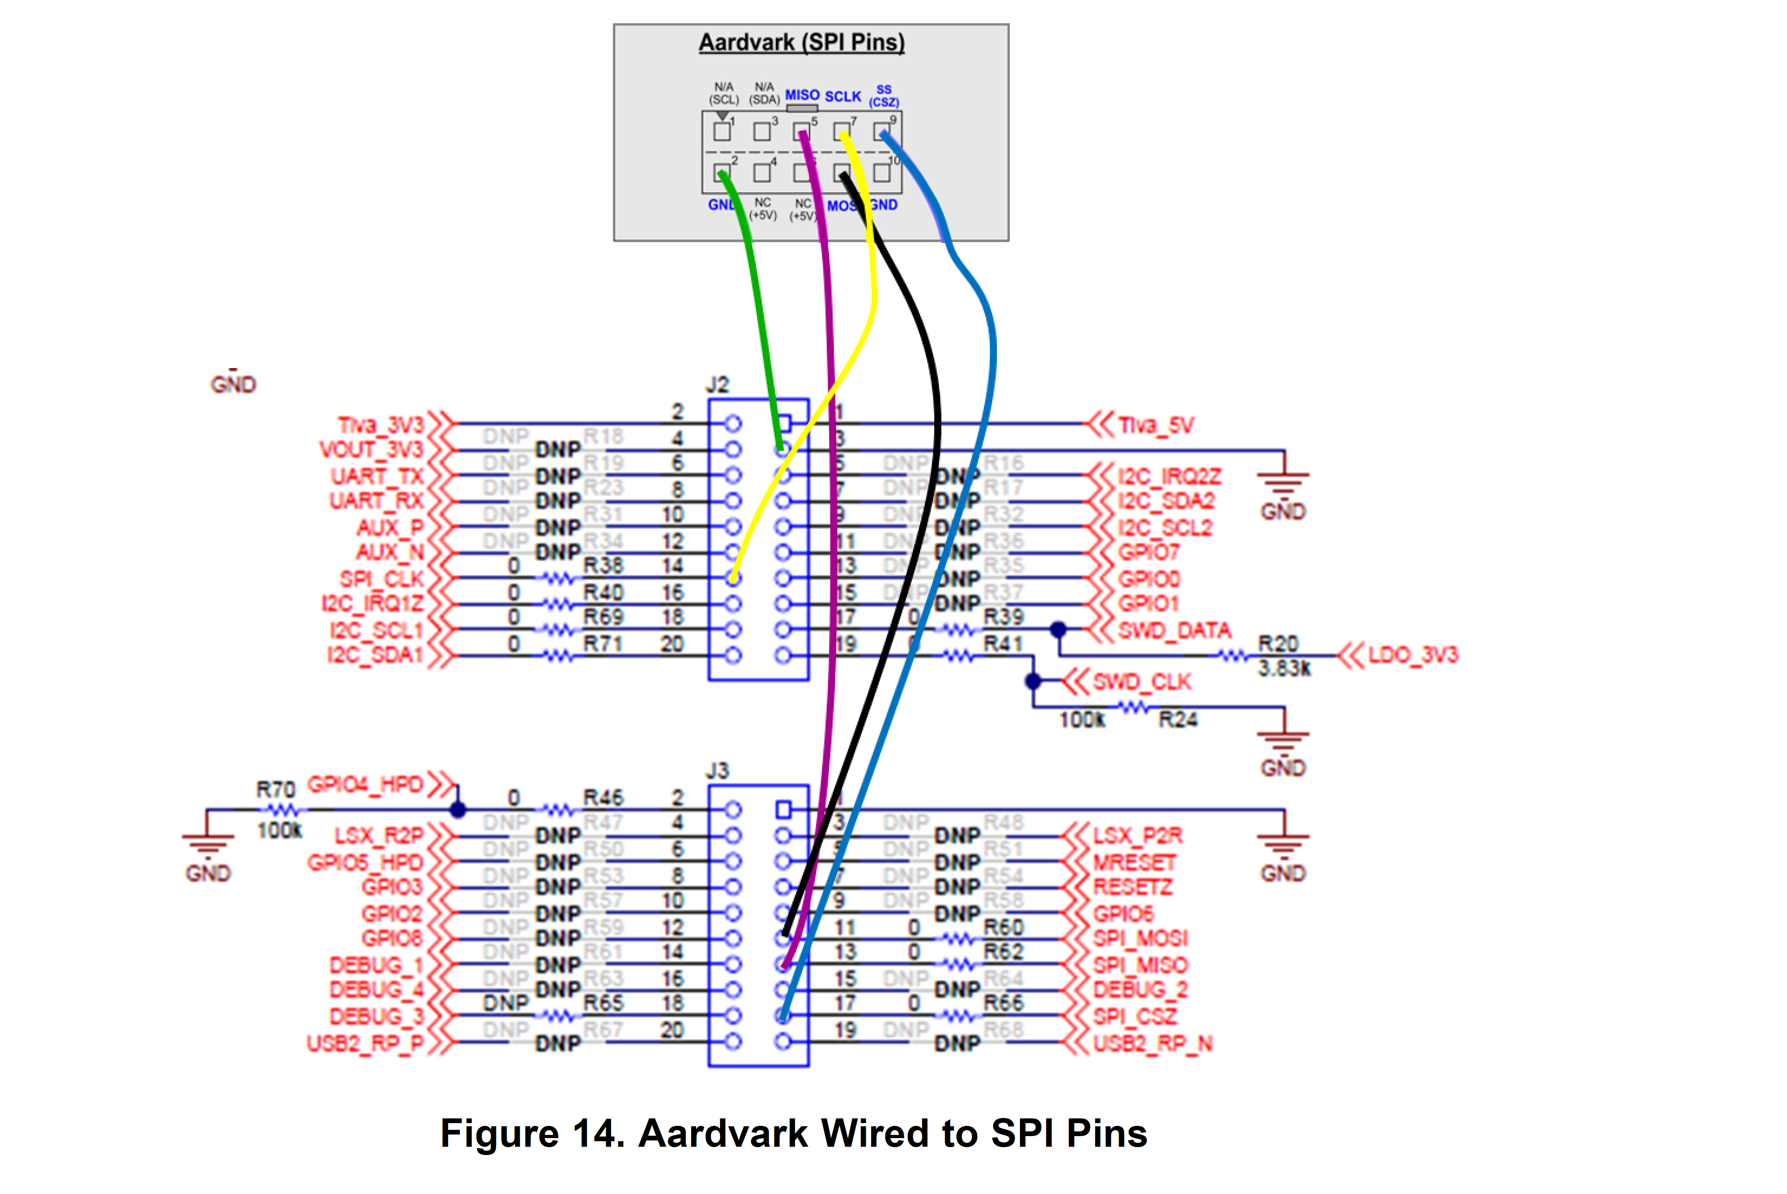
- What is the part number for the Aardvark programmed shown in the TPS65982 EVM manual?
- Is there any reason why we need the T.I. Launchpad to program the Flash, or any of its features to operate the TPS65982 EVM in our end application? We’d rather not bother.
- Are DEBUG_CTL1/2 necessary when operating TPS65982 EVM as a stand-alone power consumer? If not, I will disable them.
- I presume the TPS65982 EVM can operate without the T.I. Launchpad, and that the resistors used in the EVM support that. There are some discrepancies between what the manual recommends when features are unused, and what the EVM does. Which is correct?
  - The data sheet says ground GPIO4_HPD through 1M, but EVM uses 100kΩ.
  - The data sheet says float SWD_DATA, but EVM pulls it up to LDO_3V3 through 3.83kΩ.
  - The data sheet says to float SWD_CLK, if not used, but the EVM pulls it down through 100kΩ.
- The USB PD section of our schematic is shown below. (Zoom in to see details.)

