Case1
Phenomenon description: The machine connected to the camera, just started up immediately open the camera APP, the screen can be normal display preview screen. After a dozen seconds, the video was interrupted, and the APP could not be rebooted; if the APP was rebooted after a period of time, the preview would not show the video.
Problem analysis：
export large log to the internet students analysis, show that the video stream just started normal transmission, transmission interruption after a period of time.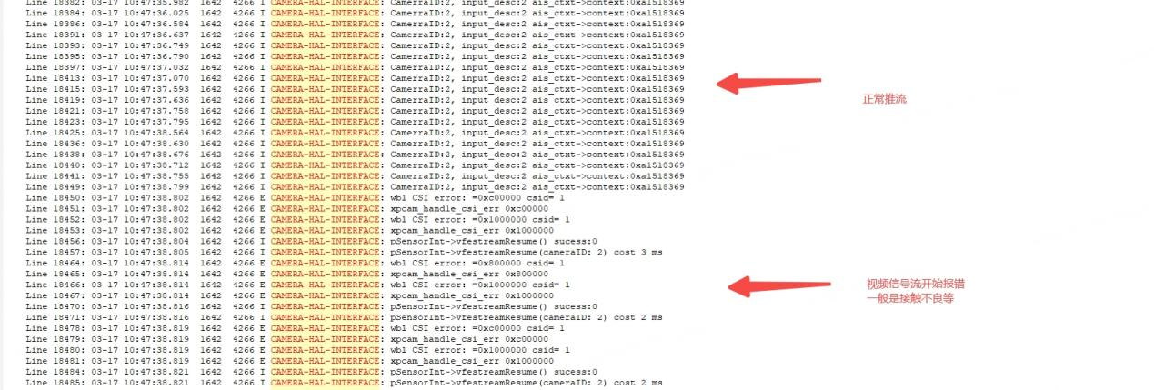
The related link connection and UB964 related circuit are shown below. Measuring the external circuit of UB964, no abnormal (including power supply, clock, resistance, function pin, etc.) , can be opened on the large screen camera APP, watch the chip welding, there were no signs of poor welding.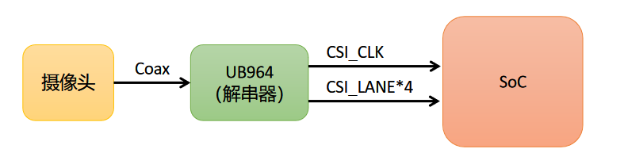
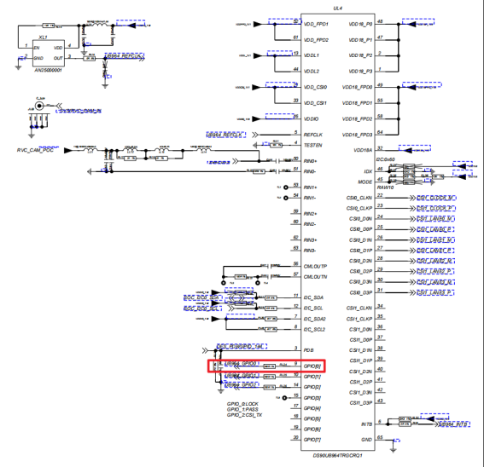
- Burn debug version (V1.6.0) , export serial port log, and found no UB964-related error printing, compared with the normal machine (the same version of both software) found no exception.
- the machine is put in high and low temperature test, the phenomenon is consistent with the normal temperature.
3.UB964 is shown in the following diagram. The GPIO0 pins can be configured for different functions through the IIC, but are not integrated into the software and need to be manually configured. The configurable capabilities of GPIO0 are shown below. The functions used to indicate the FPD LINK (the LINK between the camera and UB964) and the CSI status in the diagram, such as Rx Lock, Rx Pass, Frame Valid, CSI Interrupt, etc. , the result is that the signal between the camera and UB964 can be normal and fast LOCK, PASS, Frame Valid, Line Valid and other instructions are normal, indicating that this link is normal. When configured with the CSI link's“011: Line Valid (sending video Line)” function, the GPIO0 pin outputs 0.167V and the normal output 0.528V. Indicates that there may be a problem with the CSI link.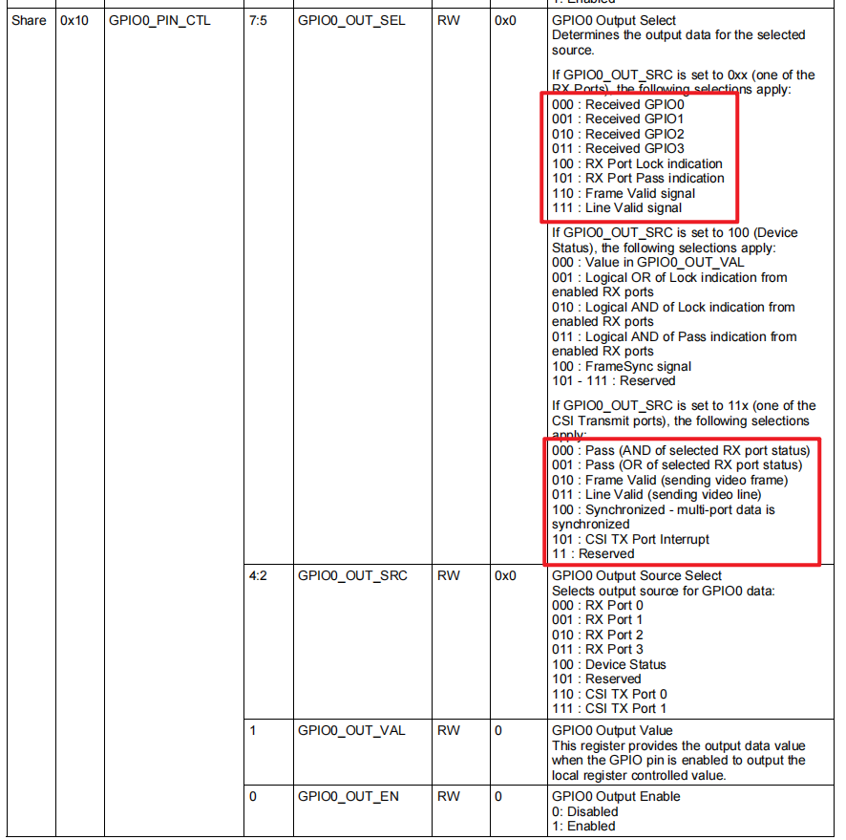
use high-speed oscilloscope to measure CSI signal, and compare with the normal machine, see the attachment. The two machines don't differ much in terms of signal quality, but the CSI clock rates for the two machines are different, normally 200 mhz, and 641 mhz for the faulty machines, as shown below. Find a normal machine and measure the CSI clock to confirm it is 200MHz.
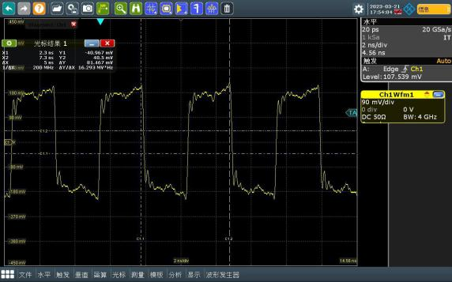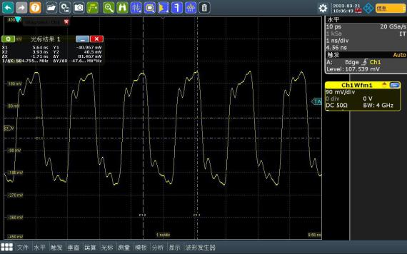
Confirm with internet classmates that UB964 is configured to open the camera APP through the IIC configuration, serial port log can print the specific register address and value, as shown in the figure below (left: normal; right: failure) . Disconnect the other devices on the UB964 IIC and compare the serial port log of the normal machine. The values of all the registers in the read-back log are also the same as on a normal machine. Where the register address that configures the CSI rate is 0x1F and the value that should be configured is 0x03,400Mbps, corresponding to the clock 200MHz. The value read back by the failed machine was also 0x03, indicating that the register was written successfully, but UB964 did not take effect.
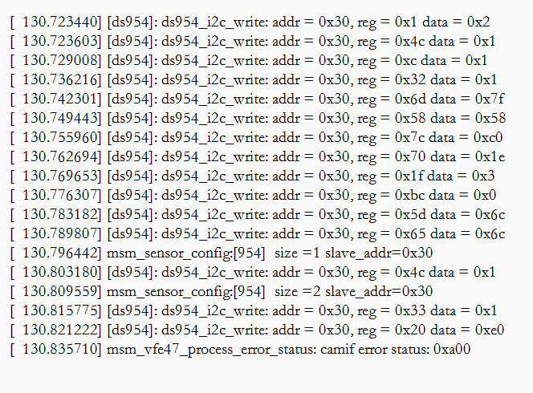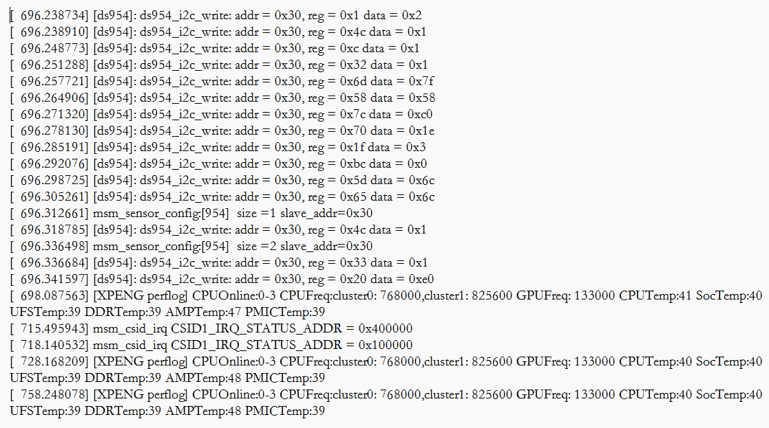
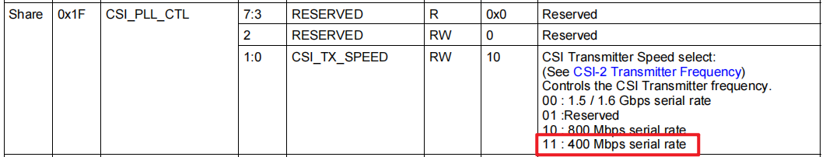
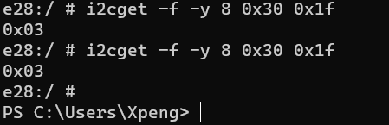
Conclusion: the link between the camera and UB964 is normal, and the CSI clock from UB964 is abnormal. The IIC writes that the value of the UB964 register is correct and does not appear to be working. The actual clock frequency is 641MHz. Recommendation 92/2000
Send this report to TI for analysis and try ABA UB964. UB964 has done ABA verification, failure to follow the chip, confirm that the chip problem.
Case2
Description: Case1 and the phenomenon is basically the same, only after about 3 minutes to boot video interrupt.
Problem Analysis:
36/2000
Clock waveforms of machines in normal and abnormal conditions:
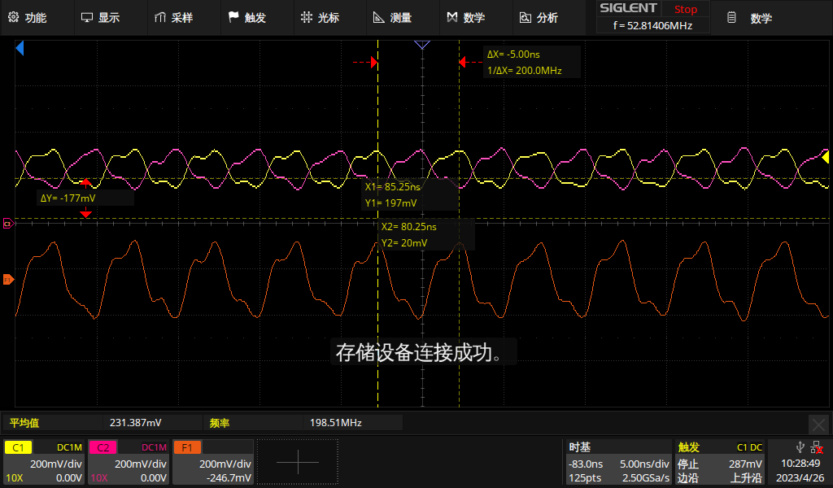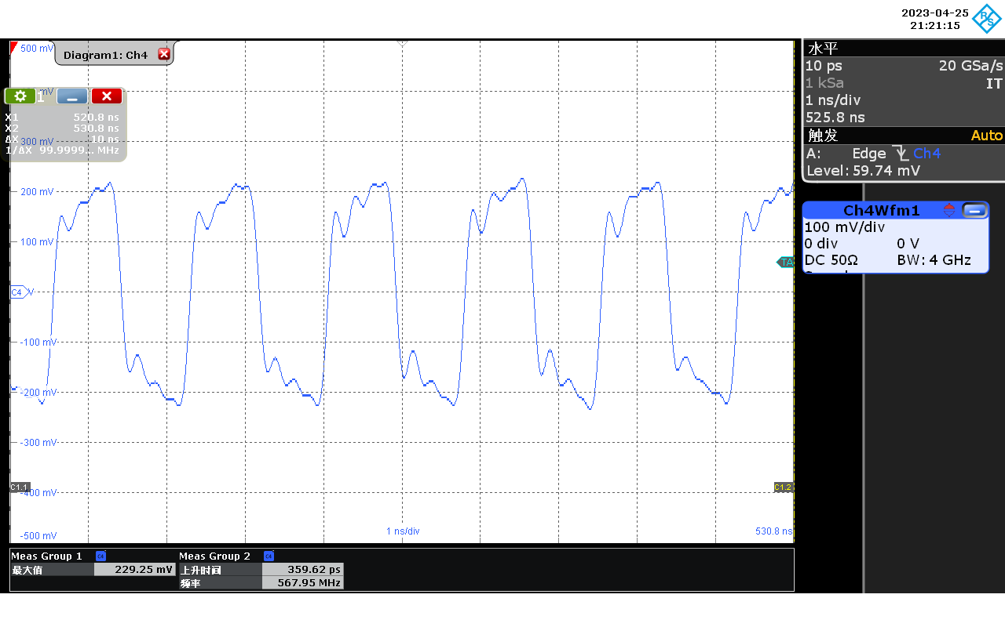
As you can see, the CSI clock started out as a normal 200MHz when the video was transmitting normally, and the black screen clock went up to more than 500mhz. The following two videos show the waveform changing process:
By switching the CSI rate with the IIC, you can see the clock frequency change, but it doesn't match the configuration value. Here are the CSI clock waveforms at 400MBPS, 800Mbps, and 1.5/1.6 Gbps:
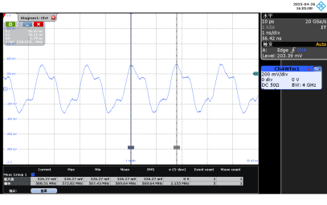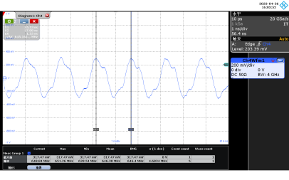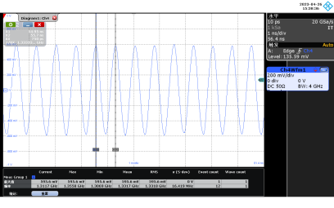
Supplementary Testing: the following is the fault machine UB964 power-on sequence and power ripple test waveform:
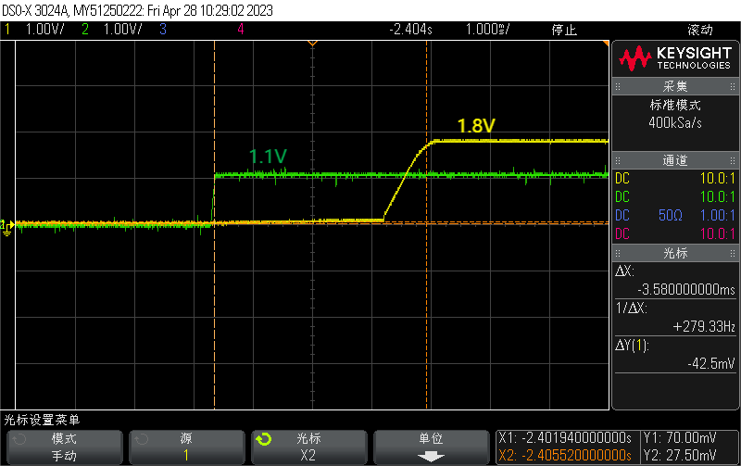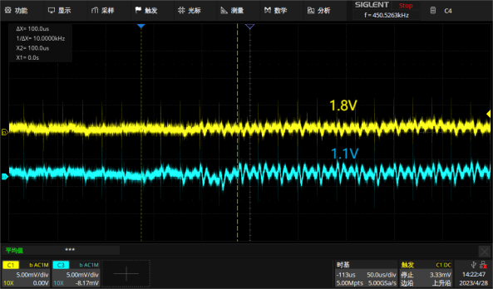
The following are the values of all the UB964 registers read by the failed machine and by the normal machine (the failed machine reads them at the time of replay) :
Here is the clock output of a normal machine when switching CSI rates (setting the 0x1f register to 0x03/0x02/0x00 for 400/800/1600Mbps, respectively) . Due to the limited bandwidth of the oscilloscope, the clock at 1600Mbps was not grabbed, but when set to 1600Mbps, the video was interrupted:
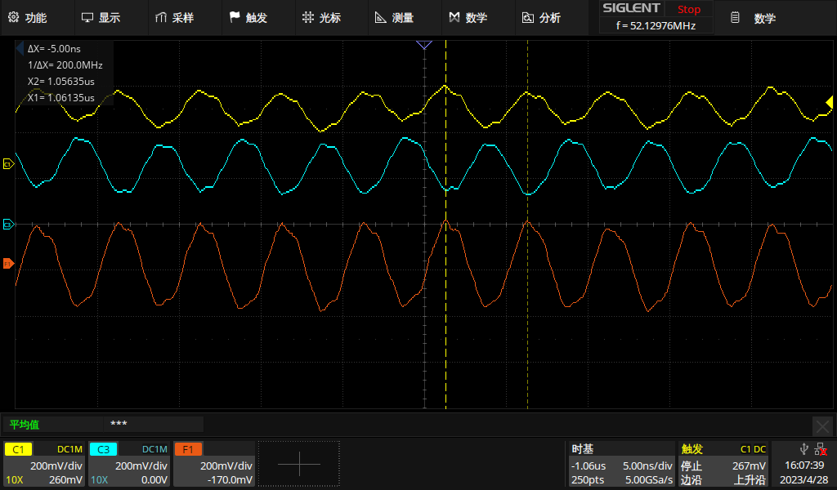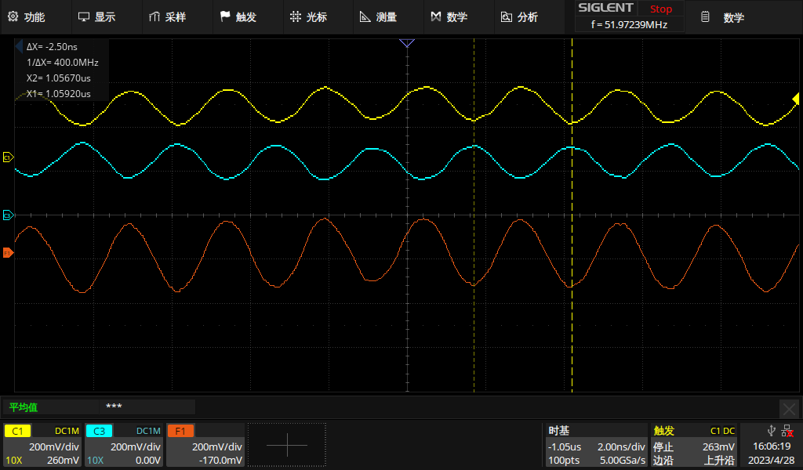
ABA cross-validation of two machines to confirm fault following chip.
Set the CSI rate to 400 Mbps as provided by Ti, and the fault remains.
