Hi Malik,

I did some more testing with the EVKs yesterday… And I have another issue… Let me start with this then roll into your questions…  
I started with the 212 because that is what the EEs initially started looking at in the design…

Setup:

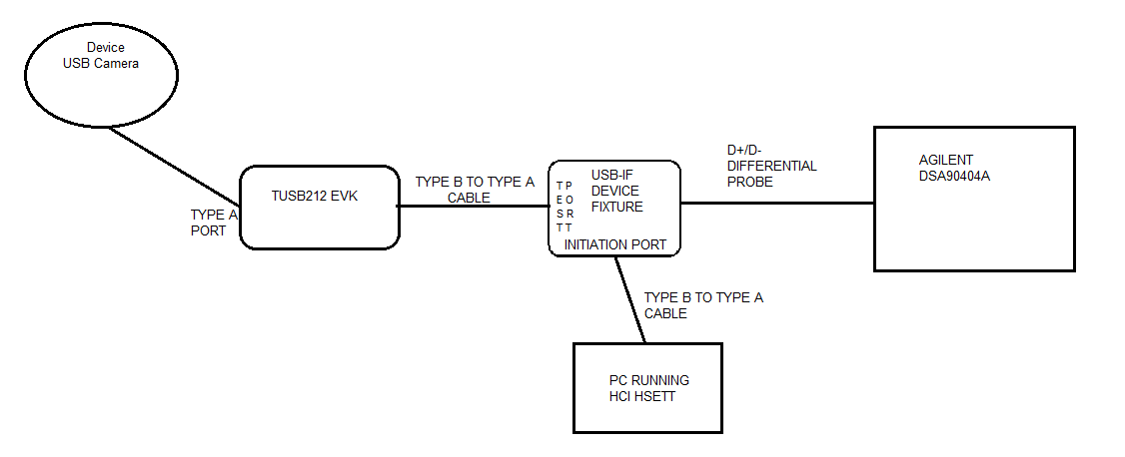

Notice the drop in amplitude…And it stays at this amplitude until I go back and restart the testing….

Why doesn’t after releasing the RESET button the amplitude of the signal go back to previous Testing levels… Because the datasheet says:

*“In order for the TUSB212 to recognize any change to the AC or DC boost settings, the RSTN pin must be toggled. This is because the EQ and DC_BOOST pins are latched on power up and the pins are ignored thereafter.”*

Your testing procedure for determining what setting to use in the datasheet give no indication that you need to restart the test between each setting change if you use the RESET line…