・S13009ボード XIO2001（PCI Bridge） PowerON/OFF Sequence Waveform

The measured carrier board :S13009 （S00006)

１．Power ON Sequence

１－１．VDD_33, VDD_15, PCIR
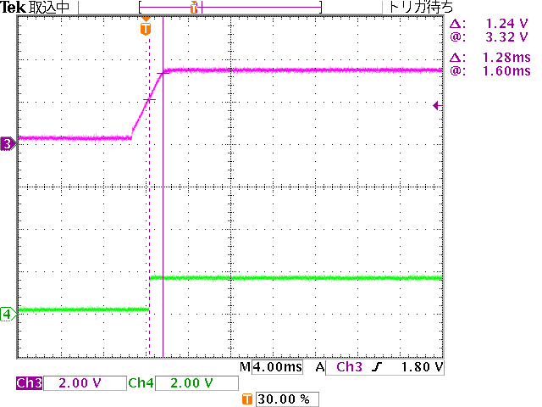
Ch3:VDD_33 (V3R3)
Ch4:VDD_15 (V1R5)

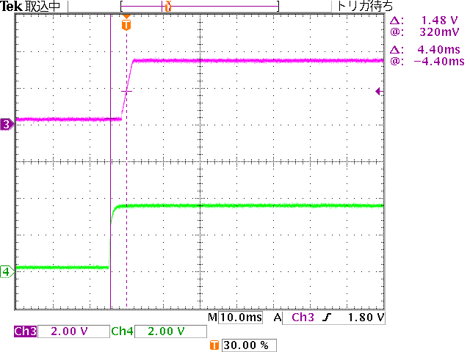
Ch3:VDD_33 (V3R3)
Ch4:PCIR (V3R3_VIO)

１－２．REFCLK
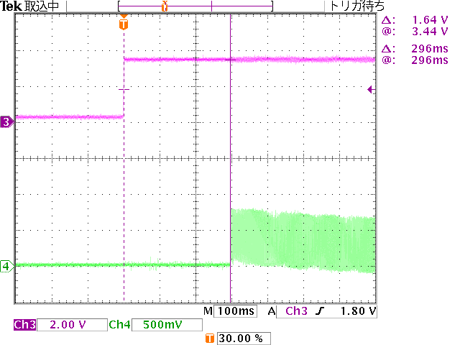
Ch3:VDD_33 (V3R3)
Ch4:REFCLK+ (PCIE_CK0+)

Transition of REFCLK+ (PCIE_CK0+) started after 110ms from the deassert of PERST# (CB_RESET#).

(Result)
The time of specification (Over 100usec) was followed

１－３．PERST#, GRST#
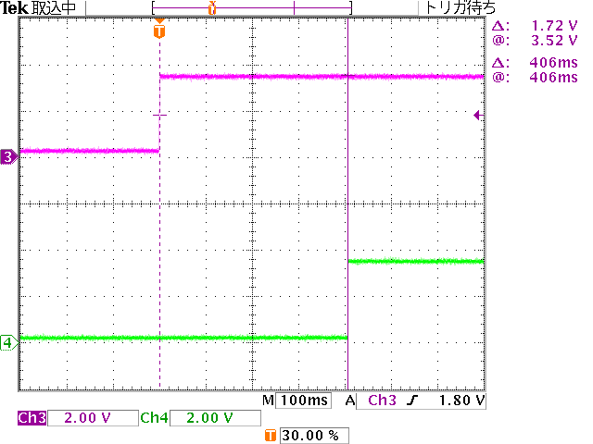
Ch3:VDD_33 (V3R3)
Ch4:PERST# (CB_RESET#)

Transition of PERST# (CB_RESET#) started after 200ms from the deassert of GRST# （GRST#）

(Result)
The time of specification (Over 100msec) is followed

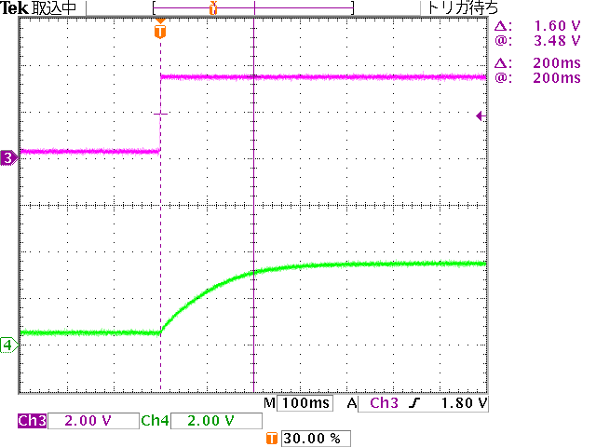
Ch3:VDD_33 (V3R3)
Ch4:GRST# (GRST#)

The assert if GRST# is not sharp.
This is the impact of CR filter.

GRST# was made open after that, but the situation is same and the issue still occured

２．Power OFF sequence

２－１．VDD_33, VDD_15
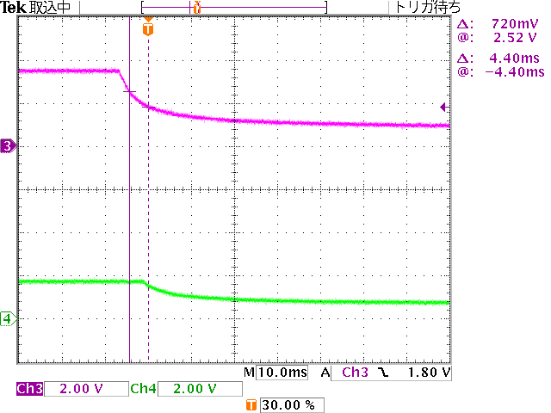
Ch3:VDD_33 (V3R3)
Ch4:VDD_15 (V1R5)

２－２．PERST#, VDD_33, VDD_15, PCIR
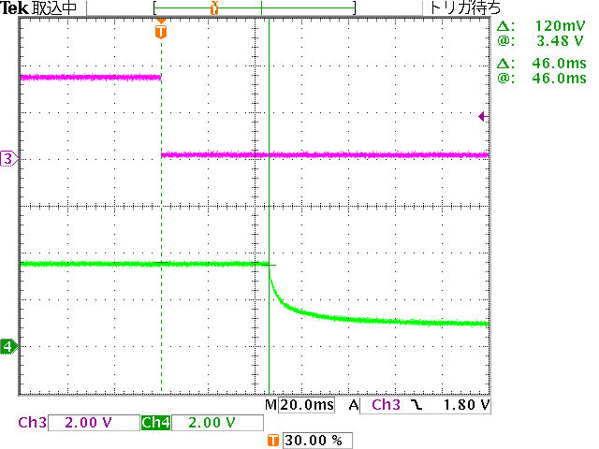
Ch3:PERST# (CB_RESET#)
Ch4:VDD_33 (V3R3)

VDD_33 (V3R3) became OFF after the assert of PERST# (CB_RESET#)

VDD_33 (V3R3)がOFFする

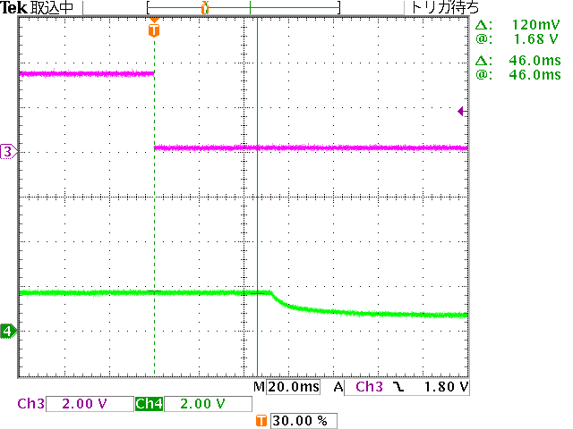
Ch3:PERST# (CB_RESET#)
Ch4:VDD_15 (V1R5)

VDD_15 (V1R5) became OFF after the assert of PERST# (CB_RESET#)

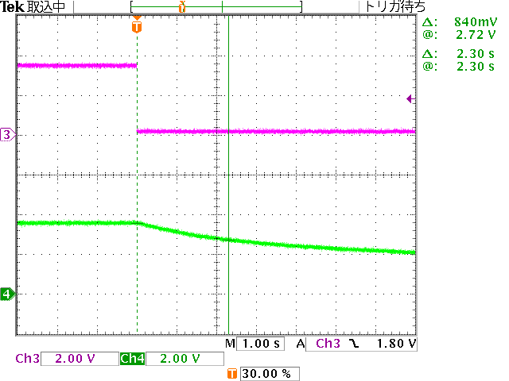
Ch3:PERST# (CB_RESET#)
Ch4:PCIR (V3R3_VIO)

The lump down of PCIR (V3R3_VIO) takes a little bit log because the power load of the PCIR (V3R3_VIO) is low.

１－２．REFCLK
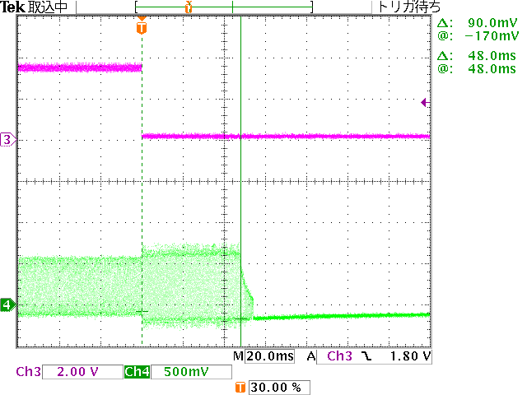
Ch3:PERST# (CB_RESET#)
Ch4:REFCLK+ (PCIE_CK0+)

REFCLK+ (PCIE_CK0+) stopped after the assert of PERST# (CB_RESET#)

