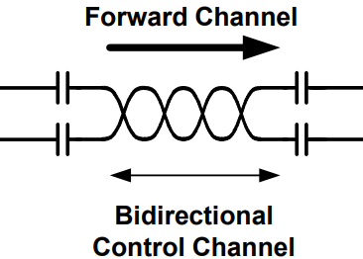

I2S Slave

I2S Slave

I2S Slave

I2S Slave

**ADC-3**

MCLK

BCK

LRCK

SD

AUDIO IN

SDA

SCL

**uC**

I2C

GPO [3:0]

GPI [3:0]

GPI [3:0]

GPO [3:0]

DOUT[4-7]

DOUT[3]

DOUT[2]

DOUT[1]

AUDIO-4

AUDIO-3

AUDIO-2

DOUT[0]

BCLK

LRCK

AUDIO-1

SCK

**DAC-1**

MCLK

BCK

LRCK

SD

AUDIO OUT

**DAC-2**

MCLK

BCK

LRCK

SD

AUDIO OUT

**DAC-3**

MCLK

BCK

LRCK

SD

AUDIO OUT

**DAC-3**

MCLK

BCK

LRCK

SD

AUDIO OUT

DIN[3]

LRCLK

BCLK

DIN[4-7]

SCK

PLL

DIN[2]

DIN[1]

DIN[0]

DESERIALIZER

DS90UA102-Q1

SERIALIZER

DS90UA101-Q1

AUDIO-4

AUDIO-1

MCLK OSC – 12.288MHz

I2S Master

I2S Slave

I2S Slave

I2S Slave

**ADC-3**

MCLK

BCK

LRCK

SD

AUDIO IN

AUDIO-3

AUDIO-2

**ADC-2**

MCLK

BCK

LRCK

SD

AUDIO IN

**ADC-1**

MCLK

BCK

LRCK

SD

AUDIO IN