As below is SATA Eye paten.

1. May we know how many improve we can know after we add SN75LVCP600?

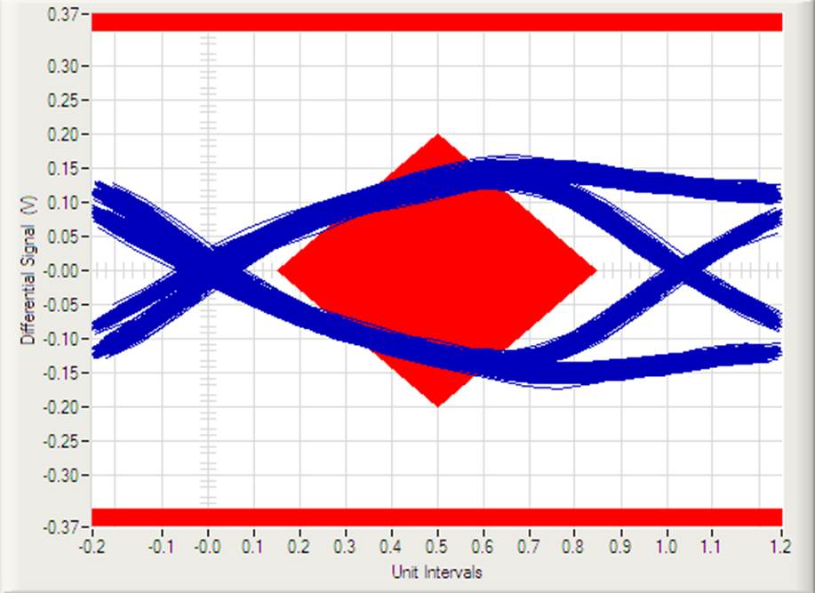

1. Where is put the SN75LVCP600 best location?

Datasheet Figure.12 ，currently I put one SATA Port RXP RXN /TXP TXN both put Redriver. Is it correct?

