TEXAS INSTRUMENTS
LMH1251EVAL Test Procedure
Revision A
March 17, 2013

- General
  - Purpose
    - The purpose of this document is to provide instructions for testing EVM Modules.
  - Scope
    - This document provides details of test, safety, quality and disposition of the LMH1251EVAL, assembly number SV012649-001. Additional information on the boards may be listed in the Reference Documentation section.
  - Reference Documentation as required
    - LMH1251EVAL Application Notes AN 1836
  - Definitions
    - DMM is reference to Digital Multi-meters
    - LED Load is reference to boards with mounted LEDs
    - UUT is reference to Unit under Test
    - EVM is reference to Evaluation Module assembly, in this case the UUT
    - “Hi Voltage” is defined as DC voltages greater than 75V and AC voltages greater than 50 volts (RMS)
  - General Test Guidelines
    - Always check test equipments’ capabilities in terms of power, current and voltage rating to make sure it can support the test requirements for UUT. Failing to follow equipment specs may cause equipment damages, board assembly damages and could pose a hazard to safety of the operator
    - A quick open/short test of the input and output terminals of the UUT is recommended to make sure upon power up, the terminals are not shorted to ground. High current surge can occur as a result of a short and could damage the equipment as well as pose a hazard to operator
- Safety
  - General Safety
    - This test must be performed by qualified personnel trained in electronics theory and who understand the risks and hazards of the assembly to be tested
  - Electrostatic Discharge (ESD)
    - Personnel handing ESD sensitive material must be familiar with ESD prevention procedures and be equipped with the appropriate attire listed in the Apparel section of this document.
    - ESD precautions must be followed while handling assemblies
    - NO ESD wrist strap to be worn for Hi Voltage testing

  - Eye Protection
    - Safety glasses are to be worn
    - If LEDs are present on the UUT or used as loading the UUTs, dark glasses are to be worn to protect the eyes from bright LED lights

  - Thermal or Shock Hazards
    - Precautions are to be taken to avoid touching areas of the assembly that may get hot or present a shock hazard during testing
- Quality
  - Boards under test are to be visually examined for physical defects, damages or missing components. Defects are to be separated and disposed of as stated in the Material Disposition section.
  - Test limits are to be followed strictly. Borderline or sporadic pass/fail are considered a FAIL
  - In the event that the failure rate is greater than 5%, recorded data for the failed units are to be kept for further investigation.
- Apparel
  - Electrostatic Smock
  - Electrostatic gloves or finger cots
  - Safety glasses with dark lenses
  - Ground ESD wrist straps

- Training & Qualifications
  - This test must be performed by qualified personnel trained in electronics theory and PCB assembly testing. The testing technician must be familiar with standard bench test equipment and know how to safely operate them
- Test Equipment/Software/Material
  - Power Supplies:
    - DC Power Supply capable of 2.7V/1A
  - Loads:
    - Electronic Load capable of sinking 100mA at 100W
  - Meters:
  - One 6 ½ Digit DMM or equivalent for VOUT
  - Test Leads and other cabling:
    - One pair of banana connector to double banana red cable wire
    - One pair of banana connector to double banana black cable wire
  - Test Hardware:
    - n/a

- Equipment Setup
  - Ensure “JP4 – POWER SAVE” is jumpered to pins 1&2 to turn on the device. See jumper configuration example in figure 1.
  - Connect power supply brick to J1 (Output: 6V 1000mA). Verify power brick is working by measuring voltage on bottom side of J1. Limits: 5.5V to 9.5V. Be sure to test all power bricks.
Limit Test: +5V voltage

- Photo
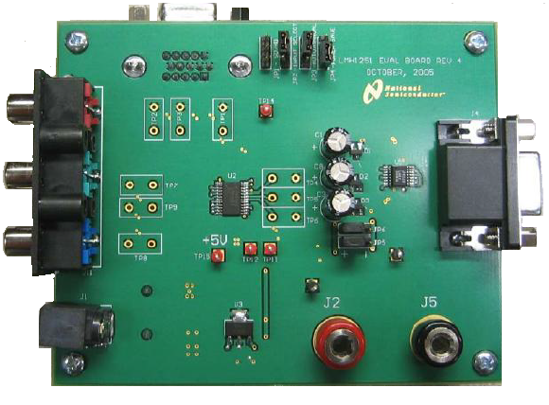

- Connection Diagram (Required
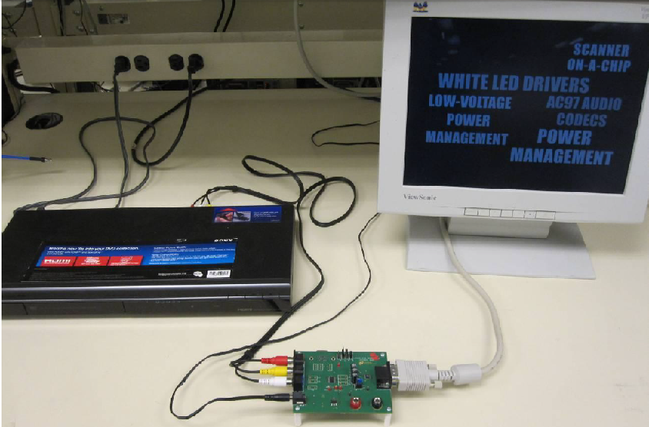

- Step-by-Step Test Procedure
  - Limit Test: +5V voltage
  - Verify TP15 voltage is nominally 5V +/- 5%. Limits: 4.75 to 5.25V
  - Connect a monitor’s RGBHV cable (DE-15M connector) to J4.
  - Verify the video from the DVD player is displayed on the monitor, it is properly centered, and the colors are present and look normal. If the video doesn’t display or the colors don’t appear normal, fail the board. Use a video that was viewed on a TV to get a baseline for ‘normal video’.
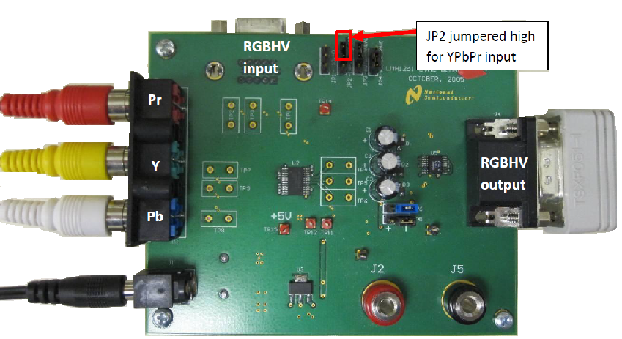

  - IF necessary, connect a TV to the DVD player to verify what the colors should look like.
  - Only progressive mode (example: 480p) will properly display on a monitor. Interlaced mode (480i) will not display on most PC monitors. It may be necessary to connect to a TV and program the DVD player to force Progressive Only on Component outputs.
  - Only progressive mode (example: 480p) will properly display on a monitor. Interlaced mode (480i) will not display on most PC monitors. It may be necessary to connect to a TV and program the DVD player to force Progressive Only on Component outputs.
  - Go/No Go Test: RGBHV input
  - Connect an RGBHV male to male cable (DE-15M to DE-15M) to J3 (input) and PC RGB monitor out. Change JP2 to be jumpered to logic low for RGBHV input. See figure 3. Verify the video is on screen and the colors appear normal. If the video doesn’t display or the colors don’t appear normal, fail the board.

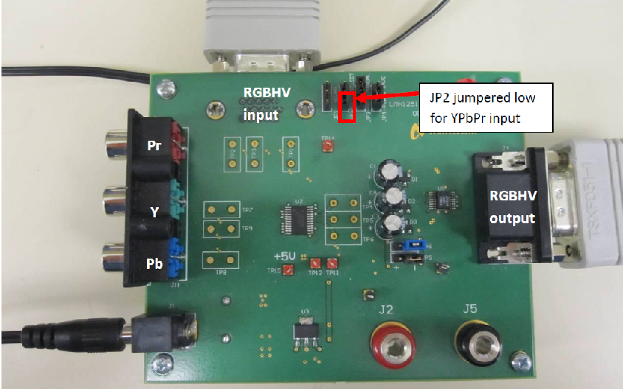

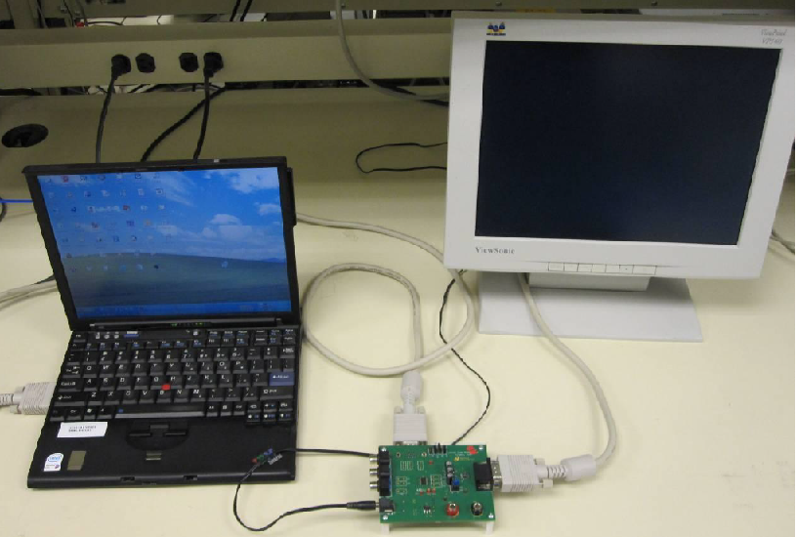
  - Connect the monitor directly to the PC to verify what normal video (alignment / colors) looks like.
  - If the monitor cannot display the video through the LMH1251, then try connecting the Monitor directly to the PC RGB video out. Try reducing the resolution of the PC video out to something the monitor can handle.

- Equipment Shutdown
  - Turn Power Supply OFF and Turn ELOAD output OFF
- Disposition
  - Conforming Material
  - Units that have passed this test procedure shall be packaged into anti-static ESD approved bags, labeled per table below and shipped per the P.O.
Label 1  Assembly Number + Dash Number if Applicable | Label 2  Orderable Number
SV012649-001 | LMH1251EVAL/NOPB

  - Non-conforming Material
    - If yield loss is 2% or less, scrap non-conforming units and adjust P.O. to reflect total amount shipped. If yield loss approaches or exceeds 5%, contact EVM coordinator for assistance

