SafetyDSP 3.1.3 EtherCAT to Expansion 1.1.1

Without expansion :
1
Port
T2
MUX
Trancei
U14
DSP1
Main
Trancei
U12
Port
T1
2

3

1
2
3
P1_TD_N
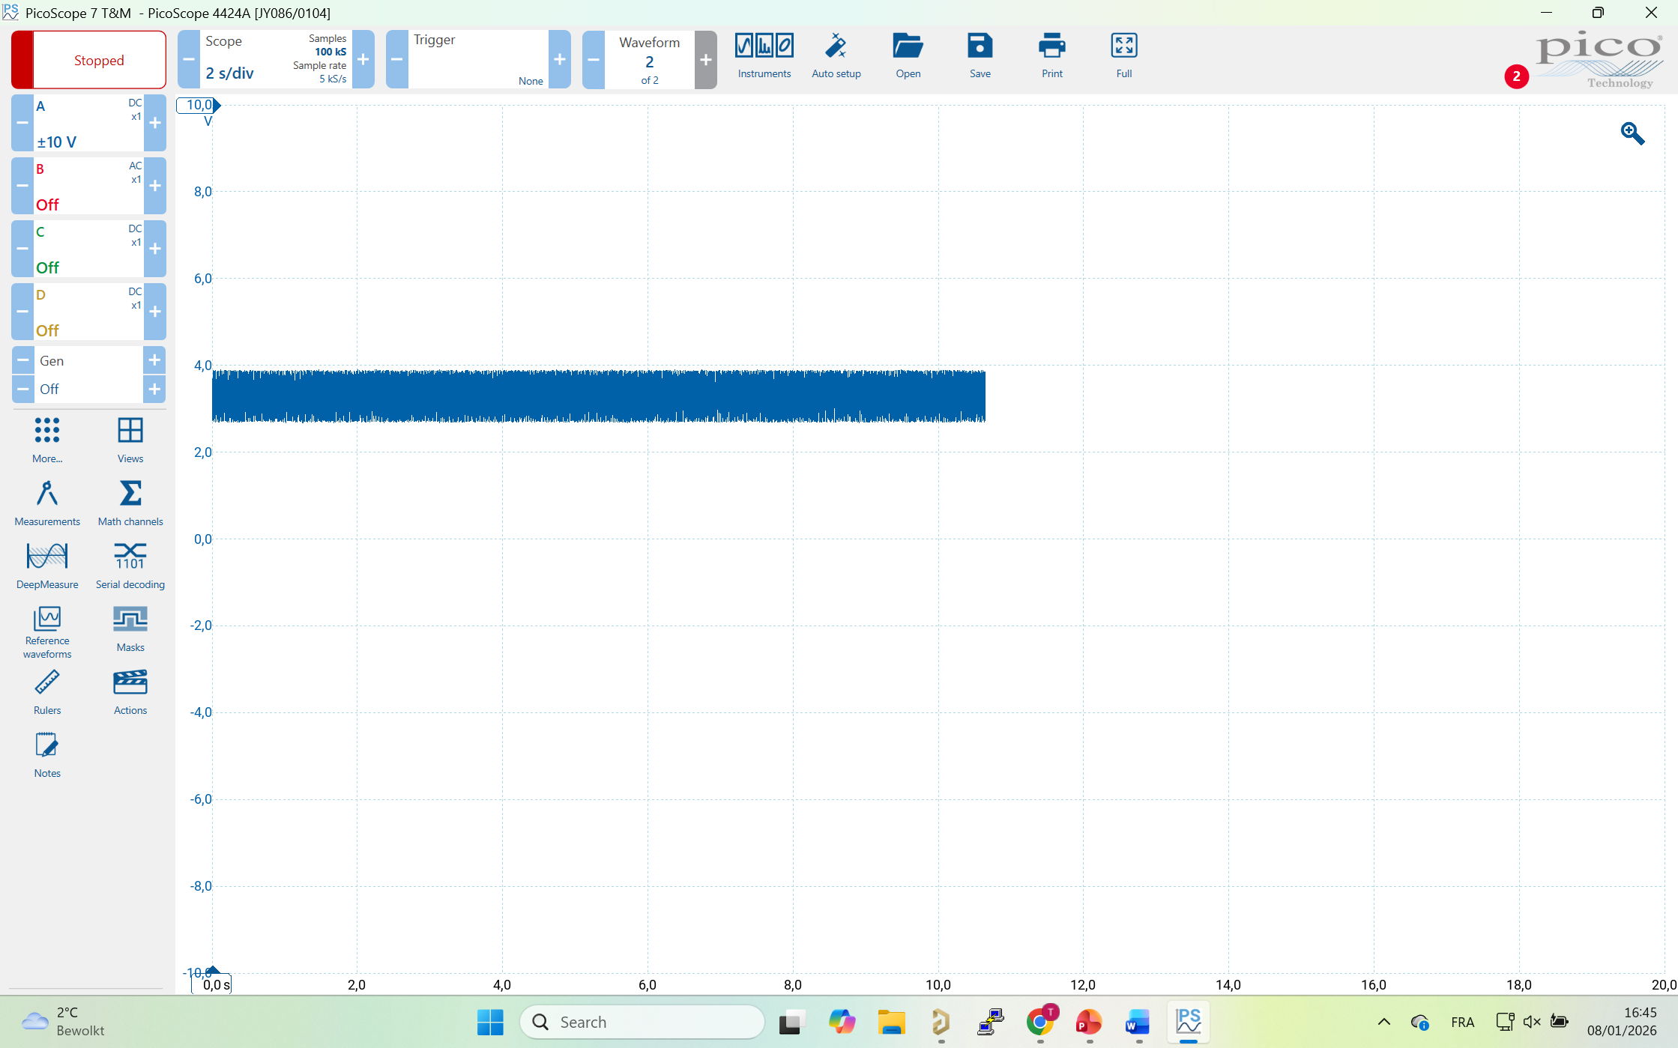
P1_RD_N
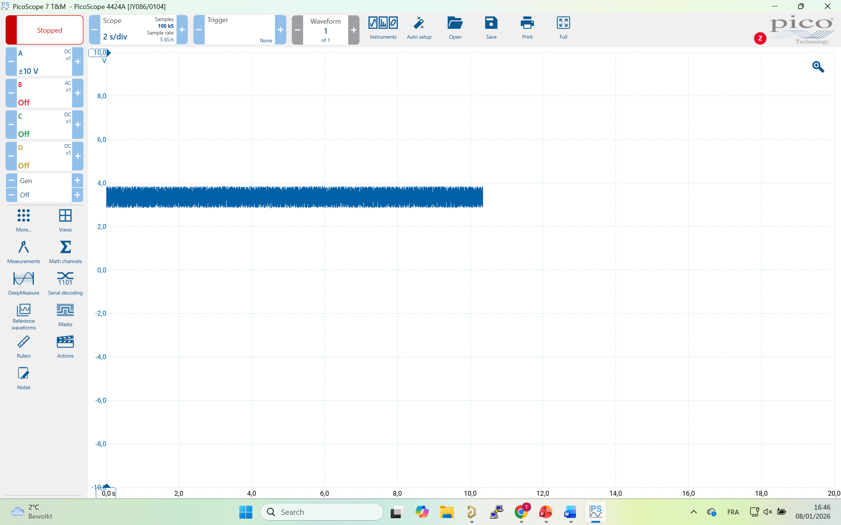

SafetyDSP 3.1.3 EtherCAT to Expansion 1.1.1

With expansion :
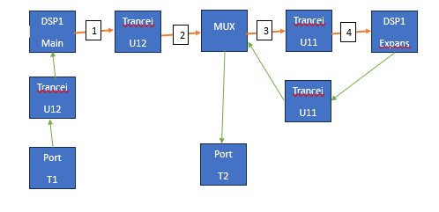
U14
U18
1
2
3A

EX1_TD_N (goes to RX of Transceiver)
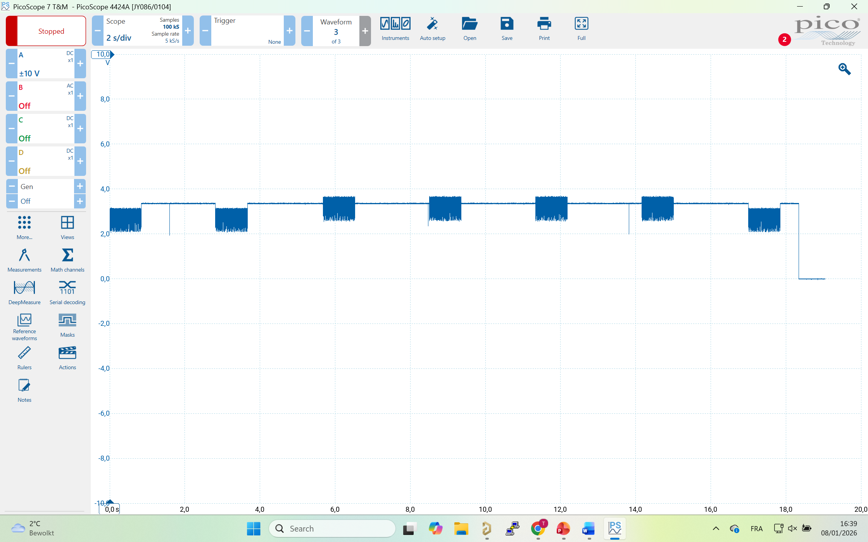
EX1_RD_N (goes to TX of Transceiver)
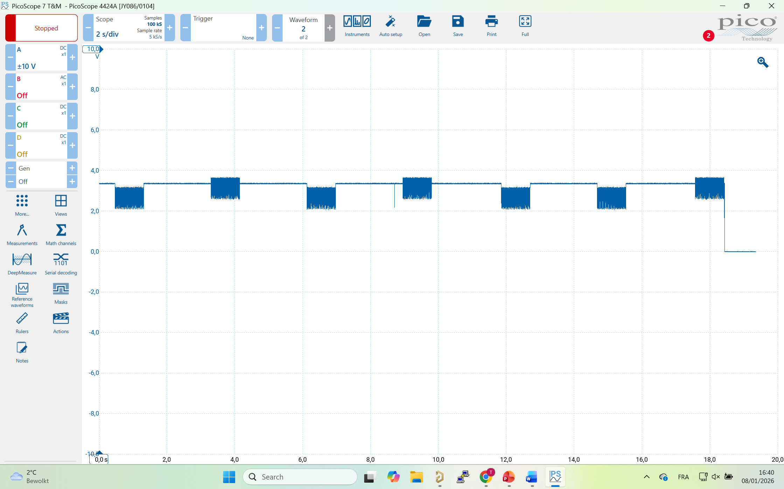
3B
EX1_TD_N (goes to RX of Transceiver)
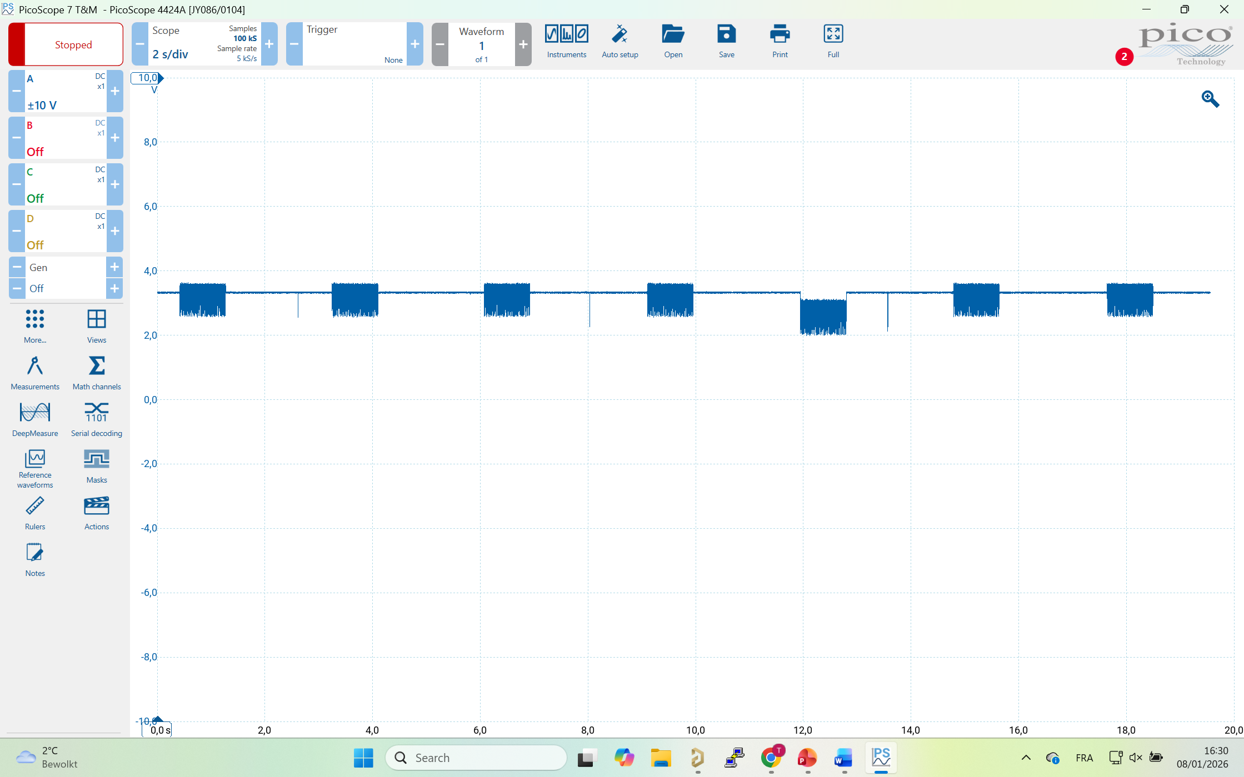
EX1_RD_N (goes to TX of Transceiver)
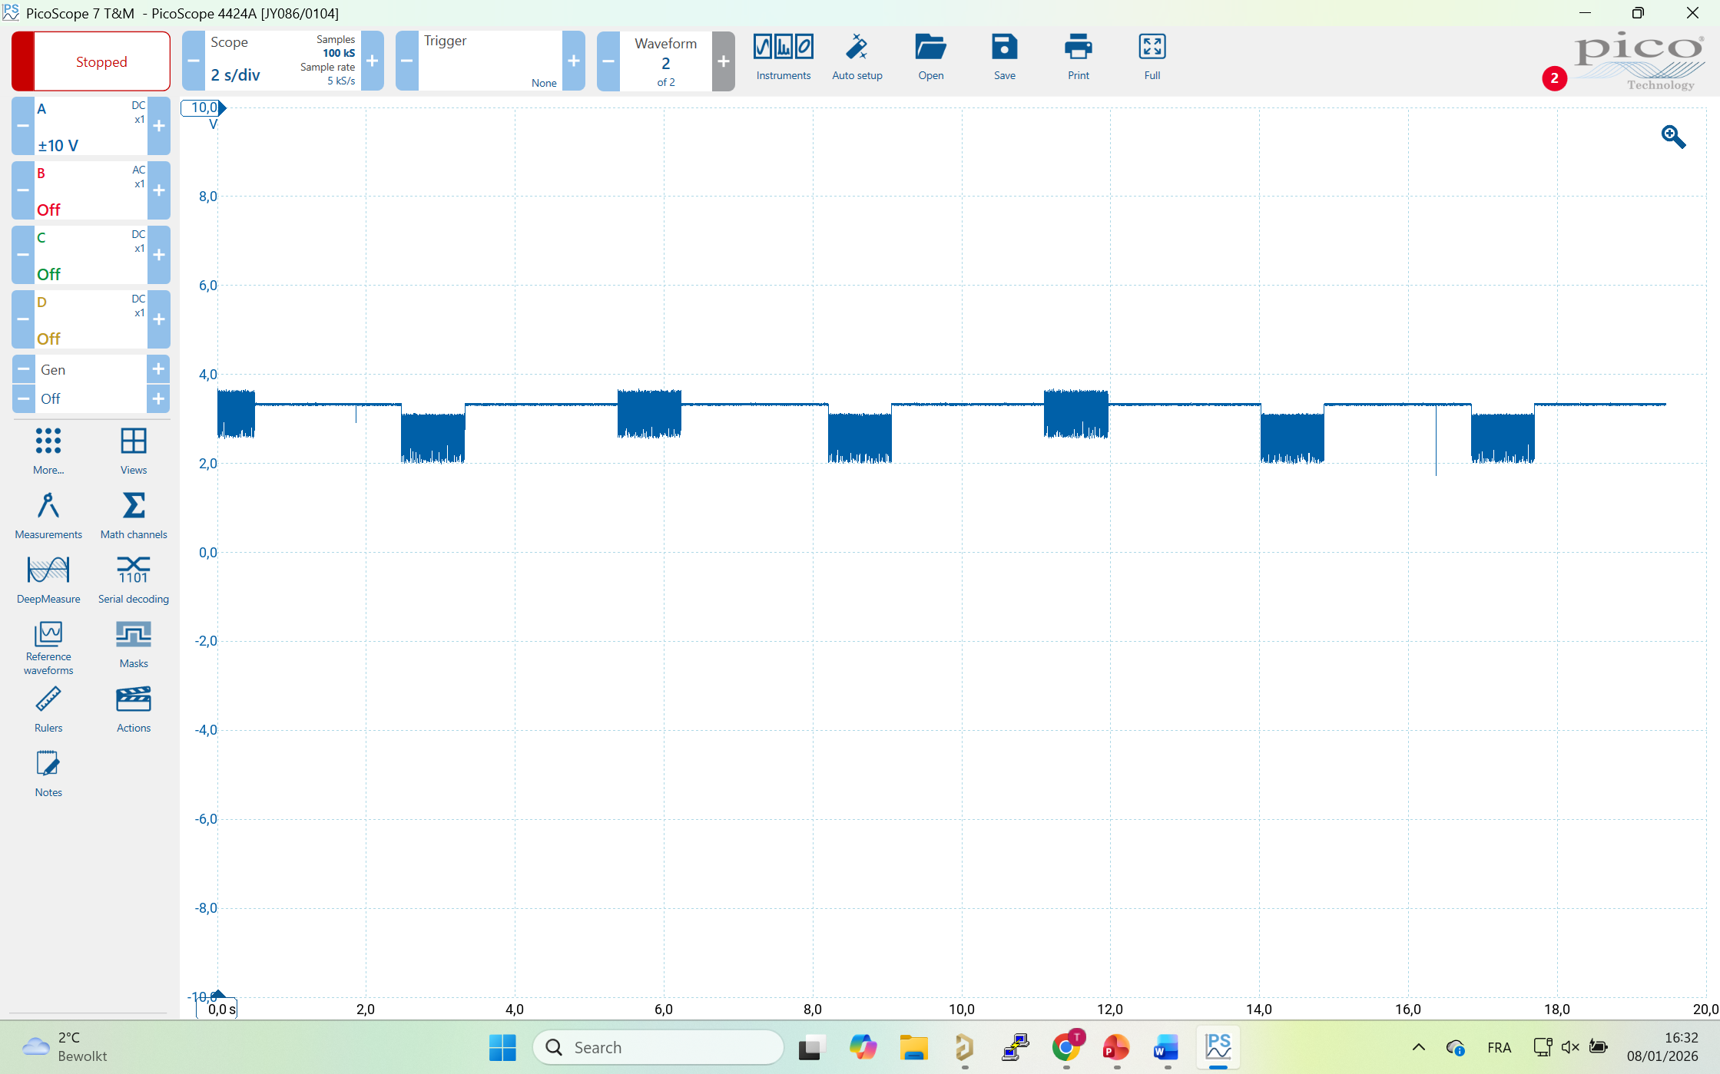

4

