Step 1

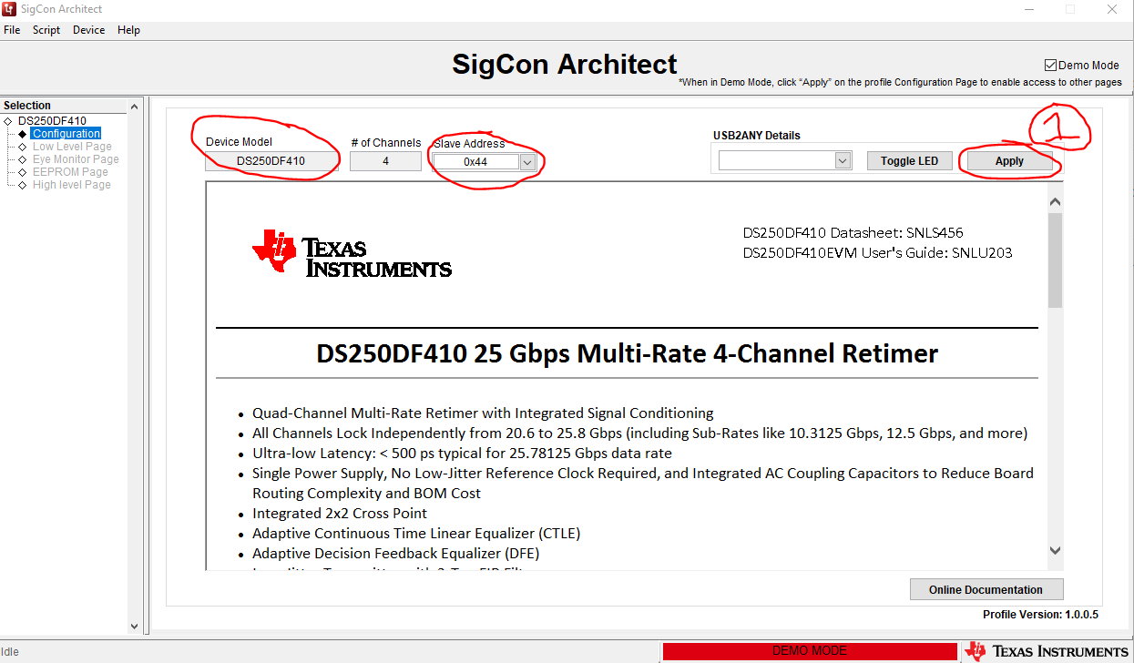

Step2

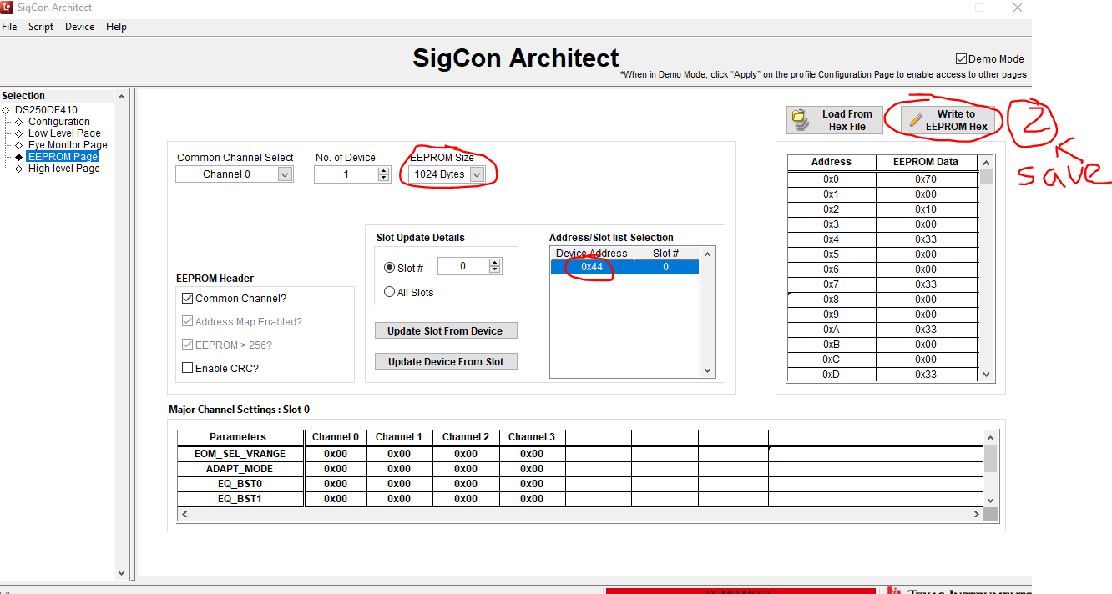

After I load the hex I saved, the size has been saved, but slot is 0x30 again.

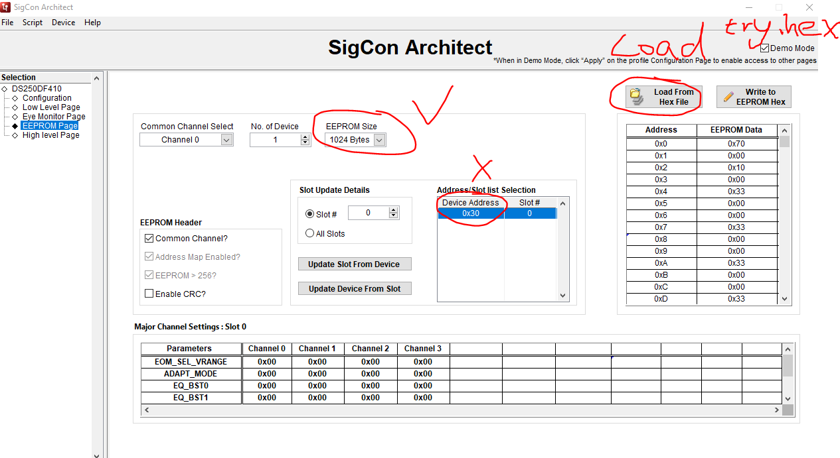

Can you please help check try.hex, is there anything I need to modify?

Thanks.