1.Pin oxidation was found

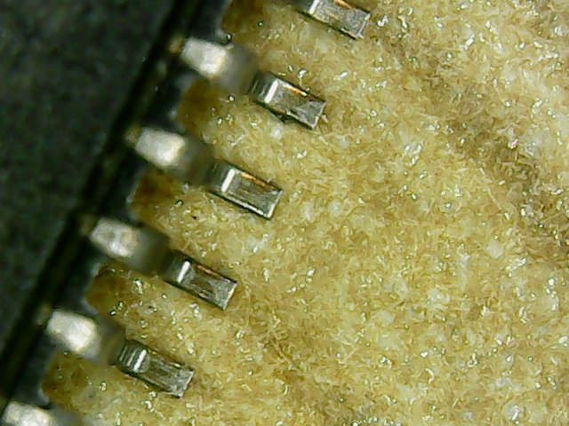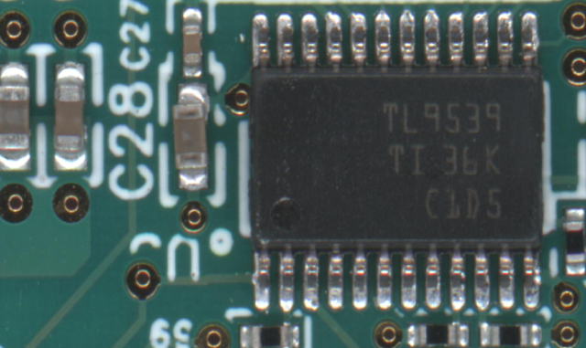

① Soldering effect: Only the bottom of the pins is tinned, and the tin cannot cover the pins, which will not form a soldering slope and the effect is not good.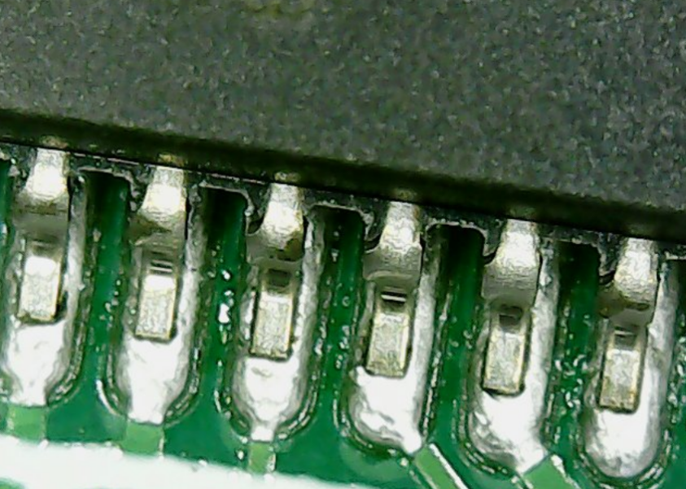

1. The soldering status of other chips on the board: The soldering on the pins is fine, and the toe filling is okay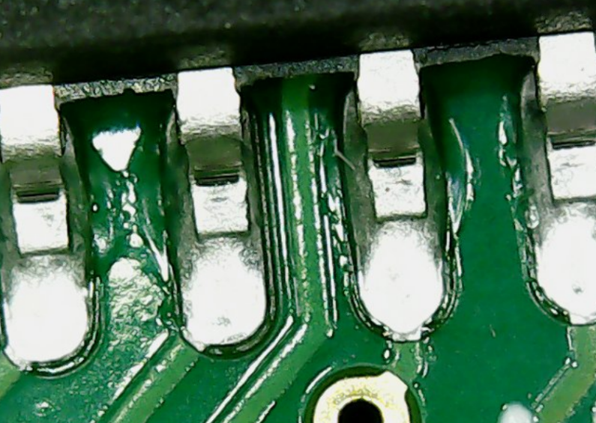
2. Furnace temperature curve graph
3. 