I’m setting up two TCAN4550 modules to send messages back and forth but I’m having a problem with the Transmit operation. I was expecting to see a single transmission. After the transmission, I was expecting to see the CAN Lines go Idle. What I’m seeing is an abbreviated message being transmitted every 91.6us (As shown in the picture below).

The only way I have been able to stop the transmissions is either Power cycling the transmitting device or by canceling the transmission by writing to the TX Buffer Cancellation Request.

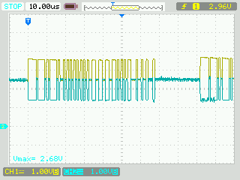

The message I’m trying to send is a 32 Byte message out of the Transmit Buffer. I’m using the STD 11 bit ID (Not the Extended). The Bit timing of the message looks to be correct at 1.11MHz.

Here is a picture of my Physical HW setup.

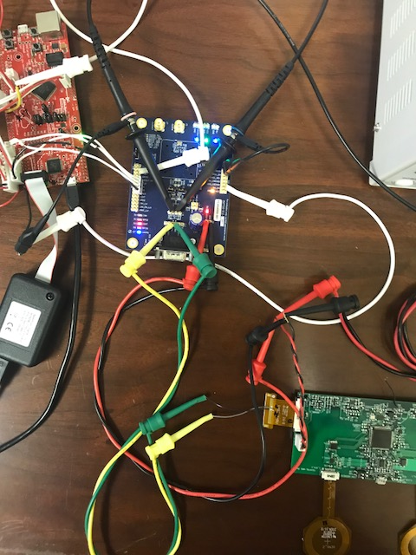

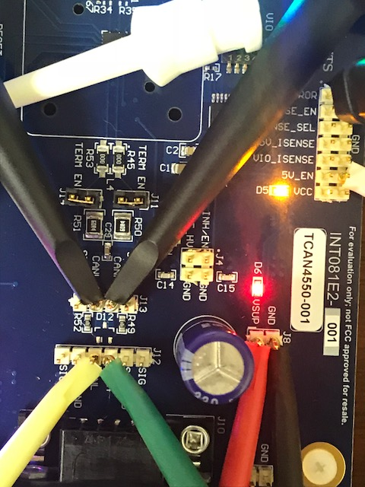

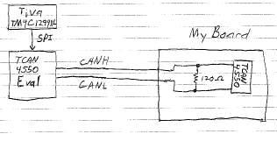

CODE USED TO SETUP THE TCAN4550

//-- RESET the chip

CAN_RESET();

//--Test the CAN Transceiver

CAN_Trans_Commands(CAN_PORT, CAN_DEVICE_ID);

/*-- Run a test to ensure

* device compatibility and communication

*/

**if**(!dwError)

{

//-- Setup the Transceiver for Initialization --

CAN_Write(dwCommPort,&TCAN4550_W_CCCR_INIT_ENABLE[0]); // 0x1018

//Control Register Write to being

//the initialization process and make registers

//write accessible.

CAN_Write(dwCommPort,&TCAN4550_W_STANBY_NOTCONFIG[0]); // 0x0800

//Standby Mode, Pin Config

//& MCAN_CONFIG = 0

//-- Setup the Interrupts --

CAN_Write(dwCommPort,&TCAN4550_W_nINT_CLEAR[0]); // 0x0820

//Clear Interrupt/Diagnostic Flags

CAN_Write(dwCommPort,&TCAN4550_W_nINT_INTERRUPT_ENABLE[0]); // 0x0830

//Enable interrupts for nINT

CAN_Write(dwCommPort,&TCAN4550_W_INTERRUPT_REGISTER_SETTINGS[0]); // 0x1054

//Program the Interrupt Register

CAN_Write(dwCommPort,&TCAN4550_W_ILS_AND_ILE[0]); // 0x1058 & 0x105C

//Assign Interrupts to M_CAN_INT1

//Enable EINT0 & EINT1

//-- Setup the BIT Timing --

CAN_Write(dwCommPort,&TCAN4550_W_NOMINALBIT_TIMING_REG[0]); //0x101C

// 40MHz/4, Bit Sample settings

// Bit Time = 1.111MHz

//-- Setup the TXBuffer & FIFOs --

CAN_Write(dwCommPort,&TCAN4550_W_TXBUFFER_CONFIG[0]); // 0x10C0

// 5 Transmit Buffers

CAN_Write(dwCommPort,&TCAN4550_W_TXEVENTFIFO_CONFIG[0]); // 0x10F0

// 3 Transmit FIFOs

CAN_Write(dwCommPort,&TCAN4550_W_TXELEMENTSIZE_CONFIG[0]); // 0x10F0

//-- Setup the RX Buffers and FIFOS

CAN_Write(dwCommPort,&TCAN4550_W_RXFIFO0_CONFIG[0]); // 0x10A0

// 4 RX FIFO 0 Buffers

CAN_Write(dwCommPort,&TCAN4550_W_RXFIFO1_CONFIG[0]); // 0x10B0

// 4 RX FIFO 1 Buffers

CAN_Write(dwCommPort,&TCAN4550_W_RXELEMENTSIZE_CONFIG[0]); // 0x10BC

// RX FIFO & BUFFER Elements

//-- Setup the SID Filters --

CAN_Write(dwCommPort,&TCAN4550_W_SID_FILTER[0]); // 0x1084

// SID FILTERS

CAN_Write(dwCommPort,&SID_FILTER_IDS[0]); // 0x8000

// SID IDS

//-- Put the Chip into Normal Mode

CAN_Write(dwCommPort,&TCAN4550_W_CCCR_NORMALMODE[0]); // 0x1018

// Control Register

// Clear the CCE and INT bits

CAN_Write(dwCommPort,&TCAN4550_W_NORMAL[0]); // 0x0800

// Mode of Operation - Normal

}

}

CODE USED TO TRANSMIT A DUMMY MESSAGE.

//-- Read the Transmit FIFO Status Register

dwError = CAN_Read(dwCommPort,&TCAN4550_R_DEVICEID[0]);

dwTXBuffMemory = 0x00;

dwError = CAN_Read(dwCommPort,&TCAN4550_R_TXFIFO_STATUS[0]);

//-- Determine if a Transmit Buffer is Available

dwNumAvailTXBuffers = CAN_RX_Buffer[3] & 0x1F;

**if**(dwNumAvailTXBuffers == 0)

{

dwError = 0x01; //No Buffer Available

}

**if**(!dwError)

{

//Get the Buffer Index

dwTXBufferIndex = CAN_RX_Buffer[2] & 0x1F;

dwTXBuffMemory = CAN_TXBUFFERS[dwTXBufferIndex];

//Format the CAN_TX_Buffer for new message

CAN_TX_Buffer[1] = CAN_WRITE_COMMAND | (dwTXBuffMemory << 8) | CAN_TXBUFF_MSG_CNT;

CAN_TX_Buffer[0] = 0x00000001; //One unique Address

//Format Header#1

CAN_TX_Buffer[2] = 0x00140000;

//Format Header#2

CAN_TX_Buffer[3] = 0x01850000;

//Move Message into the Local Transmit Buffer

CAN_TX_Buffer[4] = 0xCCCCAAAA;

CAN_TX_Buffer[5] = 0xCCCCAAAA;

CAN_TX_Buffer[6] = 0xCCCCAAAA;

CAN_TX_Buffer[7] = 0xCCCCAAAA;

CAN_TX_Buffer[8] = 0xCCCCAAAA;

CAN_TX_Buffer[9] = 0xCCCCAAAA;

CAN_TX_Buffer[10] = 0xCCCCAAAA;

CAN_TX_Buffer[11] = 0xCCCCAAAA;

//Move Local Transmit Buffer into the TCAN4550 Transmit Buffer

dwError = CAN_Write(dwCommPort,&CAN_TX_Buffer[0]);

dwError = CAN_Read(dwCommPort,&TCAN_R_TXBUFFER0[0]);

//-- Request that the Loaded TXBuffer Transmit the data

CAN_TX_Buffer[2] = (dwTXFromBuffer << dwTXBufferIndex);

CAN_TX_Buffer[0] = 0x00000001;

CAN_TX_Buffer[1] = CAN_WRITE_COMMAND | TCAN_TXBAR_REG;

dwError = CAN_Write(dwCommPort,&CAN_TX_Buffer[0]);

//Determine if the Transmission is complete.

dwError = 1;

for(i=0;i<3;i++)

{

CAN_delay(0x00000FF);

dwError = CAN_Read(dwCommPort,&TCAN4550_R_TXBUFF_PENDING[0]);

dwTXBufferIndex = CAN_RX_Buffer[3] & 0x1F;

if(!dwTXBufferIndex)

{

i = 3;

dwError = NO_ERROR;

}

}

//Cancel if not complete.

**if**(dwError)

{

dwError = CAN_Write(dwCommPort,&TCAN4550_W_TXBUFFER_CANCEL[0]);

}

}

}