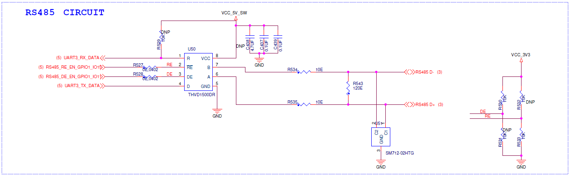

Above given is Schematics snapshot of the RS485 transceiver.
RS485_RE_EN_GPIO1_IO15, RS485_DE_EN_GPIO1_IO11 are of 3.3V voltage level.
Processor |  |  | THVD1500
NVCC_UART |  | 3.3V | VCC |  |  | 5V
VIO | Min (V) | Max (V) | VIO | Min (V) | Typ (V) | Max (V)
VOH | 3.15 | - | VIH | 2 | - | 5
VOL | - | 0.15 | VIL | 0 | - | 0.8
VIH | 2.31 | 3.3 | VOH | 4 | 4.7 | -
VIL | 0 | 0.99 | VOL | - | 0.2 | 0.4

VOH, VOL, VIH,VIL comparison table

