Hello

Thank you for your quick and complete answer. These elements confirm us in the use of the THVD8000.

For information, the length of the bus (24V DC power supply and data) is a maximum of 80 meters, 64 modules can be connected to it at most.

Regarding the topology of the communication bus with the THVD8000, can we have these types of network architectures? What do you think about it?

Network architecture #1 :

Power 24VDC

GND

+24V DC

THVD8000

Slave #6

THVD8000

Slave #5

THVD8000

Slave #4

THVD8000

Slave #11

THVD8000

Slave #10

THVD8000

Slave #9

THVD8000

Slave #8

THVD8000

Master

THVD8000

Slave #1

THVD8000

Slave #2

THVD8000

Slave #7

THVD8000

Slave #3

Network architecture #2 :

THVD8000

Master

THVD8000

Slave #1

THVD8000

Slave #2

Power 24VDC

THVD8000

Slave #3

THVD8000

Slave #4

THVD8000

Slave #5

THVD8000

Slave #6

THVD8000

Slave #7

THVD8000

Slave #8

THVD8000

Slave #9

THVD8000

Slave #10

THVD8000

Slave #11

+24V DC

GND

In our electrical cabinets, the GND of the power supply is connected to the ground, is this ok for you or do you identify a risk?

Can we not use shielded cables?

We often use this type of bar to distribute power, it is a copper bar. You can connect cables with terminals. Here's a photo

SLAVE 2 connection

(Power + datas)

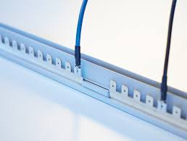

SLAVE 1 connection

(Power + datas)

copper bar