- Change PHY to Reverse Loopback
Driver config：
err = phy_write(phydev, 0x16,0x0150);
Bit[5:2] Loopback Select: 0100 = Reverse Loopback
Bit[6] 1 = Transmit data to the MDI in xMII Loopback
Wireshark info:
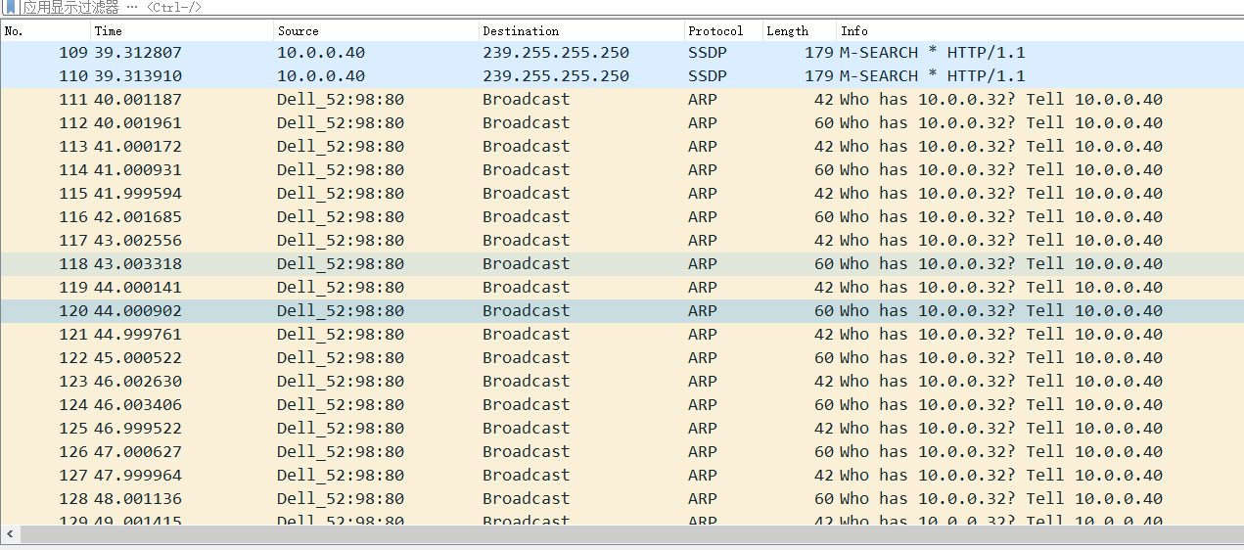
RXDV: OK
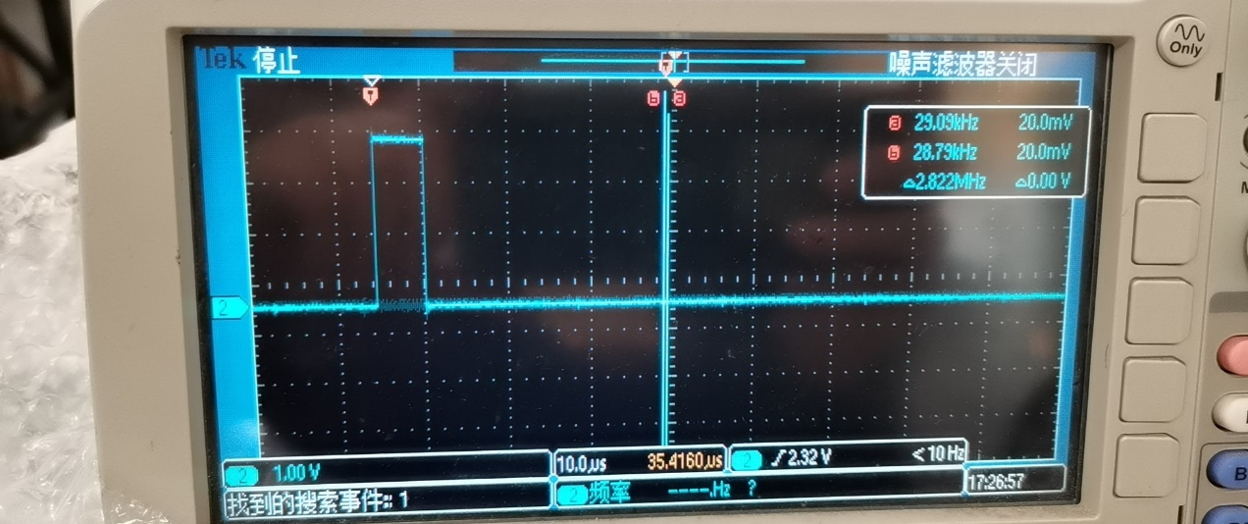
RCLK:25MHz OK
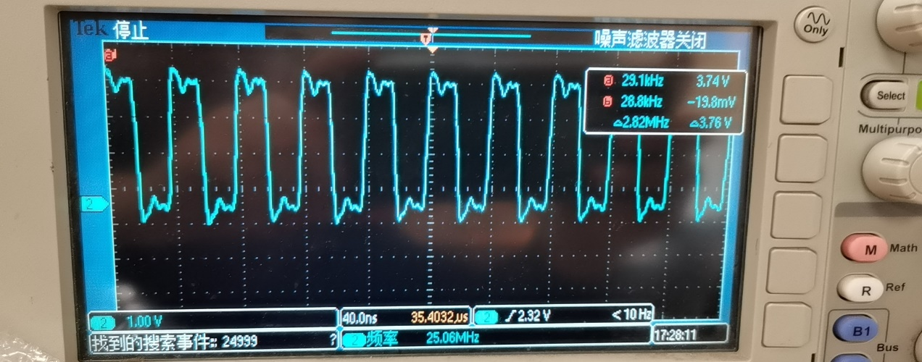
RX_D0:
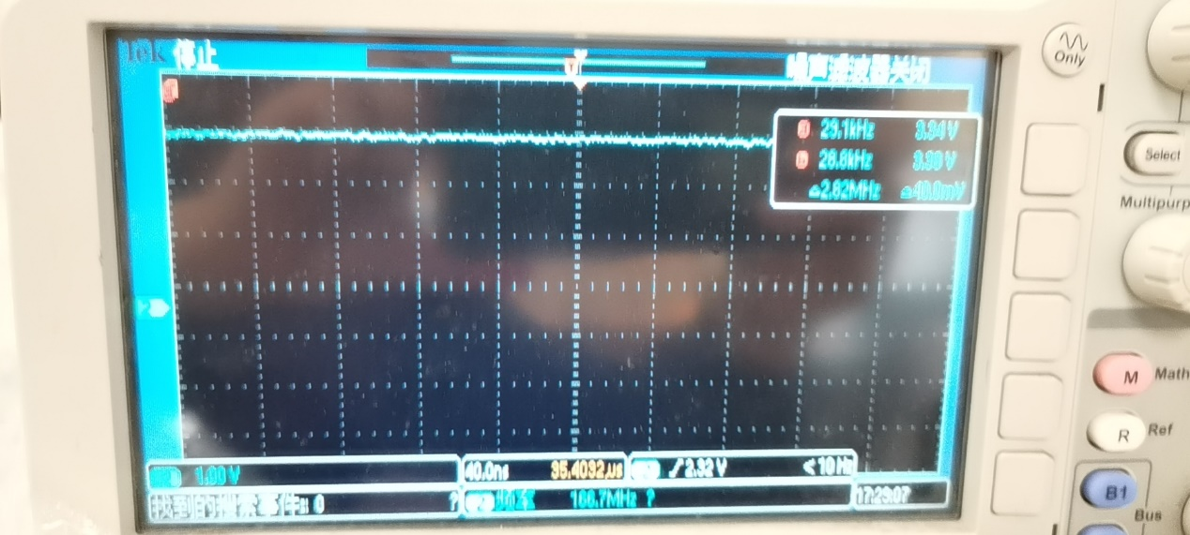
RX_D1:
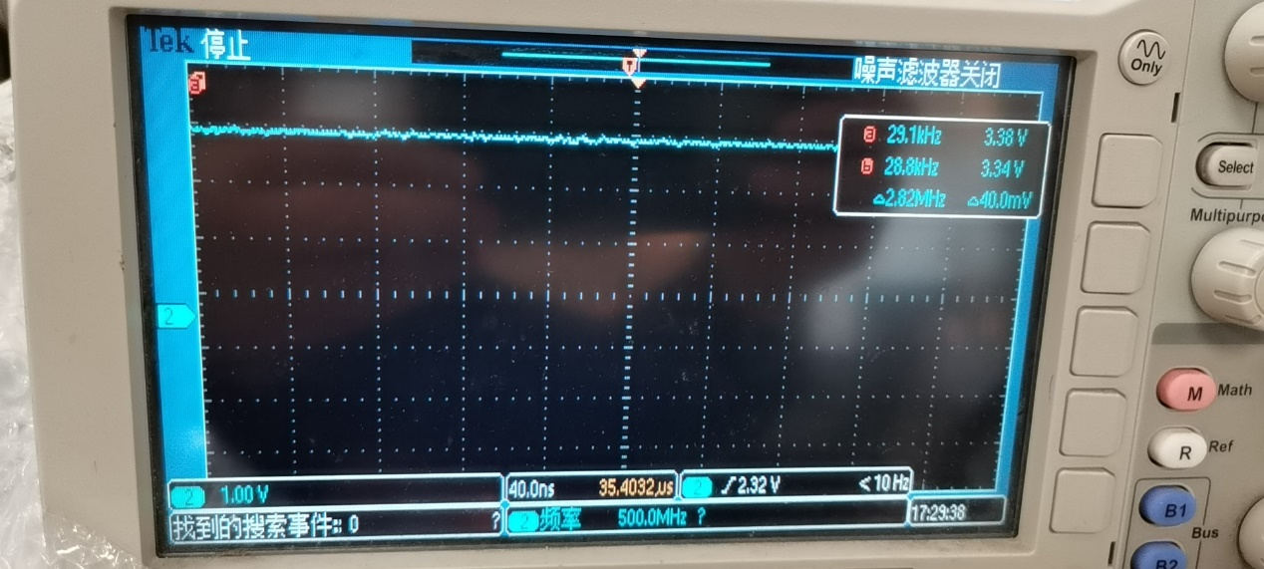
RX_D2:
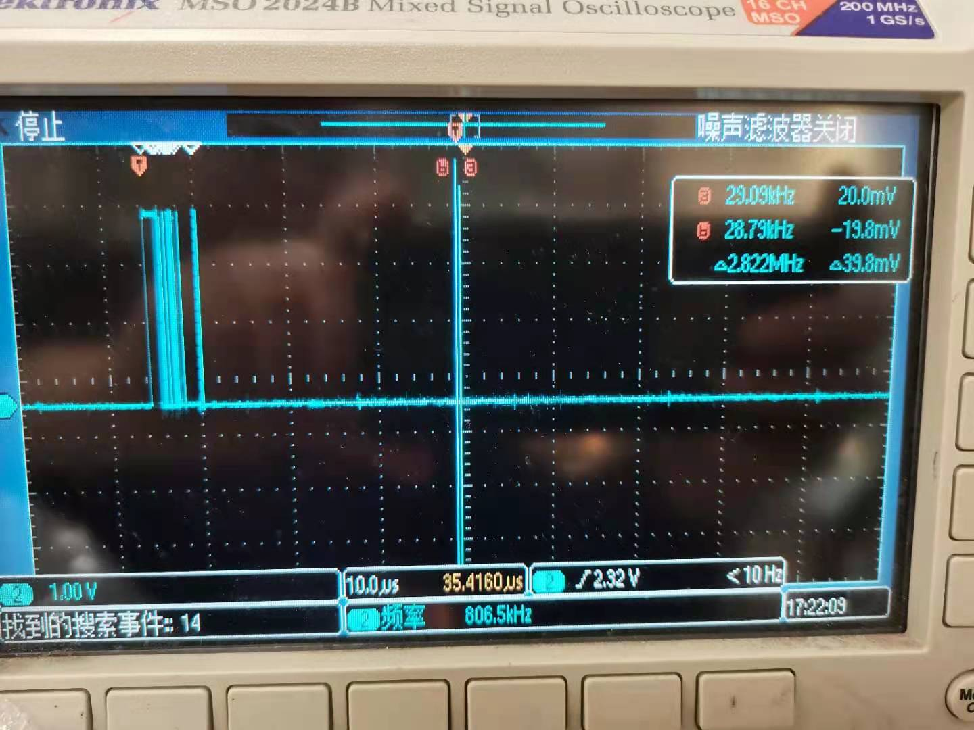
RX_D3:
