\*\*\*\*\*\*\*\*\*\*\*\*\*\*\*\*\*\*\* Questions asked during initial submission of PCB files. . .

1. As seen from the attached screen shot, I did NOT put any plane underneath ANY of the ethernet traces.  As they are not referenced to anything electrically, I could not figure out what "plane" to put underneath them.  I did route the differential pairs with 100 ohm impedance.  Can you verify this is correct?  If not, can you please let me know what I should do here.

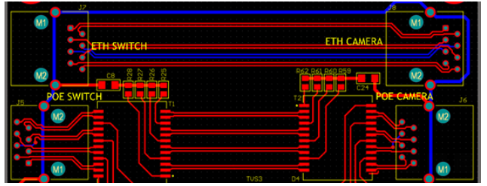

1. For the Ethernet Passthrough connectors, I just have two connectors tied together.  There are no magnetics and I routed the connections as differential pairs (again, with no reference plane).  If this is NOT correct, can you please let me know the correct way to do this.  . .

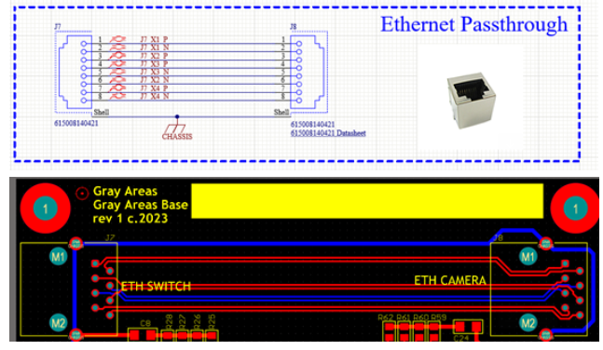

1. For the magnetics for the PoE portion, to make the routing work, I "reversed" one of the transformers so that the "+" of one transformer is feeding the "-" of the next transformer.  All of the signals (ie "P1+/P1-) remain the same throughout the signal path.  I saw a couple of things that showed this was OK.  I would like to verify that with you as well.  
   