MAX9277 -> MAX9276 (toRGB888) -> DS90UB925Q -> DS90UB926Q ( RGB888 output ),

Display fail

MAX9277 -> MAX9276 ->MAX9275-> MAX9276 Display pass

Normal display Fail Display ( Picture have left shift) by TI 925 and 926

 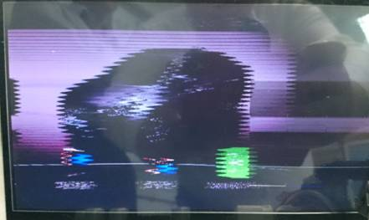

TI DS90UB925Q and DS90UB926Q VS and G7 pin

Ch2 Ch4 is input signal (MAX9276 (RGB888) to DS90UB925Q) VS and G7

CH1 CH3 is output signal (DS90UB926Q ( RGB888 output)

After TI DS90UB925 and DS90UB926Q just have delay

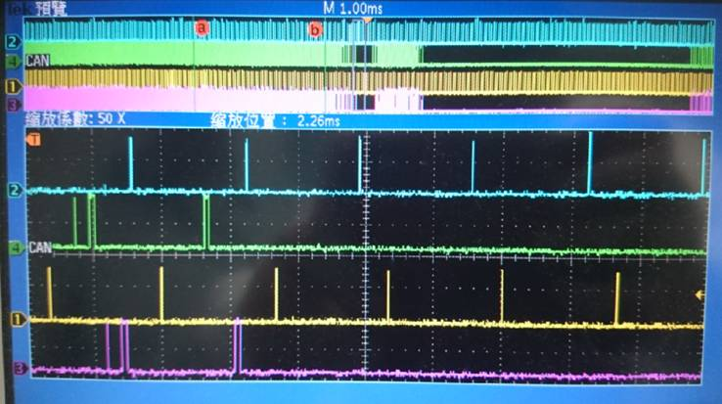

MAX9277 -> MAX9276 ->MAX9275-> MAX9276 display normal   
VS and G7 Only slight delay

