TPS2511 DM/DP signatures while driving Google Nexus 7 Tablet. FF denotes our device that contains the TPS2511.

This was captured by triggering on Vbus (Vcc). The unit was plugged in and then the enable on the [TPS2511](http://www.ti.com/product/TPS2511) was switched on. The TPS2511 had previously been powered up.

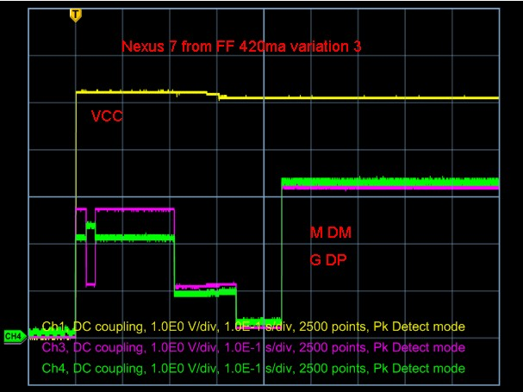

Below is another variation. the response is not identical from trial to trial. The end current was the same but I am not sure who is doing what in the signature.

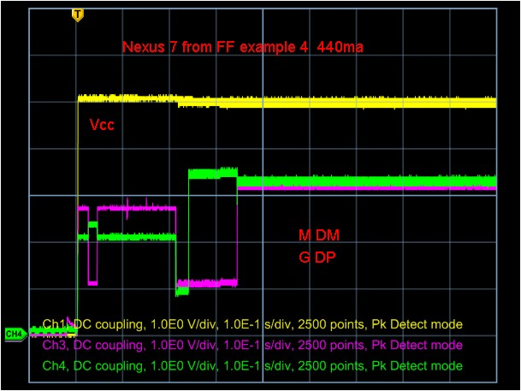

In this run the DM/DP lines were forced to 1.55V. This overrode the TPS2511 drive. As noted the current went up to 800ma.

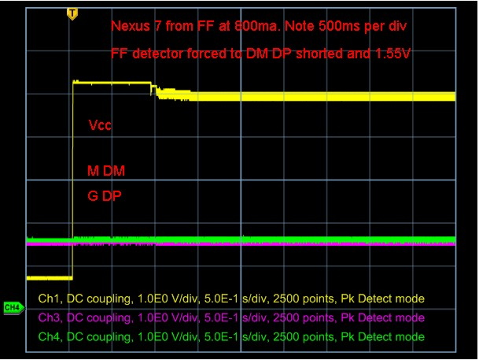

This run is with the Native Nexus 7 charger. The trigger is still on VCC but was initiated by plugging the charger into the AC line.

