Test Setup (TPS2546EVM, MAC Pro 13”, USB type A to USB type C cable

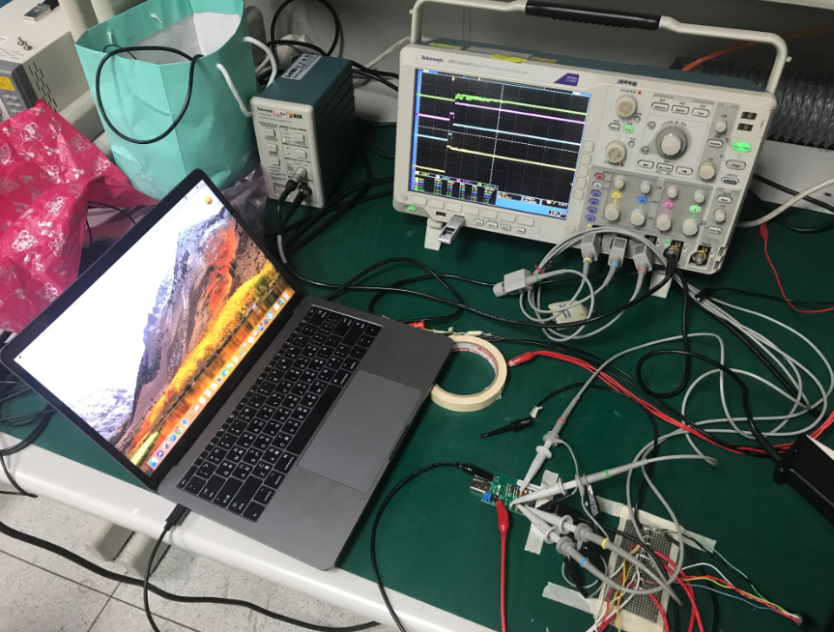

Power Supply

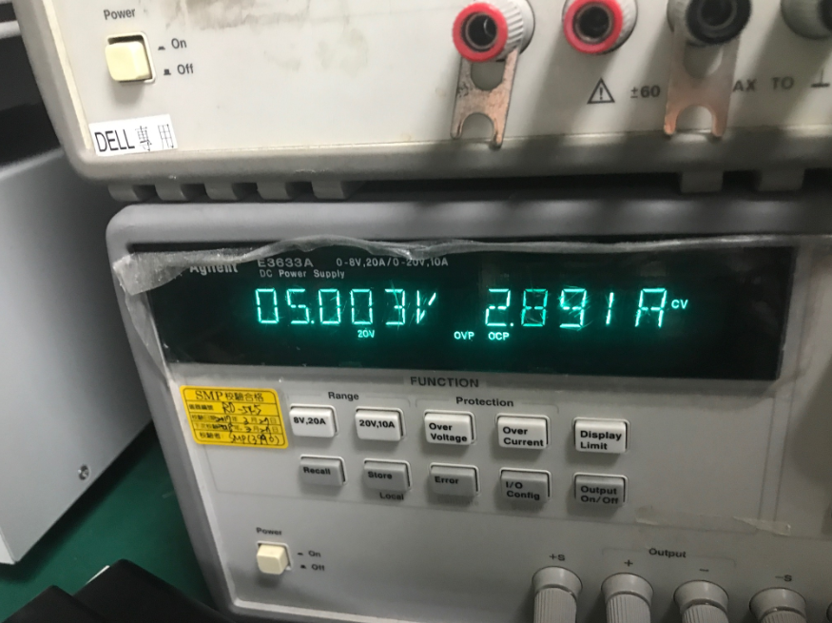

Type A to Type C

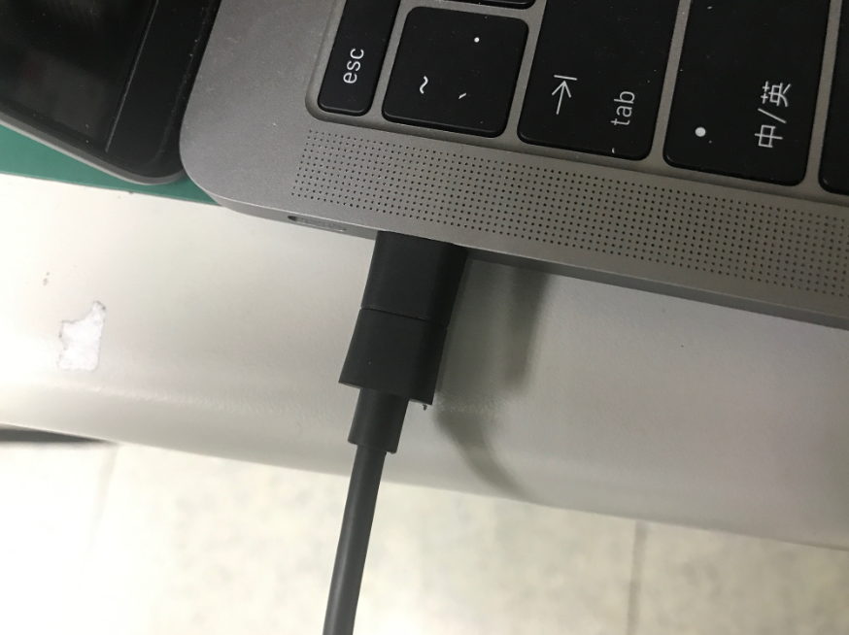

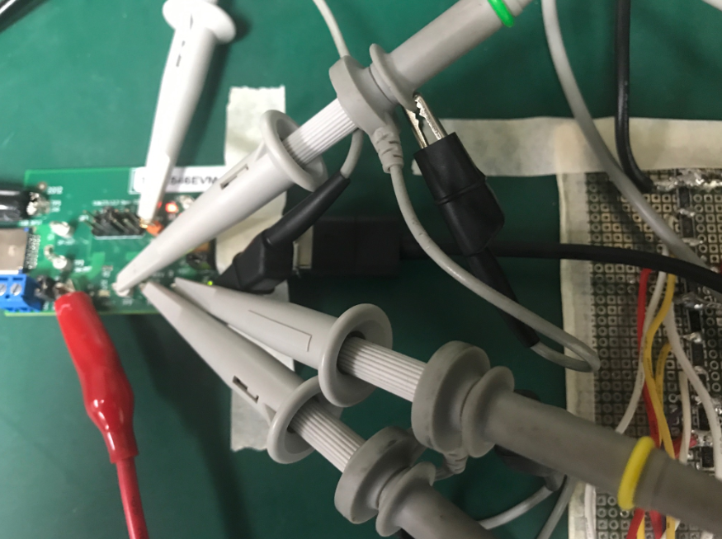

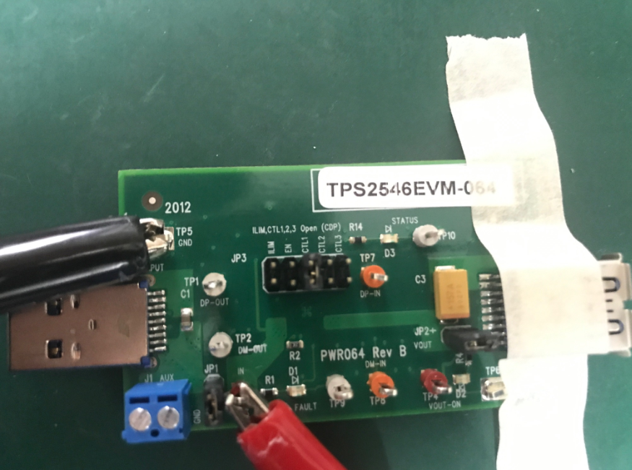

Configuration

DCP Auto mode

CLT1 =0

CLT2 =1

CLT3 =1

ILIM = 1

0026 Power on power supply (Auto mode Load detect)

CH1: VBUS

CH2:D-

CH3:D+

CH4 FAULT

(0026png)

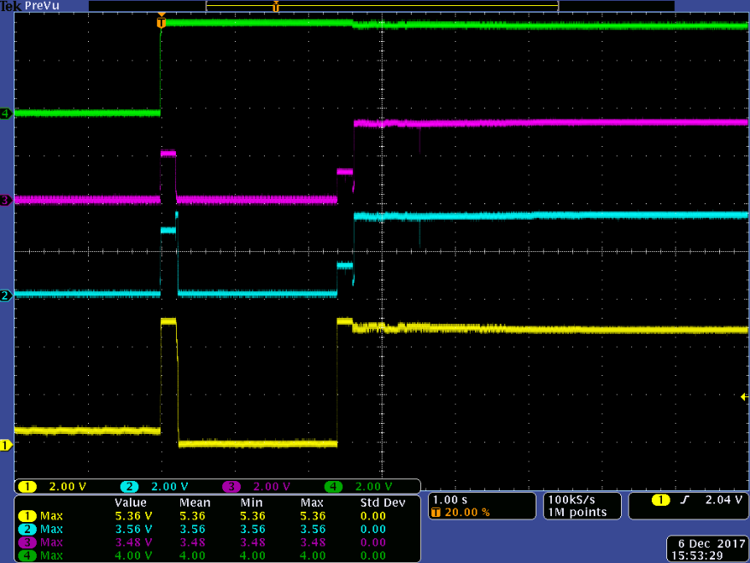

0027 Plug in Macbook

CH1: VBUS

CH2:D-

CH3:D+

CH4 FAULT

(0027 png)

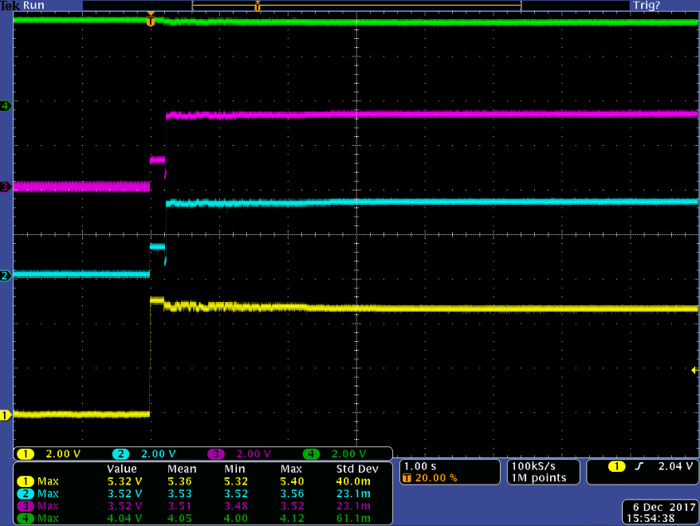

0028 Power on power supply(Auto mode Load detect)

CH1: VBUS

CH2:D-

CH3:D+

CH4 Output Current

(0028png)

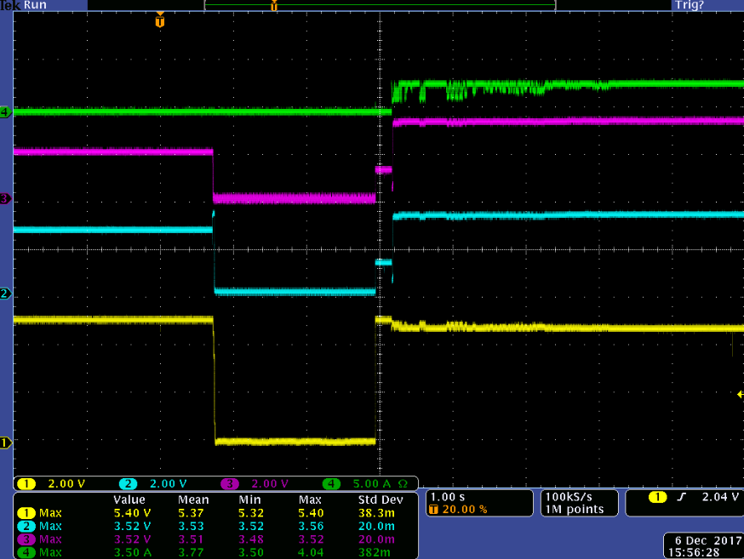

0029 Plug in Macbook

CH1: VBUS

CH2:D-

CH3:D+

CH4 Output Current

(0029png)

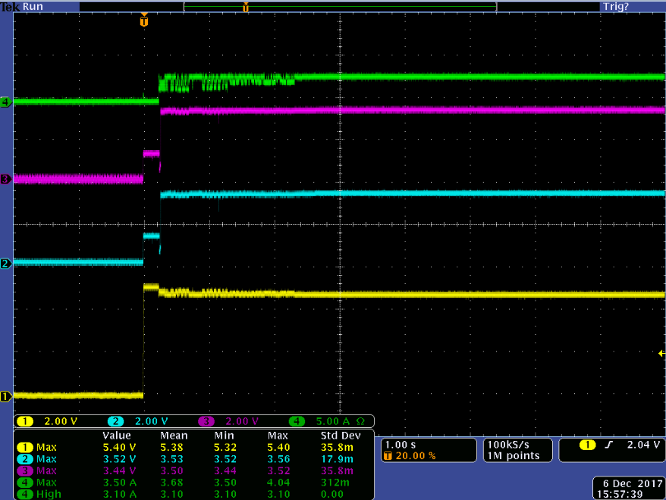

After change mode to DCP divide1 have same issue.

CLT1 =1

CLT2 =0

CLT3 =1

ILIM = 1

The oscilloscope value is a bit off,

Actual measurement on the D+D- using multimeter is around 3.2815V

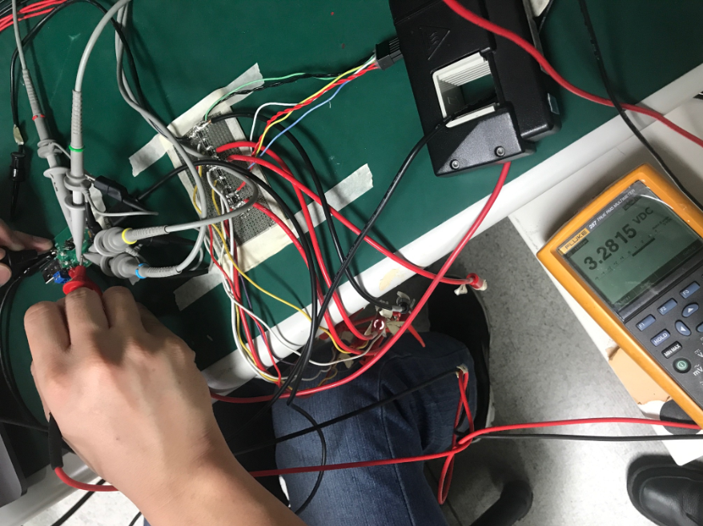

We can see the current drawn from MAC is 2.89A

The TPS2546, on customer board design has current limit at 2.5A, so Mac book drawning 2.89A so customer design will trigger protection

