The application is notebook with Windows operation, they said Windows has some requirement for the output connector.

1. They want to know if TPS25810 has UCM driver or does TPS25810 need UCM driver?

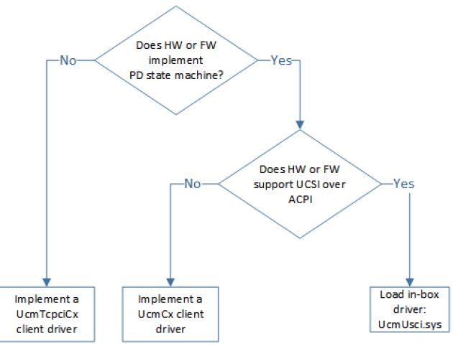

<https://sysdev.microsoft.com/en-US/Hardware/EC/FilterDetail.aspx?id=49099>

               TKS!

