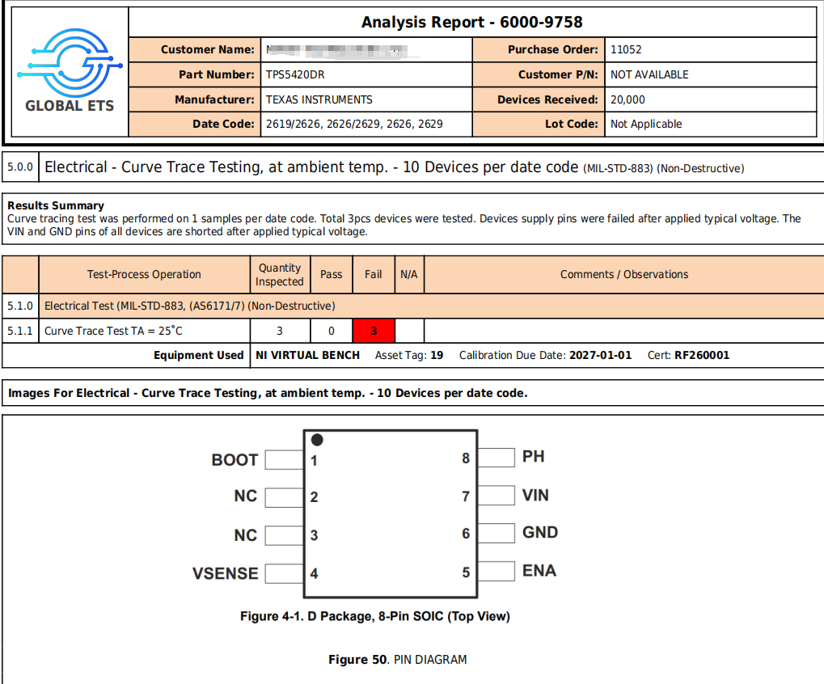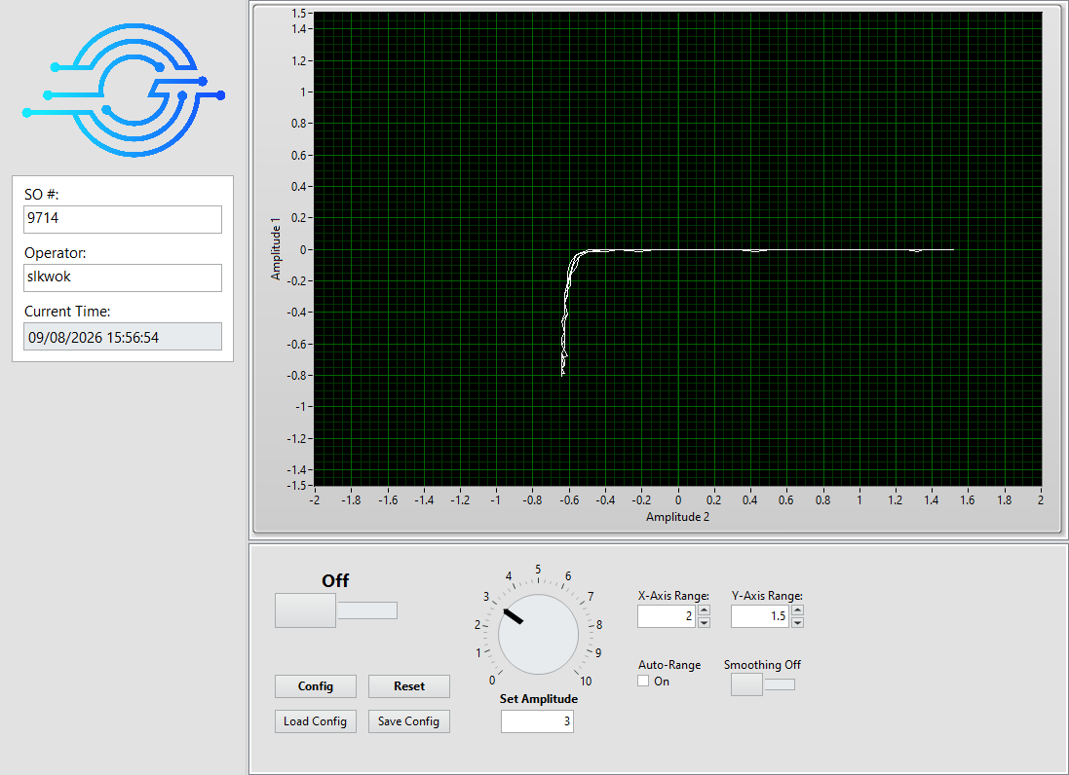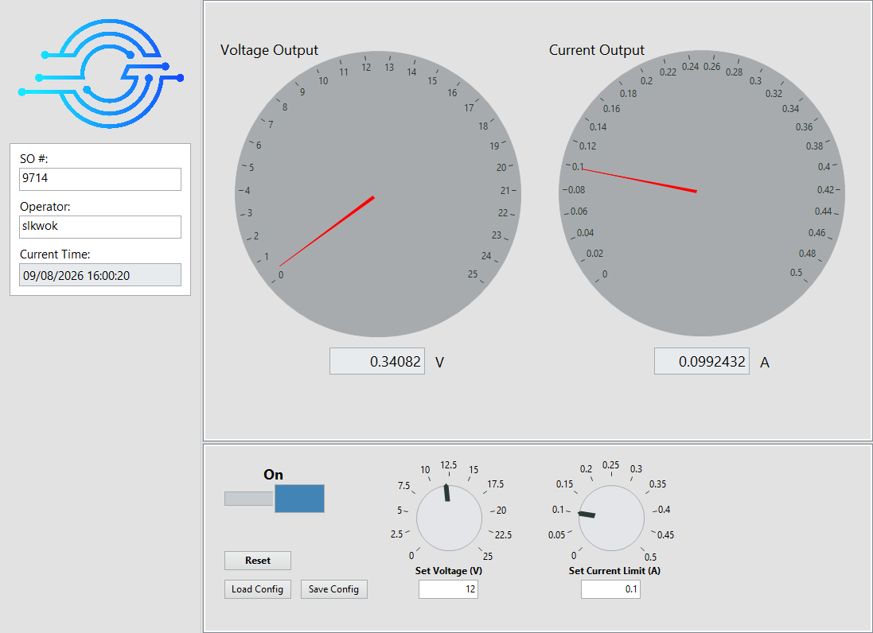
Figure 51. 2619_2626 TRACE VIN Figure 52. 2619_2626 POWER VIN
Date Code: 2619+2626: Date Code: 2619+2626:
Before apply 12V between VIN and GND Apply 12V between VIN and GND
Passed Failed

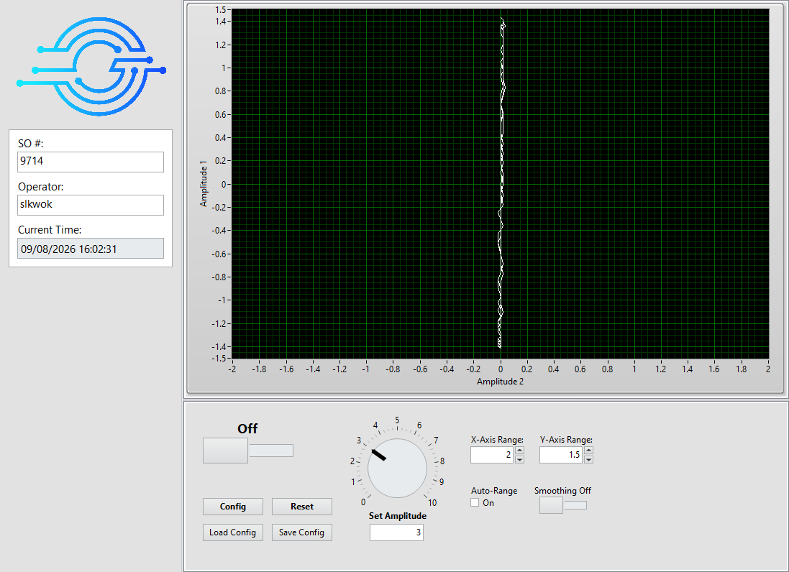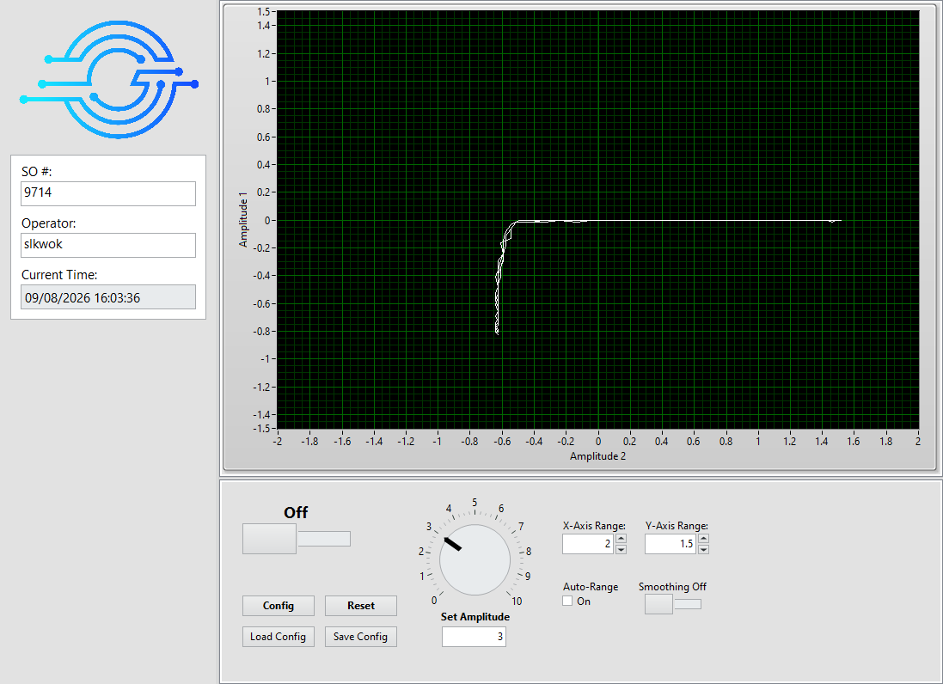
Figure 53. 2619_2626 TRACE VIN BURNT Figure 54. 2626 TRACE VIN
Date Code: 2619+2626: Date Code: 2626:
After applied 12V between VIN and GND Before apply 12V between VIN and GND
Curve Trace result Failed and show shorted. Passed

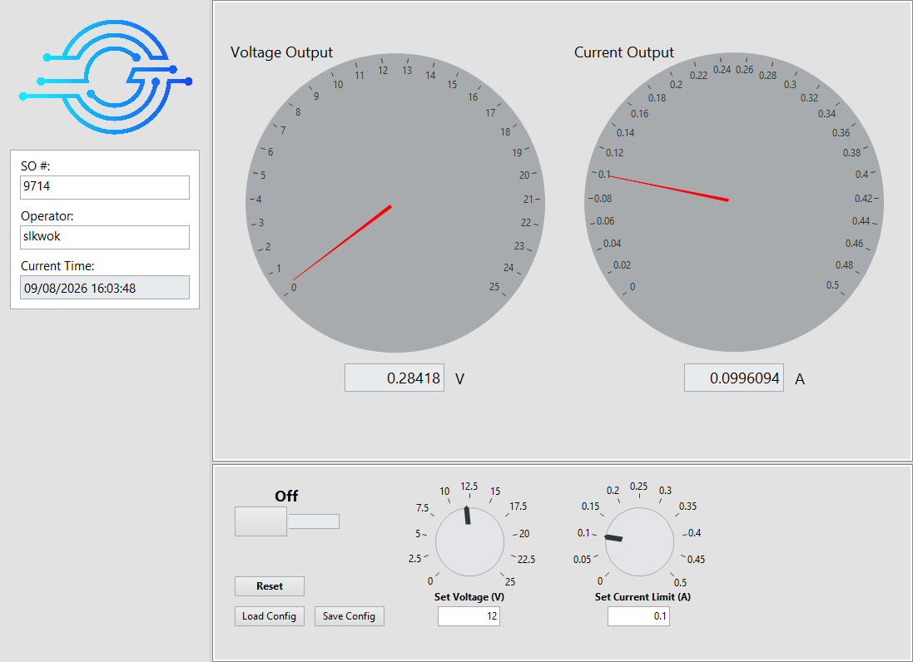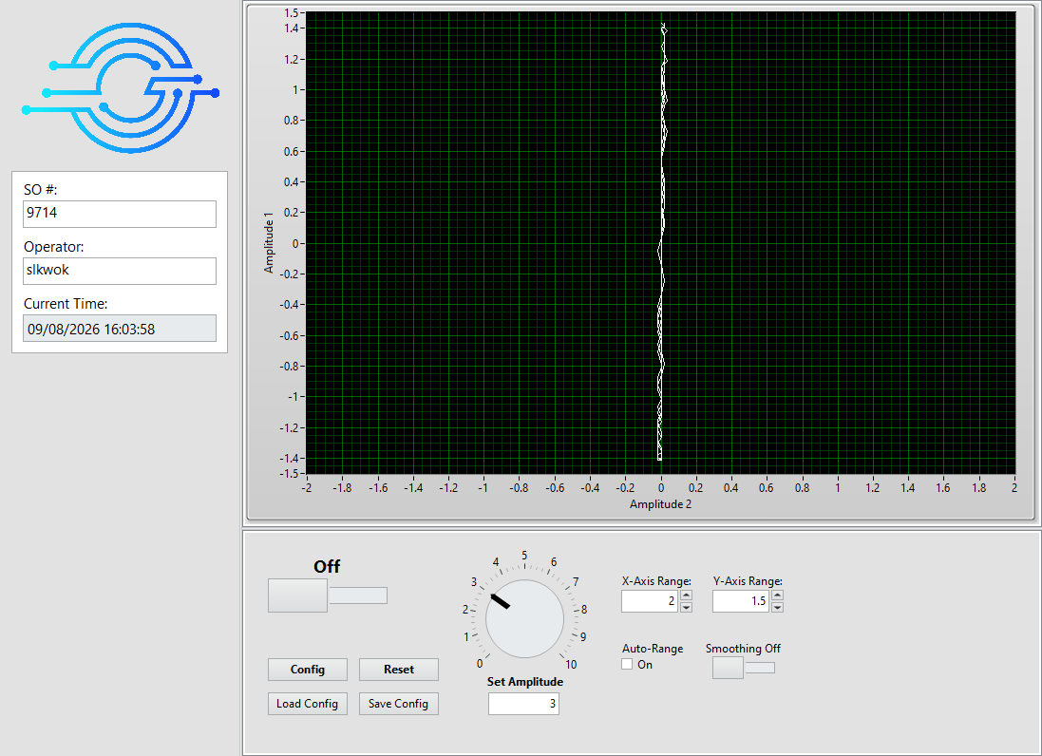
Figure 55. 2626 POWER VIN Figure 56. 2626 TRACE VIN BURNT
Date Code: 2626: Date Code: 2626:
Apply 12V between VIN and GND After applied 12V between VIN and GND
Failed Curve Trace result Failed and show shorted.

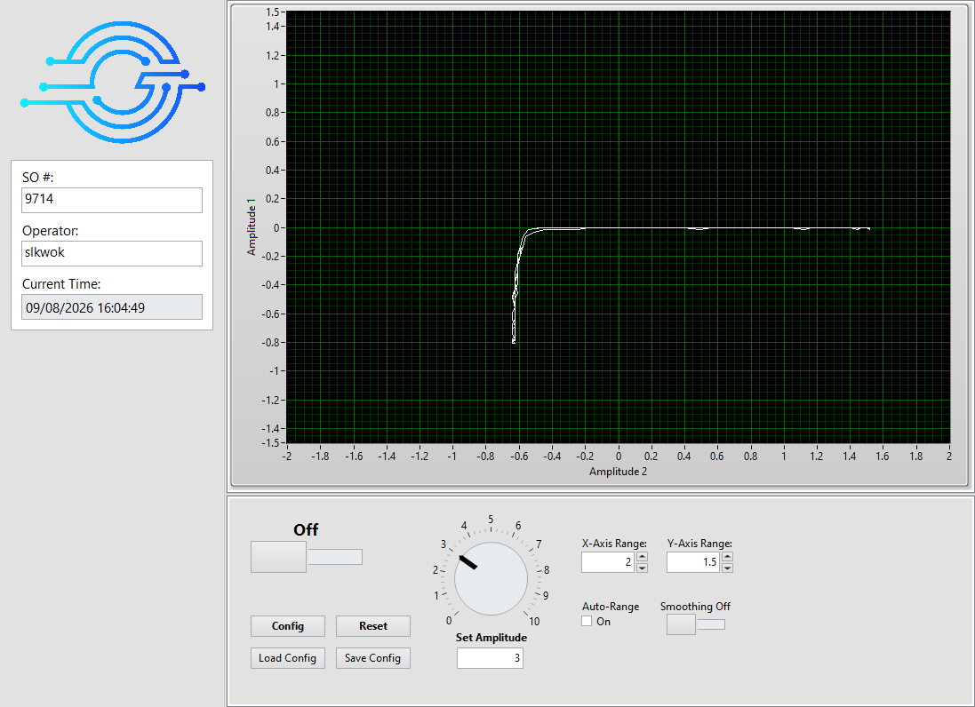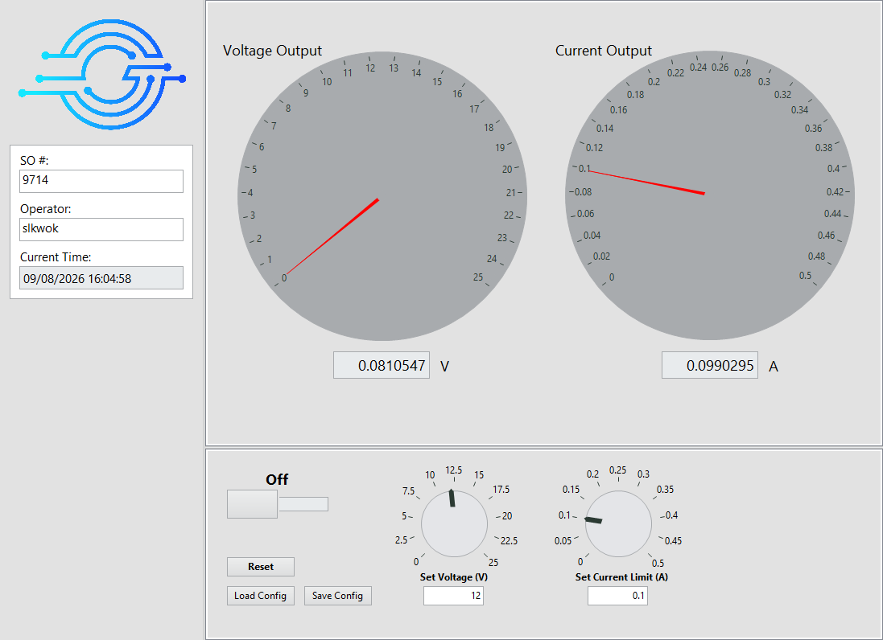
Figure 57. 2629 TRACE VIN Figure 58. 2629 POWER VIN
Date Code: 2629: Date Code: 2629:
Before apply 12V between VIN and GND Apply 12V between VIN and GND
Passed Failed
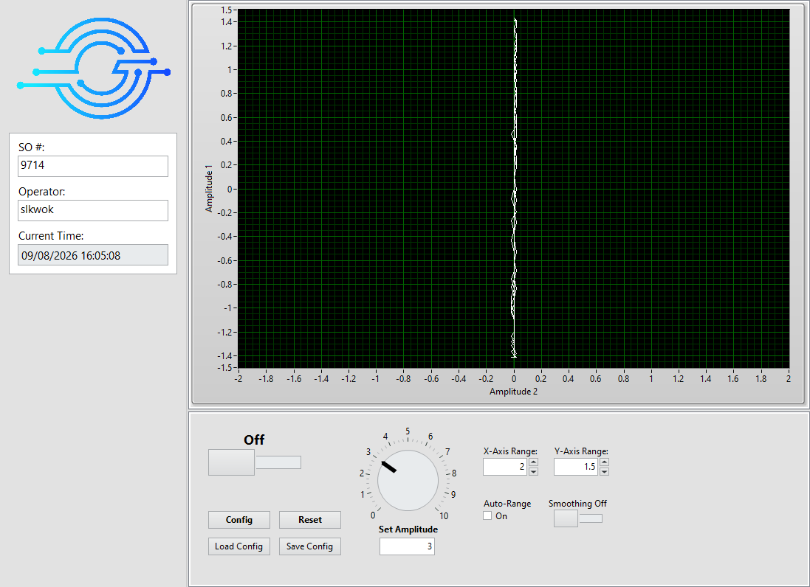
Figure 59. 2629 TRACE VIN BURNT
Date Code: 2629:
After applied 12V between VIN and GND
Curve Trace result Failed and show shorted.

