TPS65982 thermal issue
-----------------------------------------------------------------------------------------------------------------
20V is output.
FW setting
Sink capabilities
Source capabilities
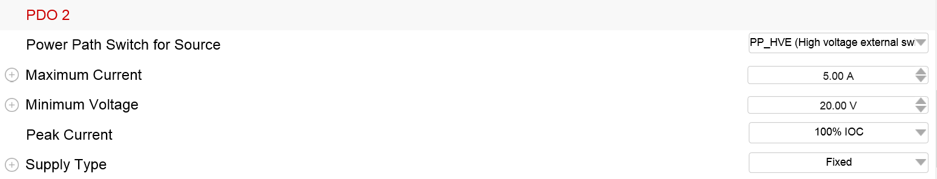
This Schematic have thermal issue on TPS65982 ( 60 degree )

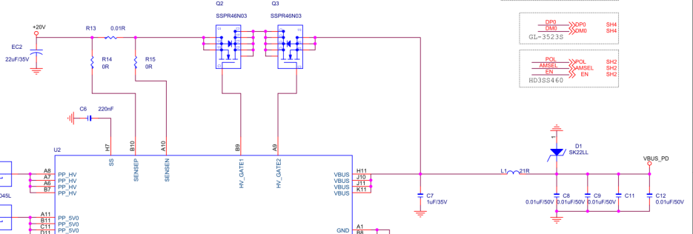
I swap SENSEP and SENSEN , TPS65982 did not have this issue
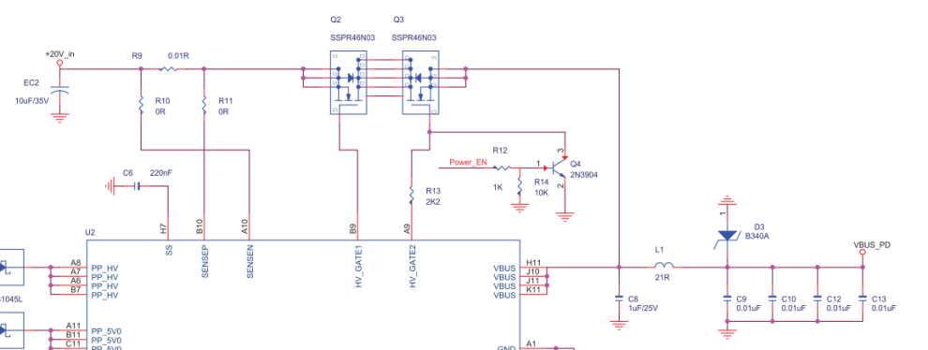
Btw , I think picture 1 is right setting. Could you help to check this issue?
