TPS65983B Configuration tool

Version:3.19

1. New project🡪 Tapex Creek

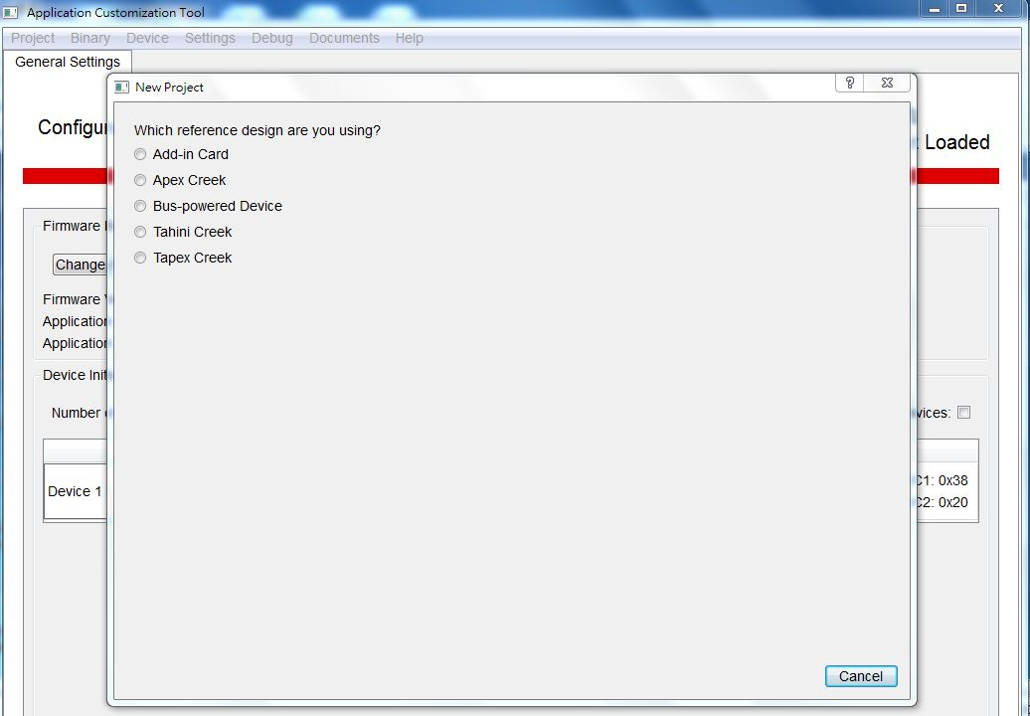

1. Selection Charging configuration🡪 Static Charging

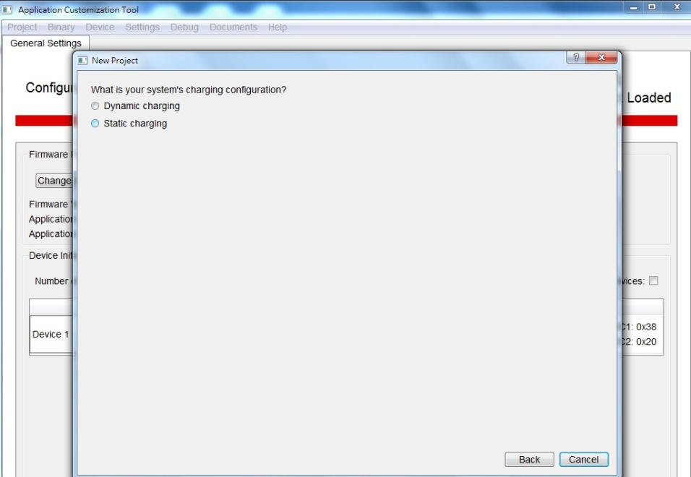

1. Which port >5V charging🡪Port A

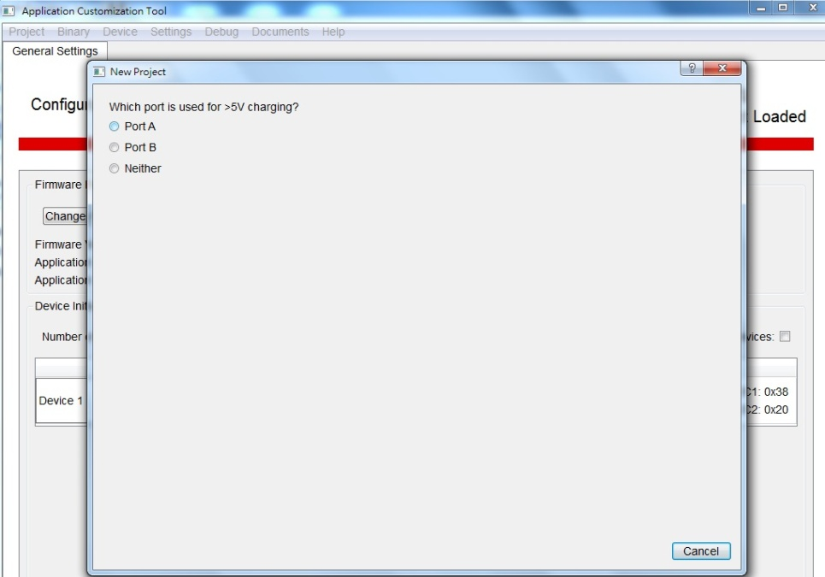

1. How is DP Hot Plug Signalled🡪 Physical pin

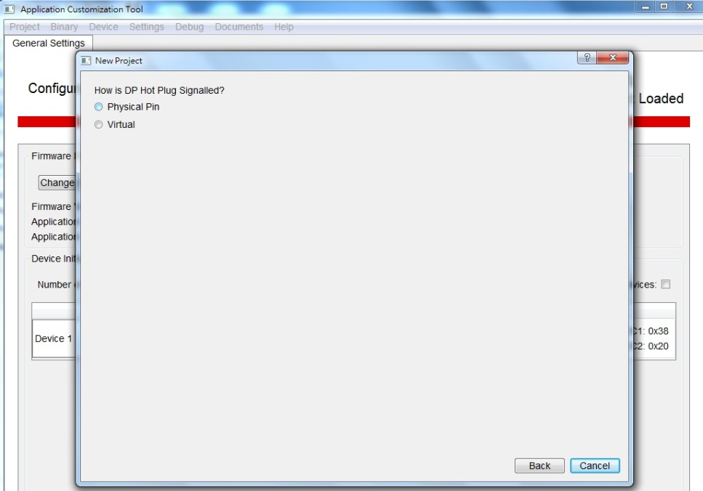

1. Device 1 Transmit Source Capabilities: 5V/9V/15V/20V (Max 85W)
   1. PDO1: 5V /3A (internal High Voltage Power Path)

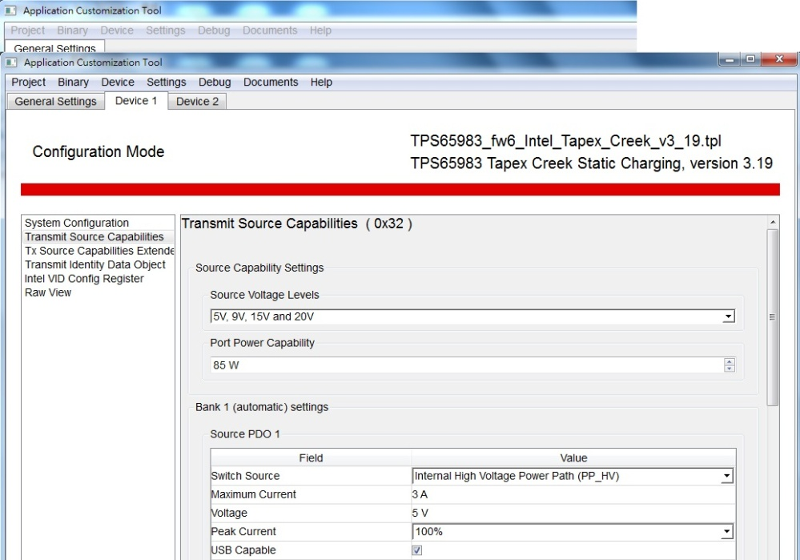

* 1. PDO2: 9V /3A (internal High Voltage Power Path)

PDO3: 9V /3A (internal High Voltage Power Path)

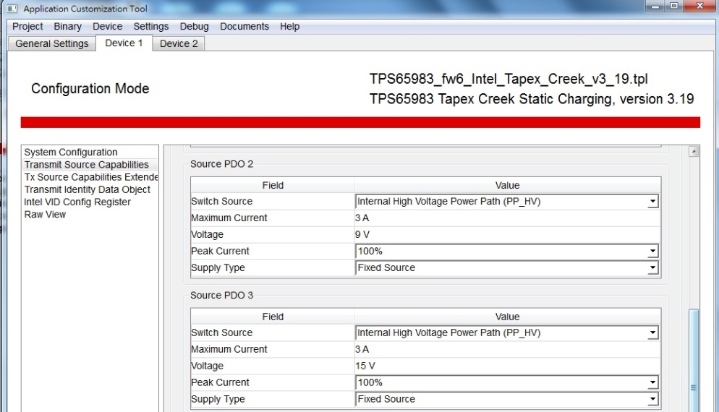

* 1. PDO4: 20V /4.25A (External High Voltage Power Path)

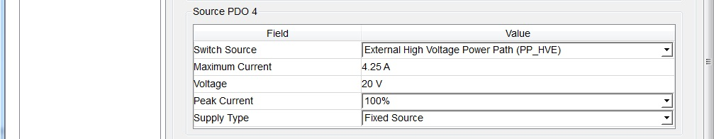

1. Device 2 Transmit Source Capabilities: 5V (Max 15W)

