TUSB1210 User Guide

1: TUSB1210 PHY

The ULPI interface corresponds to the following pins:
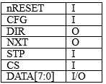
PHY Reset

The ULPI/USB device must be initialized. For TI TUSB1210 where a low signal applied to nRESET will set the internal registers to their default values. nRESET must be applied for a minimum of 200ns.

Registers

The PHY has a number of internal registers associated with various modes and interface speeds. We need only worry about two of the registers if we intend to setup the PHY as a peripheral.

The following diagram illustrates a write to a register:

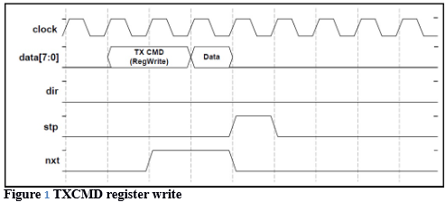

And the following a read from a register:

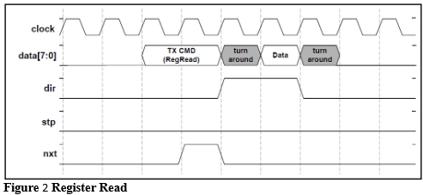

When the DIR signal is asserted and the NXT signal stays low a RXCMD byte is received that generally represents the PHY status. This is useful to determine the state of the D- and D+ lines to determine if the peripheral has been connected to a host.

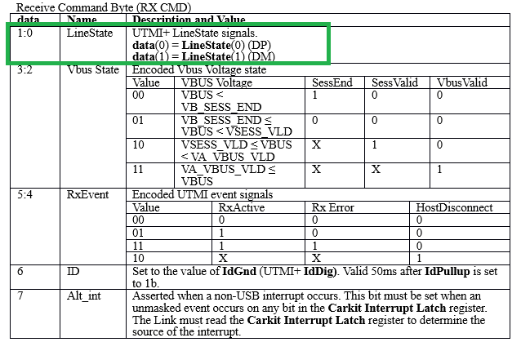
LineState can be read on D0/D1 of ULPI interface from RX_CMD
These are the signals we should expect after reset has been released on the PHY
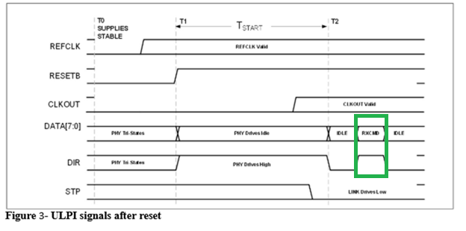
One significant aspect of reset is the toggling of DIR and a receipt of a RXCMD byte from the PHY. Once that is detected then we may move forward. The IDLE state is where the Link places 0x00 onto the Data lines. We use a registered DIR signal (so that it is delayed by one clock) as an enable for the driving of data from the FPGA.

We must then initialize the peripheral. High-speed capable devices initially attach as full-speed devices where DP is pulled up to Vbus through a 1.5k resistor.

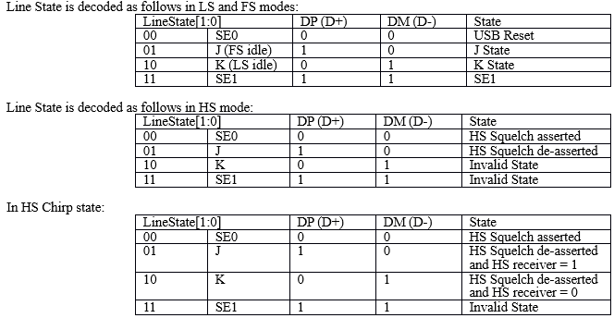

The lesser bit LineState[0] represent DP (D+), and LineState[1] represent DM (D-).

2 The sequence of events:

Apply reset for more than 200ns. The PHY will pull DIR high to ensure the Link will not drive data lines.
Wait for DIR to go low.
Wait for a RXCMD, ie a toggle of the DIR pin.

The peripheral must start as a FS device by pulling DP high through an internal resister controlled by FUNC_CTRL register. First we must disable OTG features by writing x”00” to the OTG_CTRL (x”0a) register. A TXCMD byte of x”8a” is sent then a data byte of x”00” as per Figure 1.

Send x”45” to FUNC_CTRL (x”04”) where this sets the peripheral device in the full Speed mode by making D+ high and D- low ( LineState “01” – J).

The PHY should respond with a RXCMD showing a LineState of J (“01”, FS Idle).

3 Attaching peripheral to the host (HS handshake)

An outline of the High Speed initialization and handshake process is shown in Figure 4

1 If the peripheral is attached to the Host, or now becomes attached to the Host, the Host should wait 100 ms for a stable LineState of “01” and then drive both D+ and D- low. This is the SE0 level and the PHY should produce a RXCMD to confirm a LineState SE0 (“00”)..

2 In order to signal to the Host the peripheral is capable of High Speed the device must signal a “K” (a LineState of “10”) chirp for a minimum of 1.0ms by writing x”54” to FUNC_CTRL (x”04”), then writing a NOPID TXCMD and data of x”00”. After, say 1.5ms, we drive STP to a “1” for a single clock to end the chirp.

3 The Host then sends a sequence of alternating J and K signals and once the peripheral detects these J and K signals it can then set the PHY to receive and transmit High Speed serial data.

4 This can be accomplished by writing x”41” to FUNC_CTRL (x”04”).

5 We have a peripheral in HS mode.

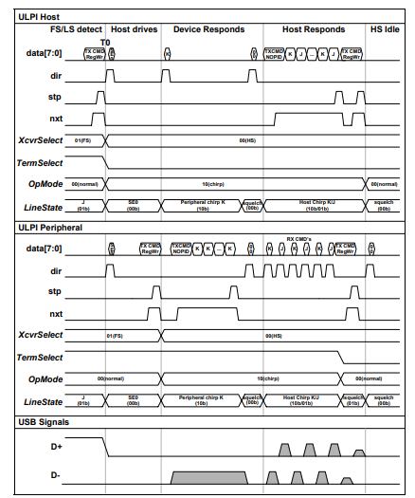
Figure 4 High Speed Initialization and handshake

